The User must have a Concur Account
User – General Information
Enhanced Workflow for Updating a User Profile in Concur
- Accessing Your Profile
  - Log in to Concur.
  - In the upper right corner, click on your name or the profile icon.
  - Select Profile Settings from the dropdown menu.
- Updating Personal Information
  - Navigate to Your Information on the left menu.
  - Update fields such as:
    - Name: Ensure it matches your government-issued ID for travel purposes.
    - Email Addresses: Add or update your primary and secondary email addresses. Verify your email addresses if required.
    - Contact Information: Update your phone numbers and address.
- Credit Cards – Required to Book Travel
  - CSUB recommends using the Concur Travel Credit Card if eligible (i.e., two or more business trips per year).
  - The Concur Travel Credit Card will automatically be added to your profile if eligible.
  - Airfare and rail travel booked in Concur will be paid by CSUB. Other travel expenses must be paid by either the Concur Travel Credit Card or a personal credit card.

- Adding or Updating Travel Preferences
  - Navigate to Travel Settings.
  - Update your travel preferences, including:
    - Air Travel Preferences: Preferred airlines, seating preferences, frequent flyer numbers.
    - Hotel Preferences: Preferred hotel chains, room type preferences, loyalty program numbers.
    - Car Rental Preferences: Preferred car rental companies, car type preferences, loyalty program numbers.
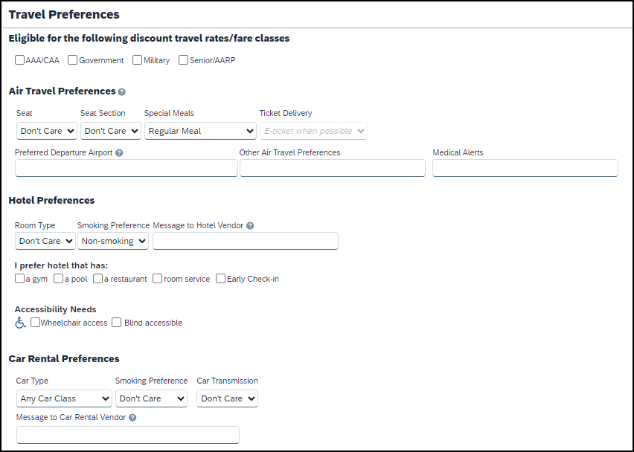

- Managing Delegates
  - Navigate to Expense Settings > Expense Delegates.
  - Add or remove delegates who can prepare and submit expense reports on your behalf.
  - To add a delegate:
    - Click Add.
    - Enter the delegate's email address, employee ID, or name.
    - Select the appropriate permissions (e.g., Can Prepare, Can View Receipts).
  - To remove a delegate:
    - Select the delegate's name.
    - Click Delete
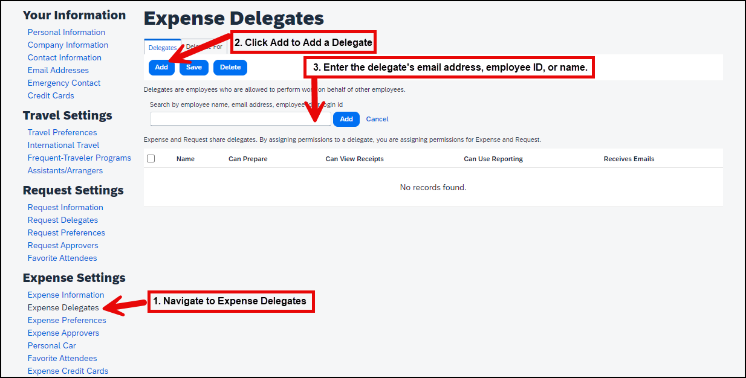

- Updating Your Personal Car Information
  - Navigate to Expense Settings > Personal Car.
  - Enter a Vehicle ID and select Vehicle Type as either Personal Car or Athletics (if applicable).
  - Click Save.

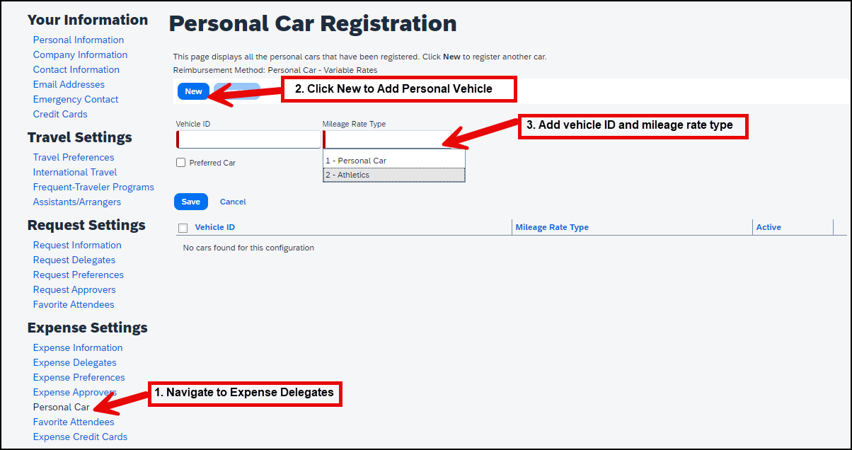

- Using the SAP Concur Mobile App
  - Downloading the App:
    - The SAP Concur mobile app is available for both iOS and Android devices. Download it from the App Store or Google Play Store.
  - Logging In:
    - Open the app and log in using your Concur credentials.
  - Updating Profile Information:
    - Access your profile settings within the app to update personal information, travel preferences, and more.
  - Managing Expenses:
    - Use the app to capture receipts, create and submit expense reports, and manage approvals on the go.
  - Travel Bookings:
    - Book flights, hotels, and car rentals directly from the app, and manage your travel itinerary.
  - Saving Changes
    - After making all necessary updates, click Save to ensure your changes are applied.

- E-Receipts
- How E-Receipts Work:
  - E-receipts are electronic versions of paper receipts that are automatically sent to Concur by participating vendors.
  - When you make a purchase with a participating vendor, the receipt is sent directly to your Concur account, reducing the need for manual entry.
- Participating Vendors:
  - Many major hotel chains, car rental companies, and airlines participate in the e-receipt program.
  - Check the Concur website or contact your travel department for a list of participating vendors.
- Enabling E-Receipts – Recommended
  - E-receipts allow for automatic receipt data submission, replacing paper receipts. To activate:
    - Click Profile > Profile Settings > E-Receipts Activation.
    - Agree to the E-Receipt Activation and Use Agreement.
    - Confirm acceptance, and if you have a Concur Travel Card, it will be opted in automatically.
  - To opt-out of receiving e-receipts:
    - Click Profile > Profile Settings > Personal Information.
    - Edit your Credit Cards section.
    - Uncheck Receive e-receipts for this card.

