The User must have a Concur Account
User – General Information
Enhanced Workflow for Submitting a Group Travel Request in Concur
- Accessing the Travel Request Section
  - Click on the “Create” button (BLUE) and then “Start a Request” or select +Start a request
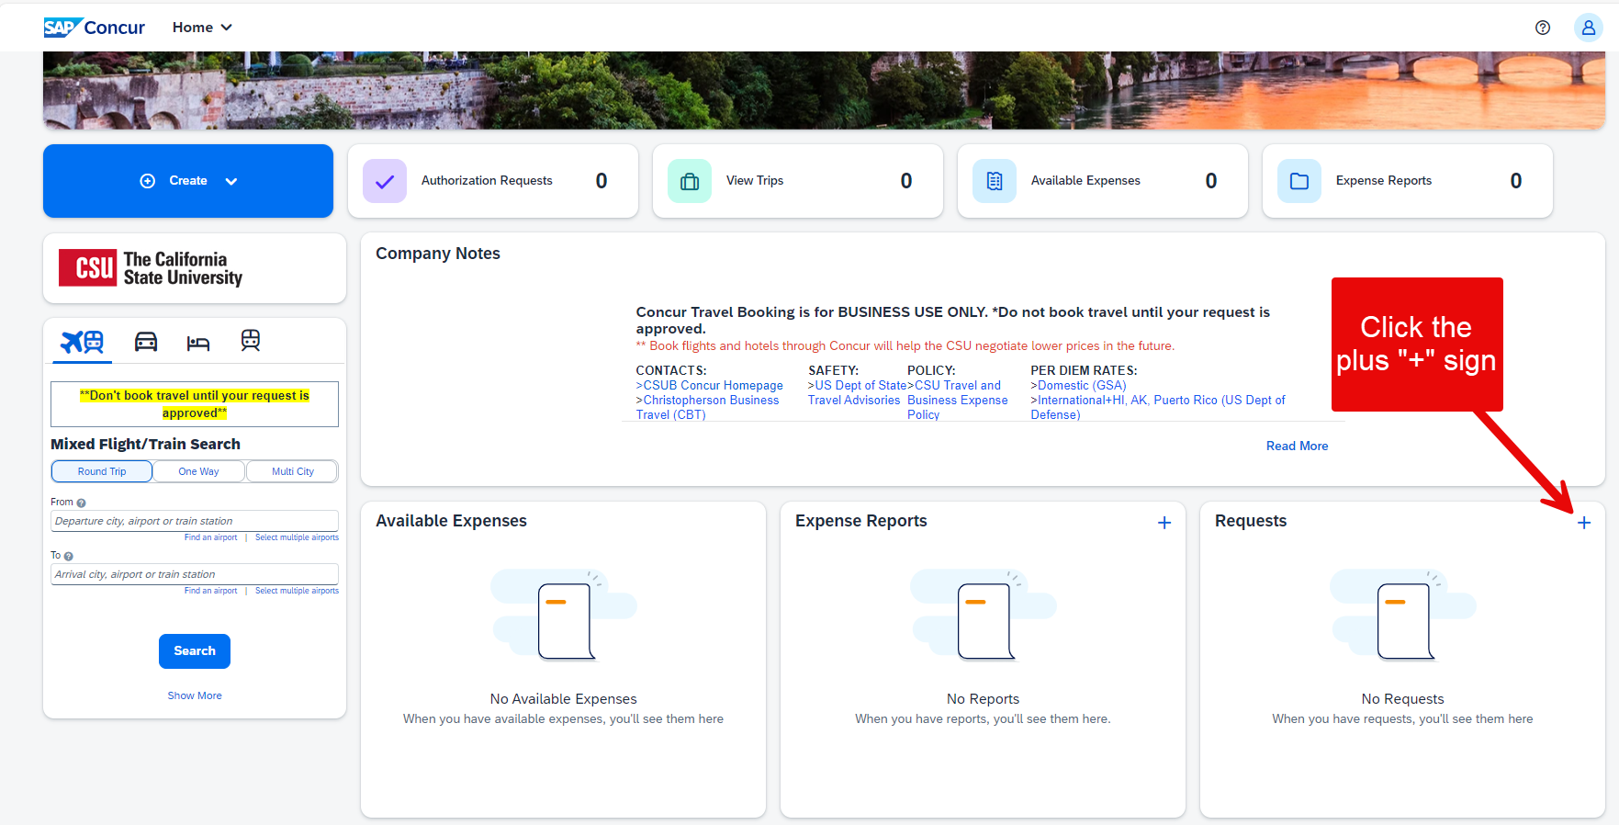
- Filling out the request Header
  - Complete all required fields marked with a red asterisk (*), then select “Create Request.”
    - Request/Trip Name: Use a meaningful name (i.e., Group to Las Vegas 11/25/24)
    - Trip Type: Select from In-State, Out-of-State, or International
    - Travel Start Date and Travel End Date
    - Traveler type and Trip purpose
    - Destination City/State and Final Destination Country
  - Additional fields like:
    - Personal Dates of Travel – not recommended with group travel
    - Are you traveling to a banned state – No (to be removed)
    - Are you traveling with students – “YES” for group travel
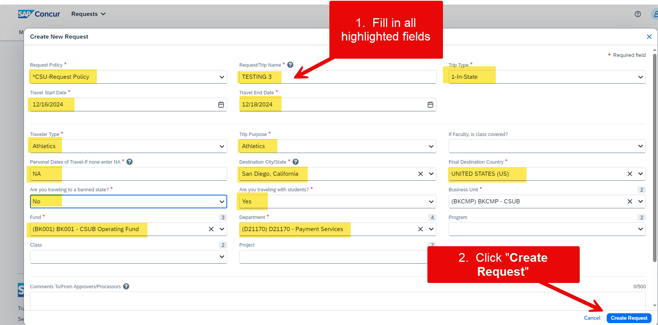

- Adding Projected Expenses
  - On the Expected Expenses page, click Add
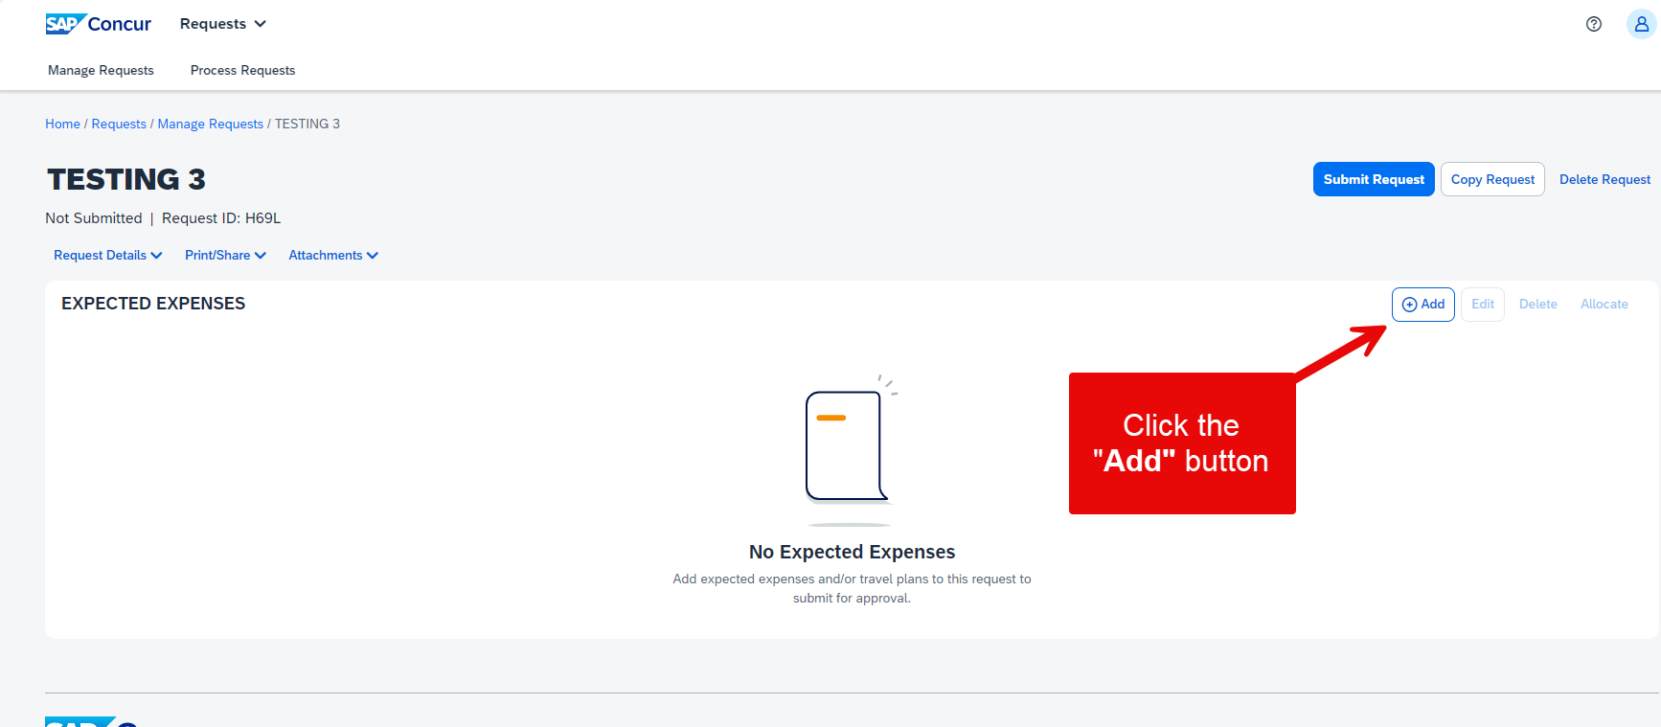
  - When creating a travel request for a group, ensure that each traveler’s details are included:
    - List all travelers in the Traveler Type field or add a note in the Comments section
    - Ensuring that projected expenses cover the entire group, including airfare, accommodation, meals, and other relevant costs
    - Use required expense categories:
      - Hotel Reservation: Choose “Other Accommodation (Group Only)” and enter details.
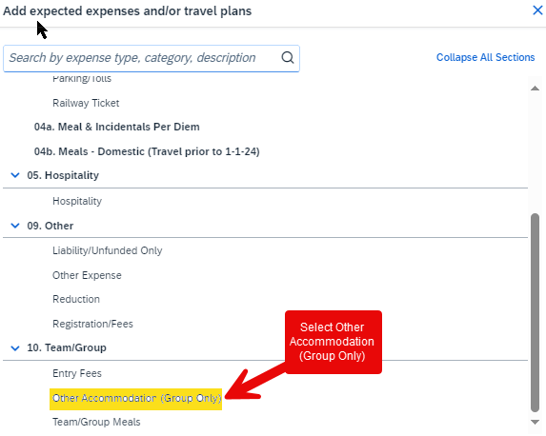
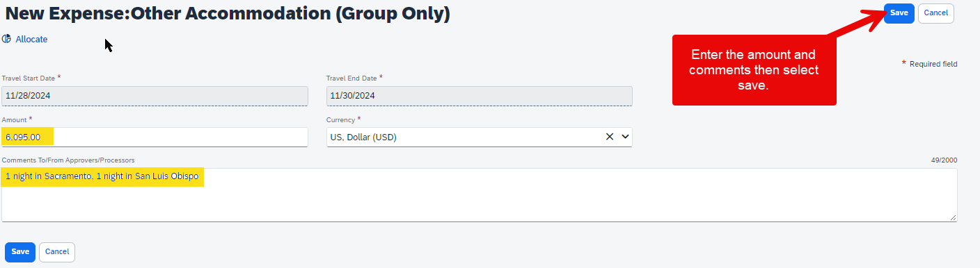
      - Group meals: Choose “Team/Group Meals and enter details.
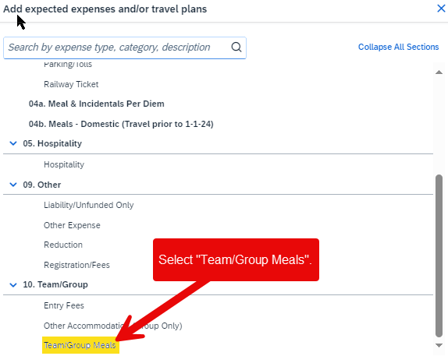
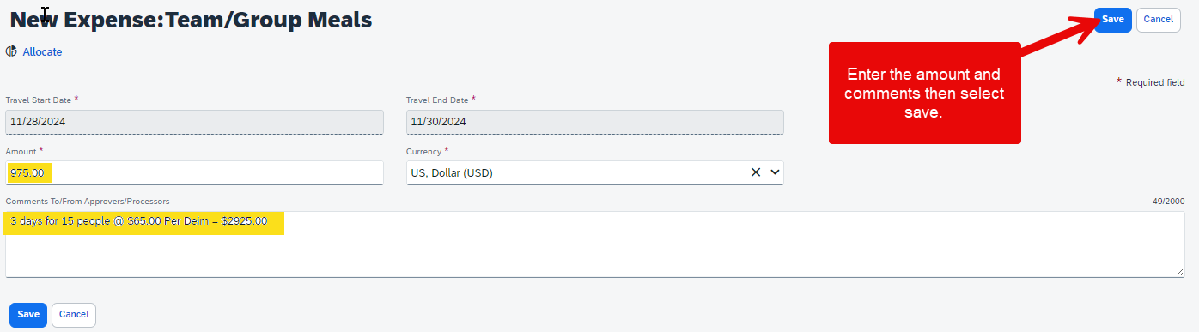
    - Enter more expenses and details as needed:
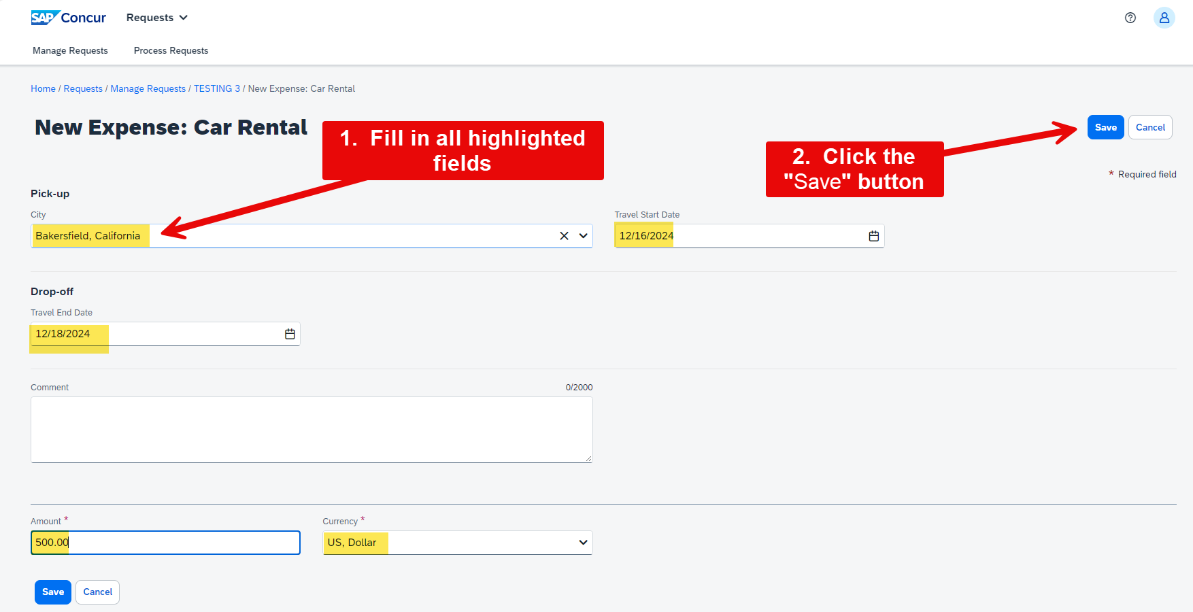
    - Parking/Tolls: City, start and end dates, and total amount
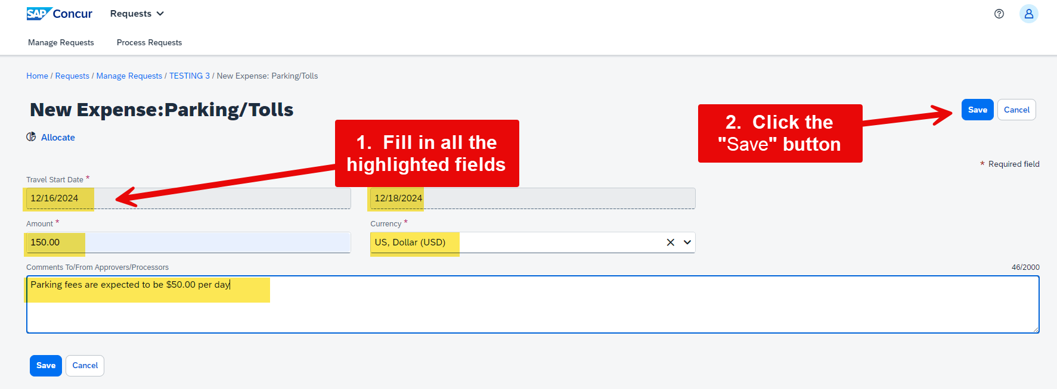
    - Airfare Ticket: round Trip, One Way, or Multi City, locations, dates, and total amount
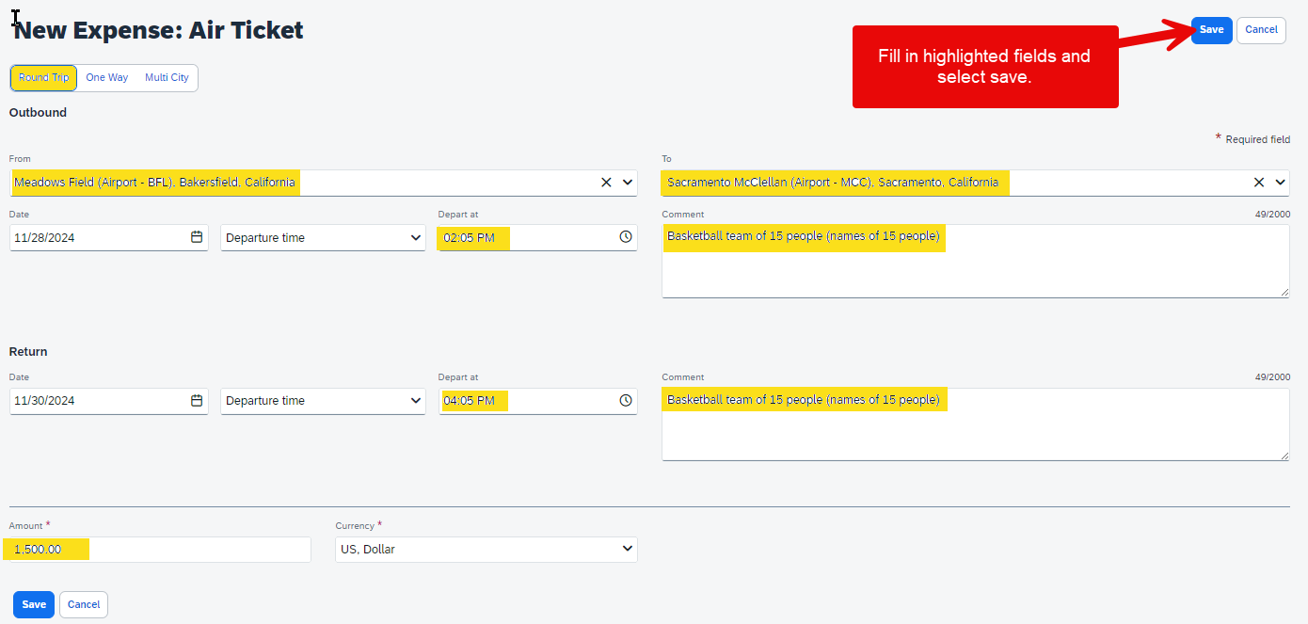

    - Other Expense: Amount and comments to detail expense total
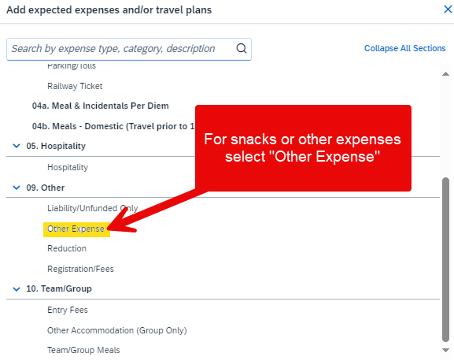
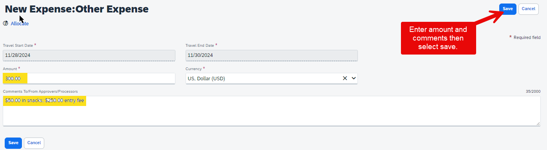

- Submitting the Request for Approval
    - Once all details and expenses are added, click the Submit Request button
    - The request will follow the approval workflow, which includes Supervisor and cost object approvers
      - Email notifications will be sent to approvers and requestors
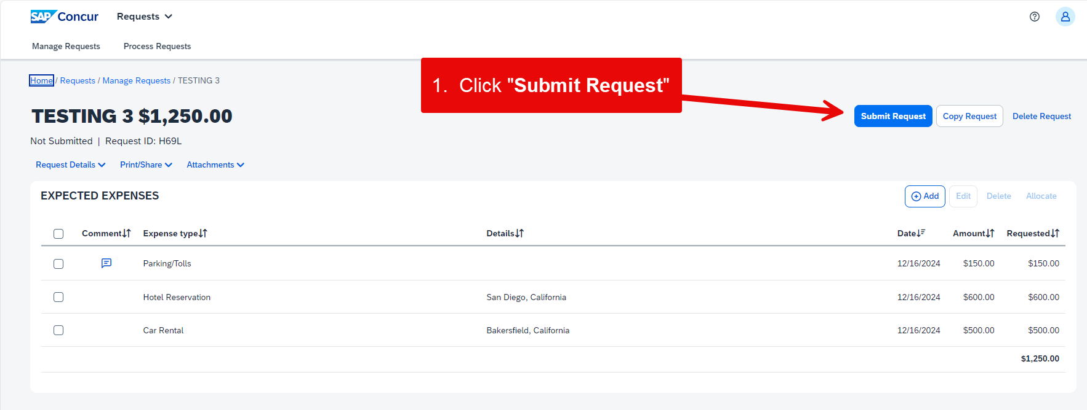
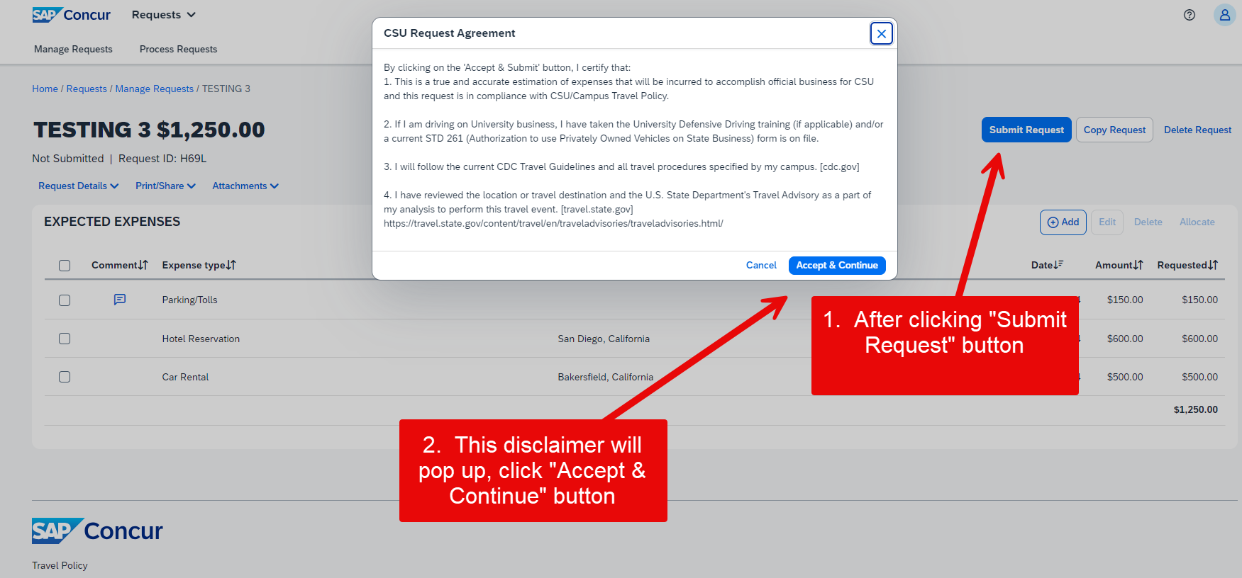
- Tracking and Managing the Request
    - Use the Request Timeline to view the approval workflow and status
    - Edit, recall, or cancel the request if necessary
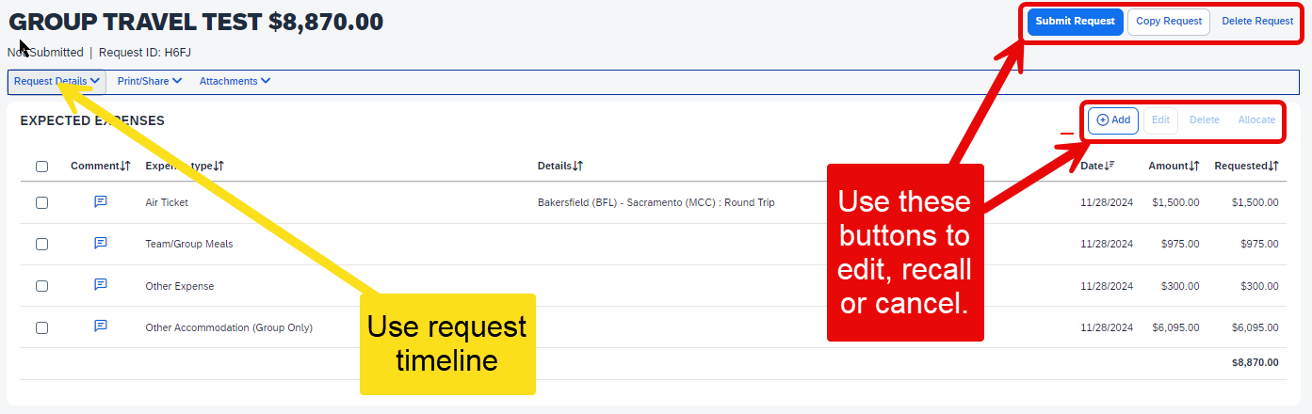
- Additional Approval Workflow
  - Initial Submission
    - The travel request is first submitted by the traveler to their delegate
  - Supervisor Approval
    - The request is reviewed and approved by the traveler’s direct Supervisor. This step ensures that the travel is necessary and aligns with departmental goals
  - Cost Object Approver
    - The request is then routed to the cost object approver(s) based on the chart field entered on the Request Header tab. This approver verifies the availability of funds and the appropriateness of the expenses
  - Final Approval
    - Once all necessary approvals are obtained, the request is finalized, and the traveler is notified. The travel elements can then be booked.

