The User must have a Concur Account
User – General Information
Enhanced Workflow for Submitting a Group Travel Expense Report in Concur
- Accessing the Expense Report Section
  - From the Home Menu, select Requests.
  - Select the approved travel request tile for the trip you want to expense.
  - Click on Create Expense Report.

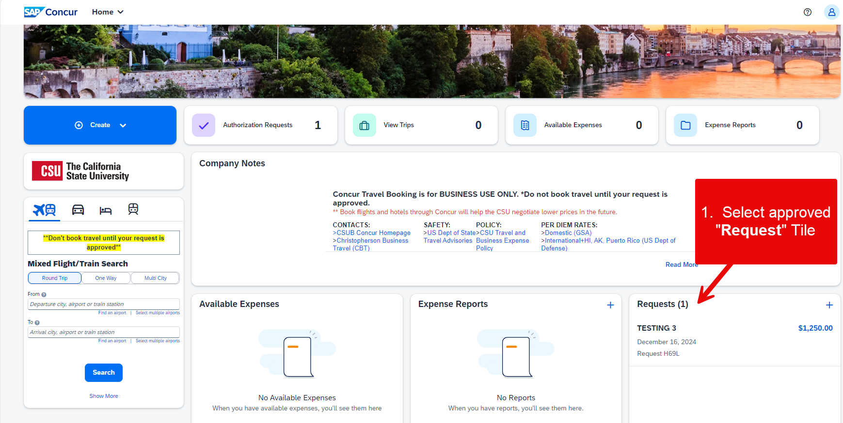

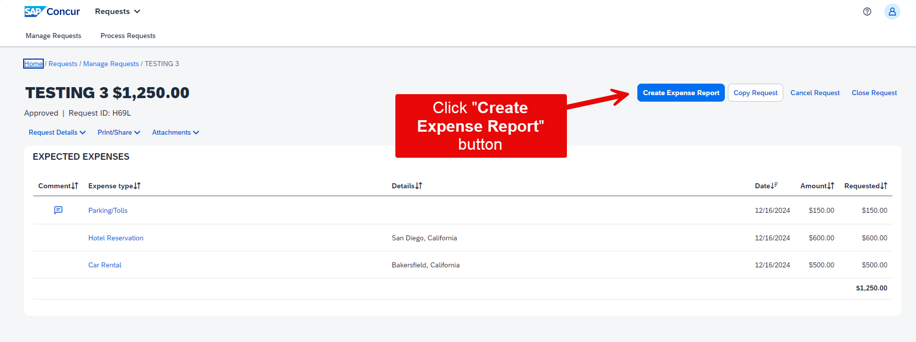
- Adding Travel Allowances
  - Navigate to Travel Allowance > Manage Travel Allowance.
    - If the Coach decides to pay for their meal separately from the group meal, they will select Travel Allowance.
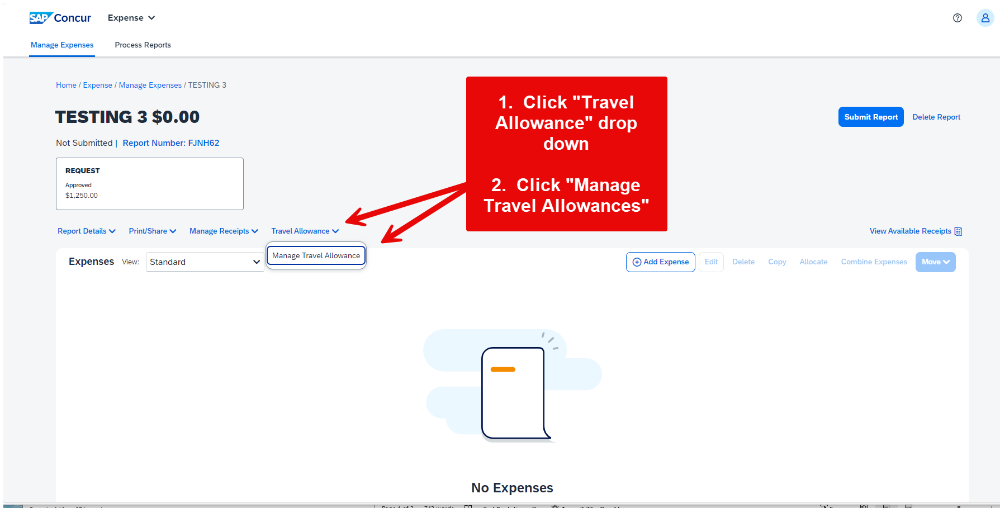
  - Manually enter the itinerary.
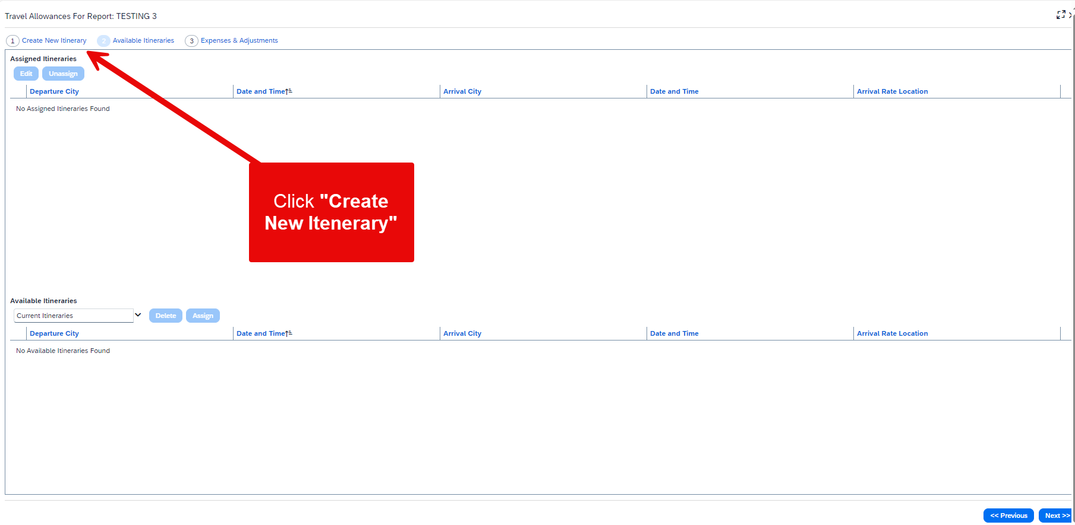
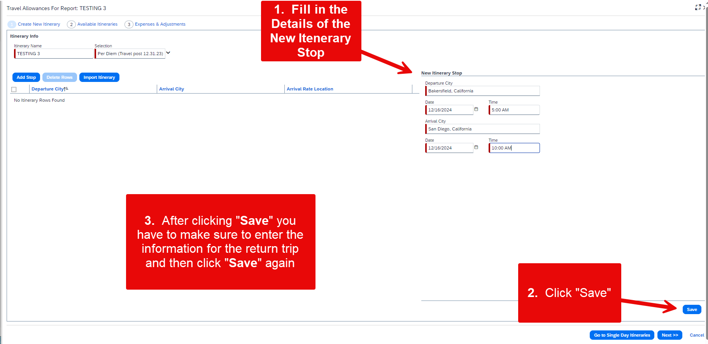
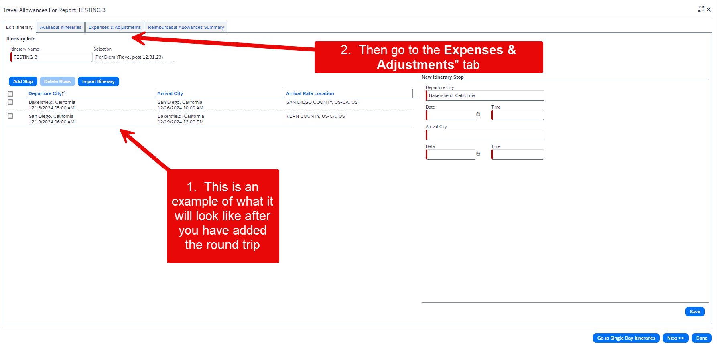
  - Adjust allowances for meals and incidentals, excluding any provided meals.
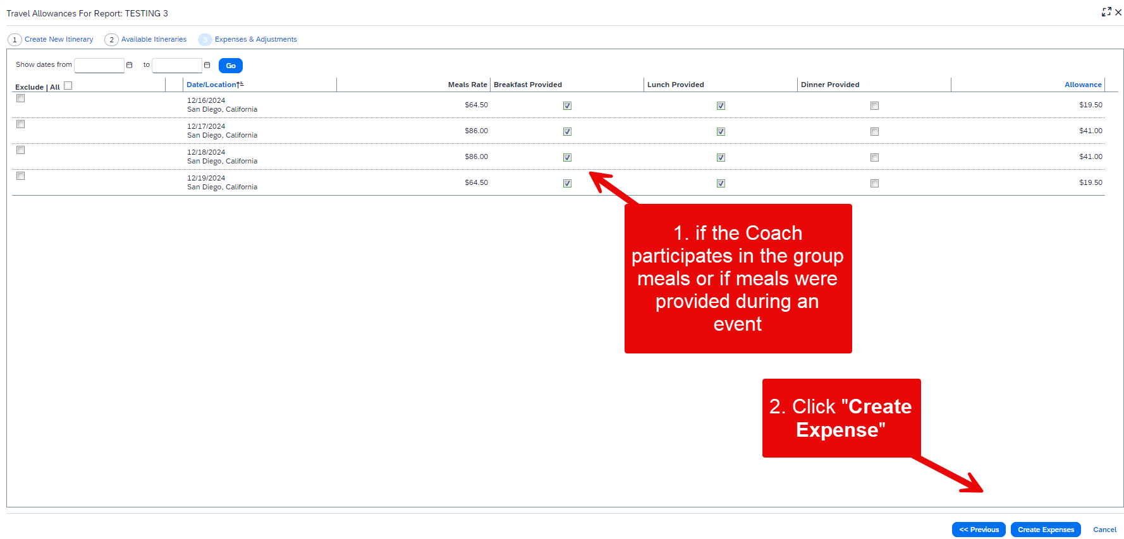
- Adding Expenses
  - Click Add Expense to enter new expenses.
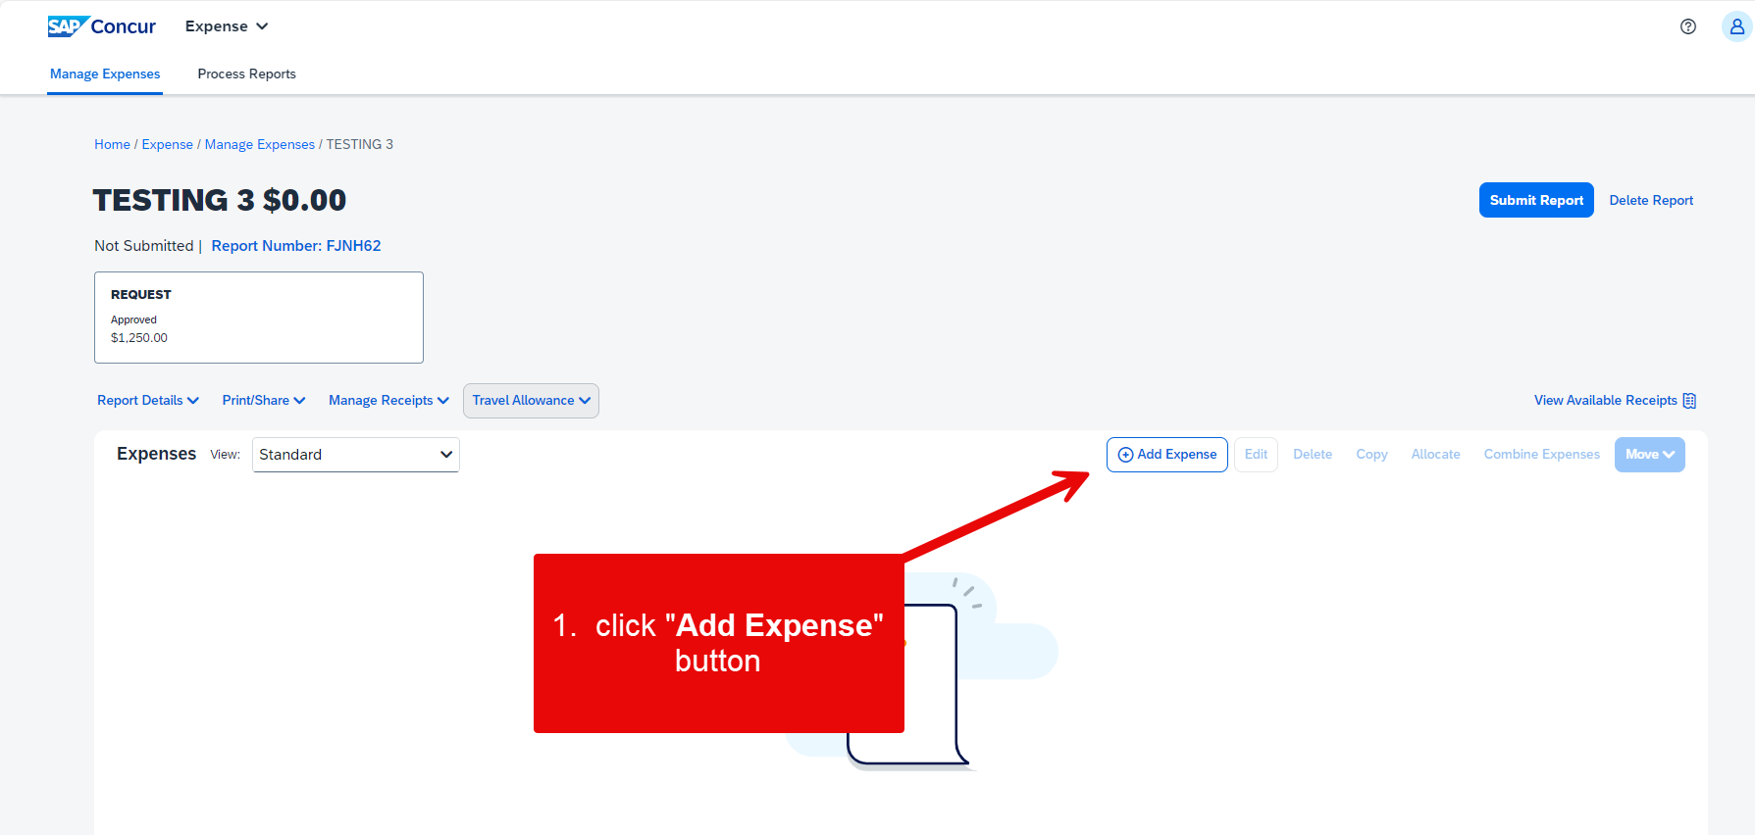
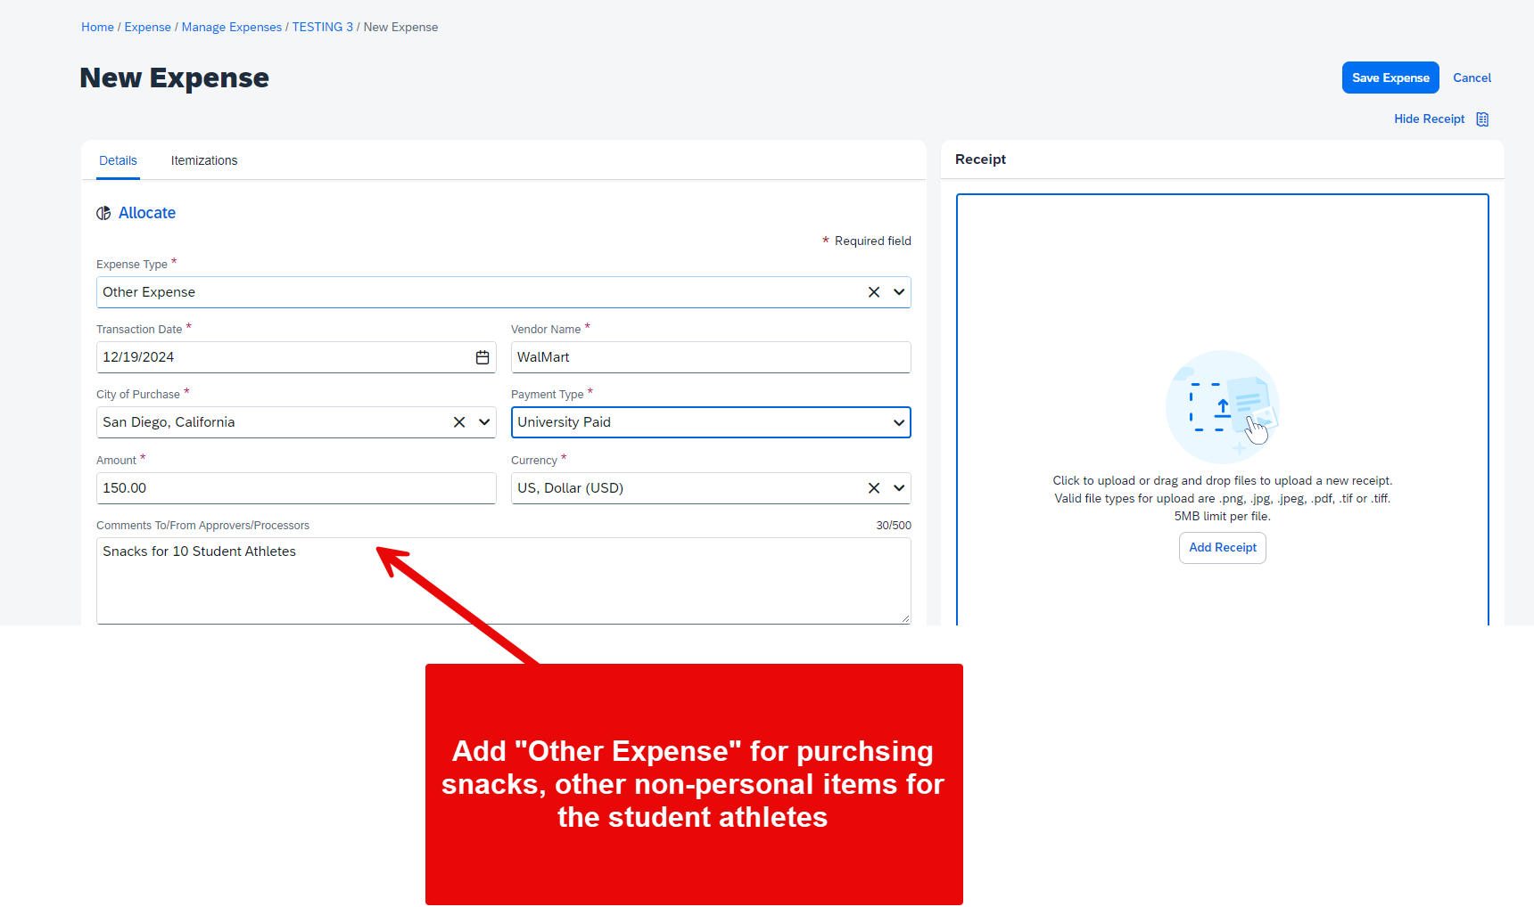

  - Select or search for the appropriate expense type (e.g., Airfare, Hotel, Meals).
  - Enter the required details such as transaction date, vendor name, city of purchase, amount, and comments.
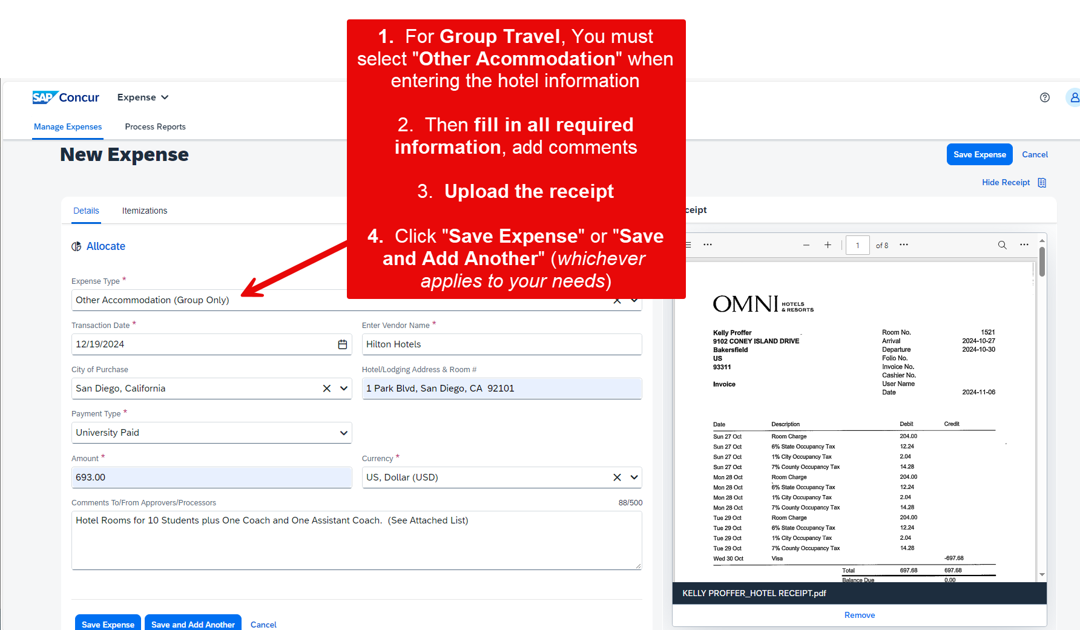
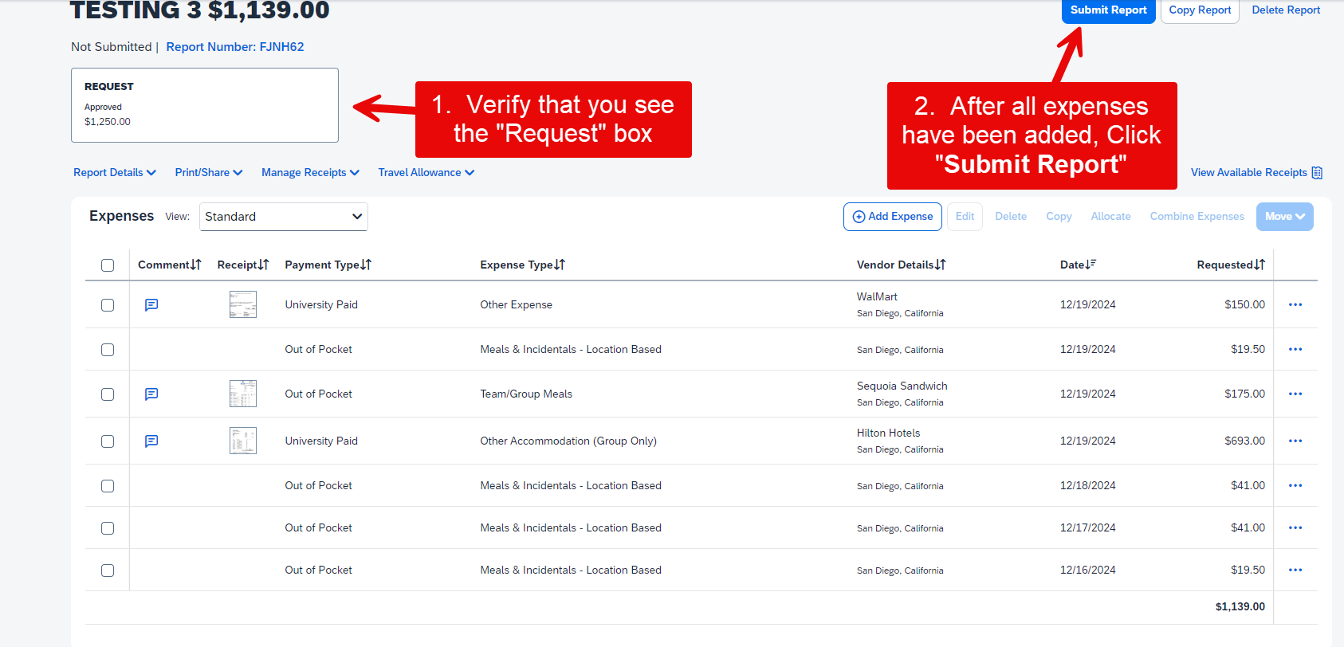
  - Attach receipts by clicking Add Receipt and uploading the necessary documents.
- Allocating Expenses
  - Select the transaction you need to allocate from the expense listing.
  - Click Allocate near the lower-right corner of the Expense Details section.
  - From the Allocate By dropdown menu, choose either Percentage or Amount.
  - Click the field under Fund or Department. Recently used chartfields will display. Select the desired data from the dropdown or enter them manually.
  - If you want to split the transaction among multiple chartstrings, click Add New Allocation.
  - Repeat steps 4 and 5 for each new allocation.
  - Click Save. The sum of the split transactions must be equal to the total transaction.
  - In the confirmation message box, click OK.
  - In the Allocate Report window, click Done
- Using Class Codes
- Concur will only allow one chartfield option for all purposes. To mitigate that issue, please use the following class codes as necessary so it is clear what type of travel the team is doing. Our travel team will update the account code based on the class code selected.
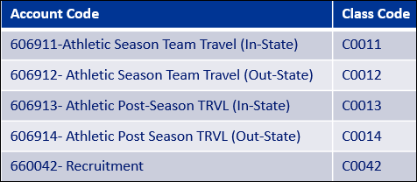

Approval Workflow
- Initial Submission
  - The expense report is first submitted by the traveler or their delegate.
- Supervisor Approval
  - The report is reviewed and approved by the traveler's direct supervisor. This step ensures that the expenses are necessary and align with departmental goals.
- Cost Object Approver
  - The report is then routed to the cost object approver(s) based on the chartfield entered on the Report Header tab. This approver verifies the availability of funds and the appropriateness of the expenses.
- Additional Approvals (if applicable)
  - For specific cases, additional approvals may be required. This could include campus approvers or the Chancellor’s Office Risk Management for high-risk destinations.
- Final Approval
  - Once all necessary approvals are obtained, the report is finalized, and the traveler is notified.
    - est. Make sure to address this alert promptly to avoid del

