“Pesticide Exposure and Health Risks in Central Valley Communities”

Steven Contreras
April 4, 2025

Abstract

California’s Central Valley is home to some of the most productive farmland in the country. To maintain this productivity, counties in the region have relied heavily on pesticides to protect their crops and to boost yields. While pesticides have increased agricultural output, there are still concerns about how they might affect the environment and human health. Previous studies, such as Paul et al.’s which linked paraquat exposure to increased rates of Parkinson’s disease, have highlighted how exposure to pesticides can lead to detrimental health outcomes. While this work is significant, more research is needed to assess how other pesticides may affect surrounding communities. This paper investigates whether counties with high pesticide usage rates, specifically Kern, Tulare, and Fresno counties, have higher rates of end-stage renal disease, Parkinson’s disease, and specific forms of cancer compared to those counties which are less agriculturally productive such as Los Angeles, San Diego, and San Francisco counties. Pesticide usage data, specifically carcinogen and cholinesterase inhibitor usage rates, from Tracking California, and health outcome data from the California Cancer Registry and the California Department of Public Health were analyzed using Pearson correlation tests. Although most correlations were weak, there was a moderate positive relationship between carcinogen use and deaths from Nephritis, Nephrotic syndrome, and Nephrosis (NEP), which were used as a proxy for end-stage renal disease. These findings suggest that while pesticides may contribute to adverse health outcomes, other factors are also at play.

Introduction

Pesticides have been heavily relied upon throughout California’s agricultural industry. In the Central Valley, California’s most productive agricultural region, pesticides have helped farmers maintain high crop yields by mitigating and eliminating pests and serving other important roles which help boost agricultural output. While pesticides undoubtedly play a tremendous role in farming, the extensive use of chemicals is concerning as many pesticides have been linked to adverse health outcomes for both humans and the environment. Exposure to certain pesticides has been linked to many different adverse health outcomes such as cancer, kidney disease, and neurological disease. An example of this is provided by Paul et al (2024) as they were able to link exposure to paraquat with increased rates of Parkinson’s disease. While previous studies have investigated the effects that certain pesticides have on human health, many focus on specific chemicals or individual cases, while less research has been conducted which utilizes a broader category of pesticides and their impacts across an entire region such as the Central Valley. Because the Central Valley is a major agriculturally productive region which also utilizes large amounts of pesticides, it is important to investigate whether pesticide exposure may be leading to higher rates of certain adverse health outcomes. This study focuses on the relationship between pesticide usage, particularly carcinogens and cholinesterase inhibitors, and health outcomes across various counties in California.

Pesticides and Agriculture

Pesticides play a significant role in the agricultural industry. Farmers rely heavily upon pesticides, which are substances intended for preventing, destroying, repelling, or mitigating pests, for agricultural production purposes (EPA 2025). There are various types of pesticides such as fungicides, which target fungi, insecticides which target insects, and herbicides which target weeds and other unwanted plants (EPA 2024). In addition to pest control, farmers also utilize these pesticides as plant growth regulators, defoliants, or desiccants (EPA 2025). This versatility that pesticides have highlights the reason that pesticides are used in large quantities on farms across the United States. While determining the exact amount of pesticides used annually in the United States can be difficult, especially since there is not a national pesticide tracking program, a previous report by the Environmental Protection Agency estimates that over one billion pounds of pesticides are used nationwide each year (EPA 2017). This staggering amount of annual pesticide use is not without good reason.
By using pesticides, farmers can boost their overall production of crops as they can target and destroy pests which would have otherwise destroyed their crops. Pesticides do not only boost a farmer’s overall yield, but they can also boost the amount of profit that a farmer makes as they have more product that they can then sell. While having more product to sell is undoubtedly benefits farmers and their wallets, it also benefits society as it increases the supply of food worldwide and helps mitigate hunger and famine which may be happening across the globe. The increased supply of food also makes accessing food easier for the masses as it often makes food cheaper. In this way, pesticides also help mitigate hunger worldwide.
Pesticides in California’s Agricultural Industry
California is the leading producer of agricultural goods in the United States of America with over $59 billion in cash receipts for its agricultural commodities in 2023 (USDA 2025). Unsurprisingly, pesticides are extensively relied upon by California farmers with 181 million pounds of active ingredients applied in the state in 2022 (CDPR 2024). Much of this production and pesticide use occurs in California’s Central Valley.
The Central Valley’s Agricultural Dominance
California’s Central Valley is the powerhouse of the state’s agricultural production. This is evident as seven of the top ten agricultural producing counties in California are geographically located within the Central Valley. The top three agricultural producing counties- Tulare, Fresno, and Kern- are all located within the Central Valley as well and had a combined total market value of over $24 billion in 2021-2022 (CDFA 2024). This means that these three counties alone account for a little over 40 percent of the state’s agricultural value. To achieve such an impressive feat, these counties rely heavily on pesticides to ensure pests do not destroy their yields. This is evidenced by the massive amounts of pesticides that each county uses as Tulare, Fresno, and Kern also lead the state in total usage of pesticides (CDPR 2024). In 2022 Fresno County was the leading county in the amount of chemicals used by pounds as they used over 26.4 million pounds of pesticides used (CDPR 2024). Kern County followed with over 25.8 million pounds of pesticides used (CDPR 2024). Tulare County was the third leading county in total pounds of chemicals used with 17.5 million used (CDPR 2024). These staggering amounts of pesticides utilized by these counties highlights the extent to which chemical inputs are relied upon to produce vast amounts of food. While these chemical inputs do help create the abundance of food that we are so used to seeing in modern day America, they are not without concern as many of the pesticides that are utilized in the agricultural industry can have dire consequences on human health.
Pesticides and Human Health
Pesticides have been linked to several detrimental health effects which include various types of cancers, increased rates of Parkinson’s and renal disease, as well as respiratory issues. Previous studies have shown that prolonged exposure to pesticides have been linked with an increased likelihood of developing various forms of cancer such as non-Hodgkin lymphoma, breast, neck, and brain cancers (Poh et al. 2022; Pathak et al. 2022; Peillex and Pelletier 2020). Research suggests that the major mechanisms that are believed to cause pesticide induced cancers are oxidative stress which causes genetic and epigenetic changes as well as endocrine disruptions (Pathak 2022). These changes can disrupt the natural cellular balance in humans and can stimulate the development, growth and progression of cancer (Pathak 2022). A recent study by Paul et al. (2024) has also highlighted how pesticides can have other detrimental health hazards such as an increased risk of Parkinson’s disease as research has found that paraquat can cross the blood-brain barrier and can accumulate in dopaminergic neurons. Lebov et al. (2016) have also found that in addition to cancer and Parkinson’s disease, chronic exposure to certain pesticides including paraquat has also been associated with an increased risk of end-stage renal disease. Previous studies have found that end-stage renal disease is more prevalent in agricultural workers compared to others who have not worked in the agricultural industry which is believed to be due to increased exposure of pesticides in agricultural workers (Lebov et al 2016). Pesticide exposure has also been found to have detrimental health effects on the respiratory system and can be associated with numerous respiratory issues such as asthma and wheezing (Hoppin et. al). These studies highlight the adverse health effects that are caused by pesticides. It should also be noted that these effects are more pronounced in children due to developmental, dietary, and physiological factors (Roberts et al.). This highlights the need to conduct more research in order to understand and mitigate the effects that pesticides have on vulnerable populations.
Pesticides and the Environment
While the effects of pesticides on human health are plenty, pesticides also have a detrimental effect on environmental health as it impacts local flora and fauna and also effects community water resources which further exposes humans to potential harms (Kumar et al. 2024). Kumar et al detail how only an estimated .01 percent of pesticides applied reach the intended target while the rest of the pesticides make their way into the environment. Pesticides make their way into the environment in several different ways including leaching, transmission, runoff, and volatilization (Pathak et al, 2022). Through this movement, pesticides can then affect non-target plants and animals and can also make their way into bodies of water that are utilized by surrounding communities for their water needs. This puts surrounding communities at higher risks of exposure to harmful substances. Adding to this issue is the increased heat brought about by climate change as increased temperatures increase pesticide volatilization rates, resulting in more pesticides entering the atmosphere and thus exasperating the detrimental effects that pesticides have on the environment and on the health of surrounding communities (Ferguson et al., 2019). The increased volatilization rates also increase the amount of pesticides agricultural producers must use to protect their crops, which also increases the amount of pesticides used and thus in the environment and atmosphere (Ferguson et al. 2019).
Research Question
Due to the high usage of pesticides in California’s agriculturally dominant regions and the aforementioned literature on the potential health impacts of pesticide exposure, this paper seeks to investigate whether counties such as Kern, Tulare, and Fresno, which are the most productive agricultural counties and also those which apply the most pesticides, are more prone to adverse health outcomes. In particular, this paper explores whether these counties experience higher rates of end-stage renal disease, Parkinson’s disease, acute myeloid leukemia (AML), non-Hodgkin lymphoma (NHL), and brain and other nervous system cancers when compared to less agriculturally productive counties such as Los Angeles, San Diego, and San Francisco. It is expected that there will be a correlation between high pesticide usage rates and more adverse health outcomes.
Data
This study relies on multiple sources of data to compare pesticide usage and related health outcomes across the selected counties. Data on pesticide usage rates measured by pounds per acre and classified as either a carcinogen or cholinesterase inhibitor, was sourced from Tracking California. Data on county level cancer rates was obtained from the California Cancer Registry (CCR), while data on Parkinson’s disease deaths and deaths from Nephritis, Nephrotic syndrome, and nephrosis (NEP) were gathered from the California Department of Public Health. Data on deaths from Nephritis, Nephrotic syndrome, and Nephrosis were used as a proxy for end-stage renal disease in this study as they represent severe kidney-related deaths and because public data on end-stage renal disease was not available. Estimates on population data were gathered from California’s Department of Finance in order to calculate rates per 100,000 for Parkinson’s and NEP related deaths to ensure an accurate comparison between counties with different population sizes.
These data sources are all trustworthy as they are all operated or in partnership with California state agencies For example, Tracking California’s website states that it is a program of the Public Health Institute and is in partnership with California’s Department of Public Health and the Centers for Disease Control’s National Environmental Public Health Tracking Program which means that the data being used and compiled by Tracking California is reputable and trustworthy which makes it an ideal source of data for this project (Tracking California).
Research Methodology
The research methodology used for this study was a quantitative one as the available data is numerical and thus more appropriate for statistical analysis. To determine whether there was a correlation between pesticide usage and adverse health outcomes, county-level data was collected from Tracking California. This data included pesticide usage rates measured by pounds of pesticides applied per acre, distinguished by whether the pesticides were classified as carcinogens or as cholinesterase inhibitors. Health outcome data such as cancer incidence rates for acute myeloid leukemia (AML), non-Hodgkin lymphoma (NHL), and brain and other nervous system cancers was gathered from the California Cancer Registry. Data on Nephritis, Nephrotic syndrome, and Nephrosis (NEP) and Parkinson’s death rates were obtained from the California Department of Public Health. The data being analyzed for this study spans from 1991-2018.
A Pearson Correlation test was then conducted to determine whether there was a relationship that exists between pesticide usage and these adverse health outcomes. This test was conducted twice, once including data from San Francisco and once without using data from San Francisco. San Francisco was initially included as it presented a good example of a highly urbanized city with little to no agricultural production. However, due to fact that virtually no pesticides were used in San Francisco for agricultural purposes during this timeframe, the county was excluded for the secondary test to ensure that the results were not being skewed.
Findings
After running the Pearson correlation tests, most of the connections proved to be very weak. This may be because while counties like Kern, Tulare, and Fresno may be more agriculturally productive, they don’t necessarily use more carcinogens or cholinesterase inhibitors per acre than some of the less agriculturally productive counties. For instance, the charts below highlight how Los Angeles County actually utilizes more carcinogens and cholinesterase inhibitors per acre than Kern, Tulare, and Fresno counties. However, Kern and Tulare Counties still show higher rates of NEP deaths which suggests that other factors may be contributing to the adverse health outcomes in these regions.
The two types of pesticides, carcinogens and cholinesterase inhibitors, were tested against the five adverse health outcomes, NEP and Parkinson’s deaths, AML, NHL, and brain and other nervous system cancers. As mentioned previously, each test was conducted twice, once including data from San Francisco and once without that data to ensure that the tests were not being skewed by the unique circumstances, mainly its lack of pesticide usage.
The most pronounced relationship was between carcinogens and NEP death rates as there was a moderate, positive relationship between the two. This was the strongest relationship with an r-value of .31 with San Francisco, and .36 without. Every other connection was either weak or very weak. Carcinogen use showed almost no relationship with AML, NHL, or Parkinson’s disease and had a weak negative correlation with brain and other nervous system cancers. Removing San Francisco from the tests did increase some of the correlations slightly, but still not enough to be considered anything other than a “weak” connection.
Cholinesterase inhibitors also lacked strong relationships to adverse health outcomes. The most notable relationship found between cholinesterase inhibitors and adverse health outcomes was the connection with Parkinson’s which had an r-value of -.22, showing a weak negative relationship. Without data from San Francisco this relationship dropped to an r-value of -.17.
Table 1: Pearson Correlation Test Results (with and without San Francisco)

See following pages for figures.

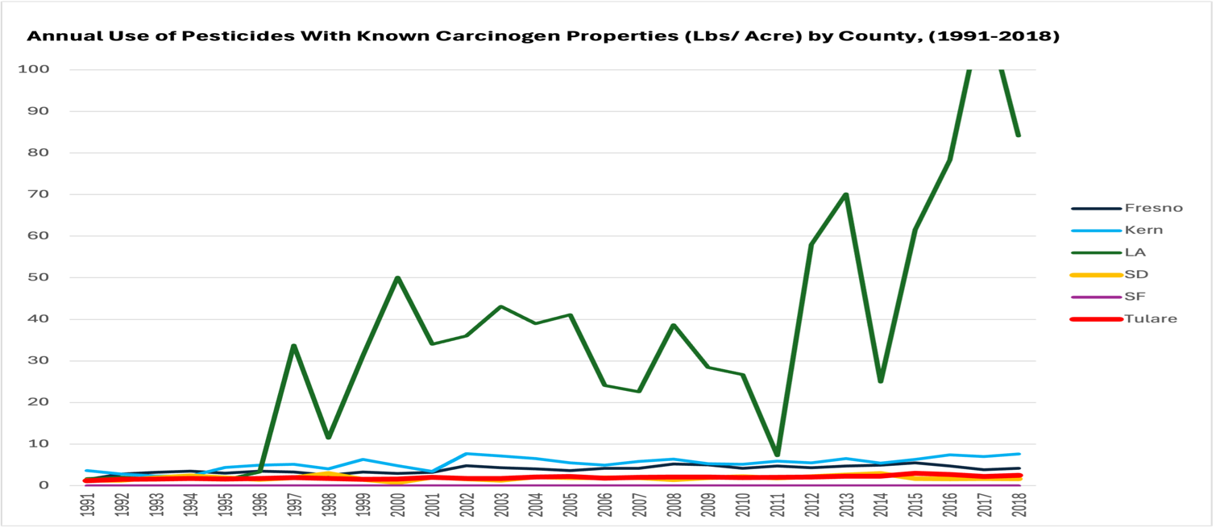
Figure 1: Carcinogen Use Per Acre by County (1991-2018)
Los Angeles county had the highest rate of carcinogen use per acre, although it is not a top agricultural producer.
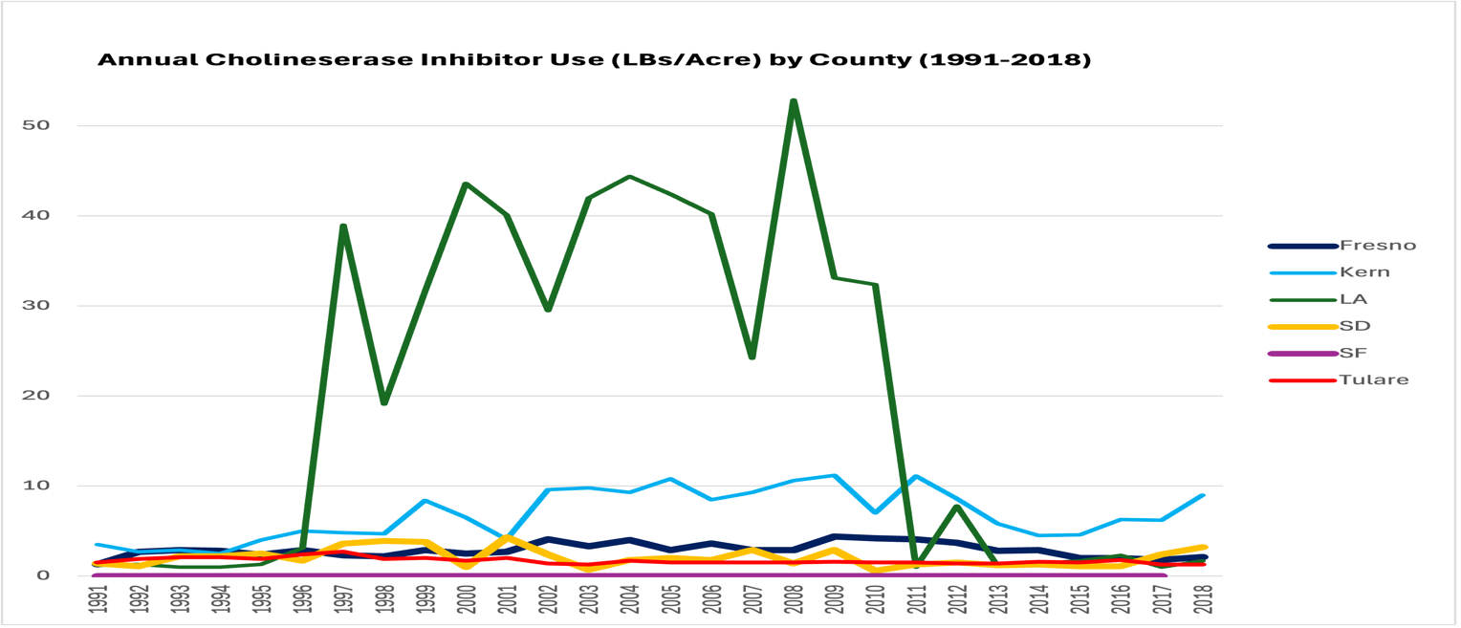
Figure 2: Cholinesterase Inhibitor Use Per Acre by County (1991-2018)
Los Angeles also had the highest rates of cholinesterase use per acre when compared to these other counties.
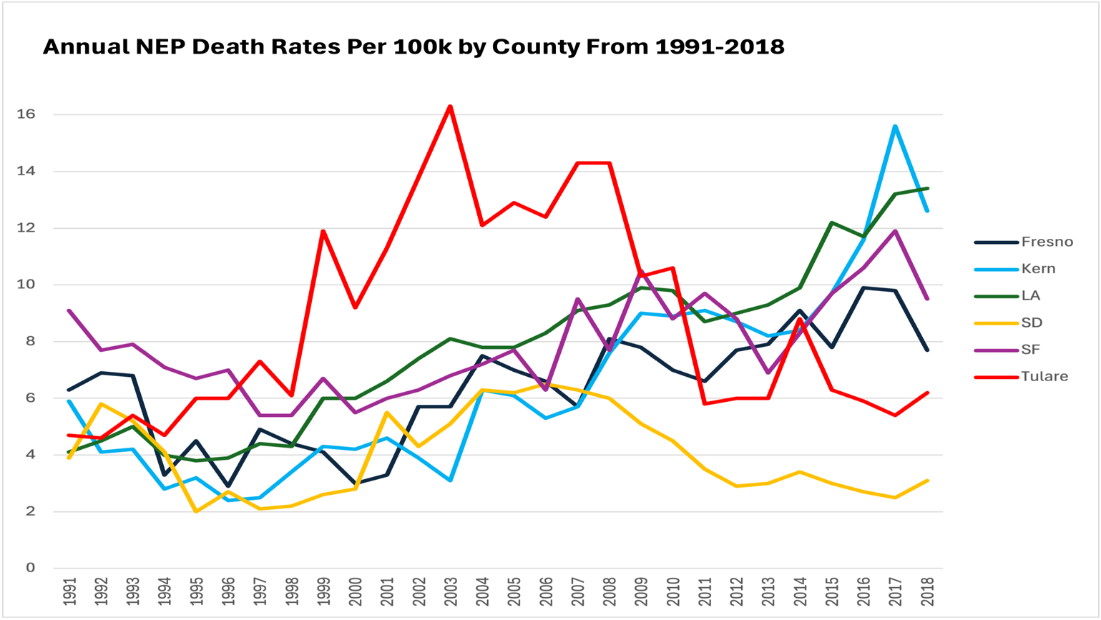
Figure 3: NEP Death Rates Per County (1991-2018)
Tulare and Kern Counties had the highest rates of NEP deaths, even though both counties averaged less pounds of carcinogens and cholinesterase inhibitors per acre than Los Angeles County.
Discussion
While I expected a stronger relationship between usage of these pesticides and adverse health effects based on the literature I read for this project, the data suggests that this was not the case as the connection was much weaker than I thought. While there is a moderate connection between carcinogens and NEP deaths, the other connections were very weak.
This does not mean that pesticides do not have an effect on adverse health outcomes, just that the relationship is a bit more complex than I initially expected. There are definitely other factors at play here that could influence health outcomes at the county level. Factors such as genetics, diets, alcohol consumption, smoking, drug use, access to healthcare, or even stress can all play a role in the development of diseases such as cancer, Parkinson’s or kidney issues.
Limitations
Limitations for this project include a lack of comprehensive data on the subjects who had these adverse health issues. For instance, more comprehensive data which included a subject’s proximity to application zones may help better determine the likelihood of exposure to pesticides which can provide a better understanding of the effects of direct or prolonged exposure to pesticides.
While this project did utilize pesticide application rates, it was hard to tell if those people who developed these issues actually lived near fields where pesticides were applied. While this data was good for painting a general picture, it lacked specificity which would have helped determine the actual effect of pesticides on people.
Future studies should seek to gather and obtain more comprehensive datasets which determine the subject’s proximity to application zones. They should also seek to expand the scope of their study to include more than six counties as that would help make their study more credible and accurate.
Conclusion
This project sought to investigate whether California’s most agriculturally productive counties, Kern, Tulare, and Fresno, were more prone to adverse health effects due to their higher pesticide usage. While the correlations between pesticide usage and most of the health outcomes were very weak, carcinogens did have a moderate positive connection to NEP death rates. These weak connections suggest that other factors may also play a role in the development of adverse health outcomes. Future studies should be expanded to analyze even more counties while using more comprehensive and specific data as this will provide a better understanding of the effect that pesticides have on human health.

Works Cited
“CAL*Explorer.” Explorer.ccrcal.org, explorer.ccrcal.org/application.html?site=1&data_type=1&graph_type=1&compareBy=sex&chk_sex_3=3&chk_sex_2=2&race=1&age_range=1&seer_area=1&advopt_precision=1&advopt_show_apc=on&advopt_display=2.
“Death Profiles by County - California Health and Human Services Open Data Portal.” Ca.gov, 2014, data.chhs.ca.gov/dataset/death-profiles-by-county.
“Estimates | Department of Finance.” Ca.gov, 2021, dof.ca.gov/Forecasting/Demographics/Estimates/.
“Farm Income and Wealth Statistics - Cash Receipts by Commodity State Ranking.” Usda.gov, 2025, data.ers.usda.gov/reports.aspx?ID=4058#Pb5e0b242c438427eafdb7d98c795c62a_4_251iT0R0x0. Accessed 4 Apr. 2025.
Lebov, Jill F., et al. “Pesticide Use and Risk of Endstage Renal Disease among Licensed Pesticide Applicators in the Agricultural Health Study.” Occupational and Environmental Medicine, vol. 73, no. 1, BMJ, 2016, pp. 3–12, https://doi.org/10.2307/43870170.
Newsom, Gavin. State of California. 2022, www.cdfa.ca.gov/Statistics/PDFs/2022-2023_california_agricultural_statistics_review.pdf.
Pathak, Vinay Mohan, et al. “Current Status of Pesticide Effects on Environment, Human Health and It’s Eco-Friendly Management as Bioremediation: A Comprehensive Review.” Frontiers in Microbiology, vol. 13, no. 962619, Aug. 2022, https://doi.org/10.3389/fmicb.2022.962619.
Paul, Kimberly C., et al. “Agricultural Paraquat Dichloride Use and Parkinson’s Disease in California’s Central Valley.” International Journal of Epidemiology, vol. 53, no. 1, Feb. 2024, p. dyae004, https://doi.org/10.1093/ije/dyae004.
Peillex, Cindy, and Martin Pelletier. “The Impact and Toxicity of Glyphosate and Glyphosate-Based Herbicides on Health and Immunity.” Journal of Immunotoxicology, vol. 17, no. 1, Jan. 2020, pp. 163–74, https://doi.org/10.1080/1547691x.2020.1804492.
“Pesticide Mapping Tool.” Trackingcalifornia.org, 2024, trackingcalifornia.org/data-and-tools/pesticide-mapping-tool#gsc.tab=0.
Pimentel, David, and Lois Levitan. “Pesticides: Amounts Applied and Amounts Reaching Pests.” BioScience, vol. 36, no. 2, [American Institute of Biological Sciences, Oxford University Press], 1986, pp. 86–91, https://doi.org/10.2307/1310108.
Poh, Christina, et al. “Environmental Pesticide Exposure and Non-Hodgkin Lymphoma Survival: A Population-Based Study.” BMC Medicine, vol. 20, no. 1, Apr. 2022, https://doi.org/10.1186/s12916-022-02348-7.
US EPA. “Types of Pesticide Ingredients | US EPA.” US EPA, 30 Oct. 2013, www.epa.gov/ingredients-used-pesticide-products/types-pesticide-ingredients.

