Overview
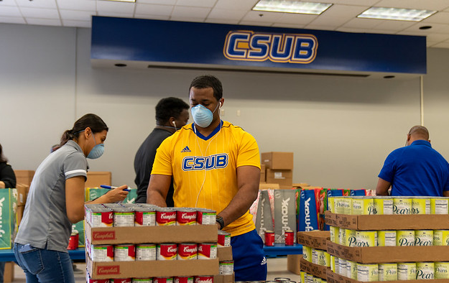
The CSUB Fund at California State University, Bakersfield is a collection of contributions from alumni, parents, faculty, and other supporters that provides the university with its greatest source of unrestricted funds. It represents the generosity of a community by serving as a catalyst for turning individual giving into a shared energy for the benefit of today's students and tomorrow's leaders. The consistency and flexibility of these funds allow university leadership to rapidly respond to emerging needs through academic innovations, hands-on research opportunities, and faculty growth and retention, and allows donors to have a direct impact on the growth of CSUB and the future success of every CSUB student.

The Need
The CSUB Fund is critical to filling the gap between state funding and the actual cost of higher education, which often exceeds state projections. Only 69% of the university’s funding comes from the state, so we must increasingly rely on generous contributions to the CSUB Fund to keep our campus thriving.

Your Support
Your gifts to the CSUB Fund directly contribute to the growth of the university and the future success of every CSUB student. Your support is also a tangible expression of your belief in the university and its capacity to make vital contributions to our community and world. When you give to the CSUB Fund, you signal your confidence in CSUB to prospective donors.

Your support may fund students and faculty in the following ways:
- Research assistantships
- Community-based field work
- Travel to conferences and intercollegiate academic competitions
- Awards for scholarly studies
- Research project support
- Professional development to enhance classroom learning

