E-Commerce Project Example

Bloom Only Floral

Please make sure to include followings on this cover page;
E-Commerce website Address
Group information (#, names)
If using Google Slide, slide online address

Contents
Executive Summary 2
Industry Analysis 3
Five Competitive Forces Model 3
Threat of New Entrants (Moderate) 4
Threats of Substitute Products or Services (Low) 4
Bargaining Power of Suppliers (High) 4
Bargaining Power of Buyers (Moderate) 5
Competitive Rivalry (Moderate) 5
Mission and Vision 6
Our Mission Statement 6
Our Vision Statement 7
Business Description 7
Products 7
Services 7
Our Location 8
Sources of Revenue 9
Product Distribution 10
Ensure Our Existence 11
Competitive Advantage 11
References 13

Executive Summary
“I must have flowers, always, and always.” Claude Monet (A quote by Claude Monet, October 13, 2017).
Many years ago, Claude Monet made this beautiful quote, and all throughout history in poems, historical texts, paintings, and even Greek mythology we see flowers being admired by people. Men would give women beautiful flowers to express their feelings of admiration and love. For years, flowers have been used to send unspoken messages. This secret language is intriguing and leads people to love and purchase floral products.
However, owing to the quickening pace of life, we find that most working people have no time to travel to far off flower shops to purchase fresh flowers to their important ones. Moreover, as flowers are perishable, there are times when people find that the bouquets which were bought last week are perished now and again they have to run to a nearby flower shop to repurchase them. Fortunately, our company, Bloom Only Floral, helps to solve these problems, and can make the gift-giving process easier through our online services.
Bloom Only Floral is a Bakersfield based online florist specializing in cut flower arrangements and retail flower products. And currently, we position our flower business to serve the residence of Bakersfield, California through our business to customer (B2C) e-commerce site. Our website address is: http://bloomonlyfloral.weebly.com/.
We use e-commerce to target customers and differentiate from the other traditional florists by offering floral product programs with better and timely services. At Bloom Only Floral, customers can select the specific delivery dates, have an option for cash on delivery (COD), and can also specify the color, scents, and arrangements of their products.
Fresh flower gifts and arrangements are beautifully packed for home delivery, pre-booking via our website as well as phone and e-mail. To different from other online florists and keep our cost competitive, we provide all our deliveries on hybrid cars and new energy vehicles (NEVs). On top of that, we collect paper and plastic materials that are used for product decoration and send them for recycling. These strategies also directly and indirectly save the carbon emission in environment, and provide us an image as an environmental-friendly company.
Our payments can be done by both cards and COD. Moreover, Bloom Only Floral website has a user friendly Graphical User Interface (GUI) so that even elder people who are not familiar with ordering online can do it with ease. An android and iOS app will also be launched for mobile users soon.

Industry Analysis
It is important to analyze the competitive nature of the florists industry in order to assess the position of Bloom Only Floral. The Porter’s Five Forces Model tool will enable us to make strategic decisions.

Five Competitive Forces Model
Michael Porter has identified five forces that are widely used to assess the structure of any industry. Figure 1.0 links the different components of Porter’s model. In this section, we will evaluate the five competitive forces of Bloom Only Floral in the florists industry within the area of Bakersfield.

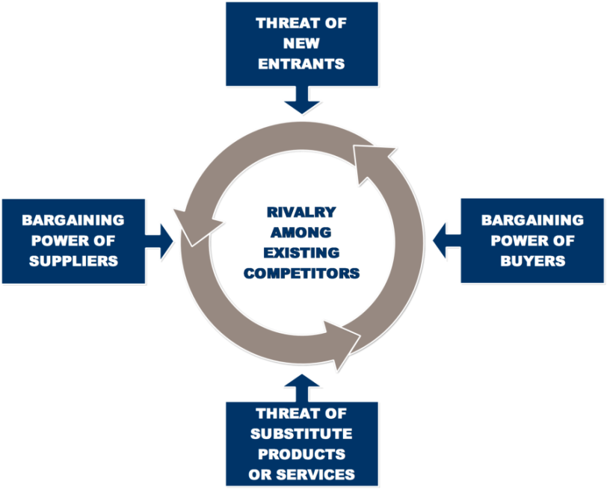
Figure 1. Michael Porter’s Five Competitive Forces Model

Threat of New Entrants (Moderate)
The online florist entrants require a small capital, moderate experience, moderate understanding of the online technology system, and no specific licensing requirements. However, as e-commerce is a growing industry and has a very high potential in the floral products sector, many florist moguls, such as 1-800-Flowers.com, FTD, ProFlowers and so on, have already entered into this online shopping sector.
On top of that, for experienced traditional florists, they have their physical stores, logistics, and storages already coordinated for their floral delivery operations. So, if those traditional florists want to enter the online business sector, all they will need is to just design a website and display all the products for sale which can be transported to the customers’ doorsteps. Therefore, we believe the threat of new entrants is moderate.

Threats of Substitute Products or Services (Low)
Alternative ways to buy floral products and arrangements are through supermarkets who are into retailing of flowers and physical flower shops. However, as an online floral delivery company, we mainly target busy white-collar workers, office goers, businessmen, online-shopping lovers, physically inconvenienced people, and people who barely have time from their work to go out and buy floral products. In this case, traditional flower shops and markets do not post much threat to our target markets.

Bargaining Power of Suppliers (High)
Every business should have a fruitful relationship with its suppliers in order to survive and beat the competition. In this case, we understand that we must have stable floral suppliers supporting us in order to have our products on time and have the demand-and-supply cycle working for our consumers.
In the florists industry, flower wholesales and gardeners are the main suppliers. They will sell their flowers and other floral materials to middlemen, merchants, floral retailers, and online floral shops. The main factors that affect suppliers’ sell decisions are the price offered to them, advance payments for future orders, and good relationship. On top of that, most of the suppliers in the florists industry are not bound by any agreement to sell their products to one specific floral merchant or retailer.
As a newly established florist, it is hard for us to find steady suppliers providing goods that can satisfy our customers’ demands. All our suppliers have the power whether to provide the goods to us or not, and they can switch to our rivals if a better price is given to them. Thus, bargaining power of suppliers is high in our situation, and a well-planned vendor management scheme is needed to be designed to solve this problem.

Bargaining Power of Buyers (Moderate)
In this modern era, especially in the California area, customers have easy access to everything with internet, so the information of floral products and prices is opened widely. Moreover, discounted prices for comparable products online and in supermarkets, such as Albertson and Walmart, have led consumers to buy fewer flowers from online and traditional flower shops.
However, as Bloom Only Floral’s products will be sold customized and on time, we believe our customers will be more than happy to pay the price specified already on our website with our handy payment option – cash on delivery. Moreover, we always bear in mind that our customers are the reason why we are in the floral business, and we are more than happy to go the extra mile to get them satisfied when they visit our website. In this case, we are confident that people who purchase from Bloom Only Floral will become our loyal customers and ambassadors.

Competitive Rivalry (Moderate)
Bloom Only Floral is a new online florist, so we don’t have the financial capacity to compete with multi-billion dollars supermarkets who are into retailing of flowers and other and florist giants who are into mass production of flowers and related products.
To add insult to injury, e-commerce is already operating and gradually becomes the mainstream in the florists industry. Many floral business giants have been operating their online services for a long time, such as 1-800-Flowers.com, FTD, and ProFlowers. However, most of these business giants within the florists industry operate their business on a nationwide scale, and very few operate in a particular state or city. Also, they sell their products at quite high prices, and the delivery fees are relatively high as well.
On top of that, most of Bakersfield-based florists do not have online services (Figure 2.0), like Stockdale Florist and The Green Thumb. And some Bakersfield florists with online services, such as Mexicaly Flower Shop, design their websites in an unprepossessing way, and barely update or maintain their website. Thus, in our current situation, we believe the competition is moderate at the local level.

Figure 2. Online Services in Bakersfield Florists Industry

Mission and Vision

Our Mission Statement
Bloom Only Floral is dedicated to operating with a constant enthusiasm for learning, being open to implementing new ideas, and maintaining a willingness to adapt to evolving market conditions. By providing a beautiful product and amazing customer service, we hope to bring joy and abundance to all who cross our path.

Our Vision Statement
Our vision is to become the leading online floral delivery brand in the florists industry in Bakersfield and to establish our own logistics centers in Bakersfield, Los Angeles, and in other cities in the state of California.

Business Description

Products
Each Bloom Only Floral product will be a natural, original work of art. We are committed to making each arrangement unique and custom-designed based on each customer's needs. Bloom Only Floral's floral arrangements will feature a wide range of seasonal flowers. All sample arrangements in the store will be available for purchase.
Our products include:
- Loose cut flowers
- Customized flower boxes
- sample cut flower arrangements
- Customized floral arrangements
- Sample floral gift items
- Customized floral gifts

Services
Our services include:
- Cash on delivery (COD) payment service
- Bloom Only Floral membership
- All floral purchases for members will be 10% off.
- Members will receive a free delivery coupon for every ten floral purchases. they made.
- Frequent Flower Gift Program
  - To foster overall romance, Bloom Only Floral offers this Frequent Flower Gift Program for men. This program will let each customer register a minimum of six days per year (birthdays, holidays, anniversaries or any day except Valentine's Day) on which we will automatically plan to deliver a floral arrangement to his place of work (which must be in Downtown Bakersfield).
  - A courtesy call will be given or an e-mail sent to each customer 48-hours in advance. To make it as easy as possible for its customers to transport flower arrangements from work to home.
  - The customer must agree to the cost of each arrangement (minimum $60), in advance and the payment must be guaranteed by cards in advance. The payment will not be charged until the day of each delivery.

Our Location
Bloom Only Floral is a newly established and Bakersfield based online florist. Currently, we position our flower business to serve the residence of Bakersfield, California.
Founders of Bloom Only Floral, Haylee Johe Roberts and Yuqing Lei, both live in Bakersfield, California. This city’s population is approximately 365,000 and it is the ninth-most populous city in California. Figure 3.0 indicates that the 2016 median income of a Bakersfield household is $56,842 (Bakersfield, California Economy, October 13, 2017). According to American Floral Endowment (AFE) and the Ipsos-National Panel Diary Group (Ipsos-NPD), households with income higher than $50,000 tend to purchase more floral products (Figure 4.0). Moreover, Bakersfield currently has less than 20 florists, which indicates that there is a low level of competition and market saturation in this area. In this case, Bakersfield has a great market for floral products, and we see a great opportunity of starting a floral business in this area.
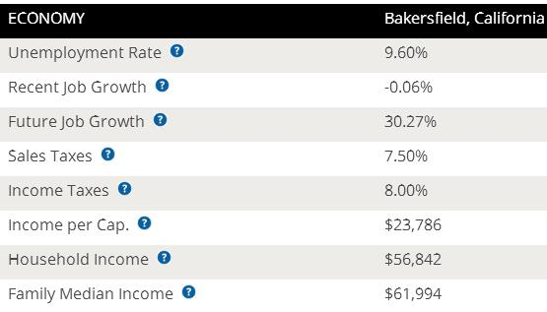
Figure 3. 2016 Bakersfield, California Economy Overview (Source: Sperling’s Best Places)

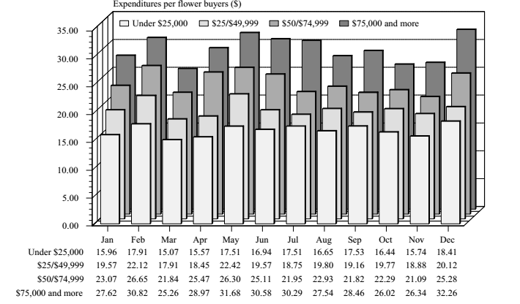
Figure 4. Seasonal Expenditures Among Flower Buyers Across Four Income Groups. Source: AFE and IpsosNPD group.

Sources of Revenue
Bloom Only Floral is in business to sell a wide range of floral products and arrangements to the residence of Bakersfield, California over the internet. We are in the florists industry to maximize profits and we are going to go all the way out to ensure that we achieve our business goals and objectives.
Our source of revenue will be the network selling of a wide range of floral products and arrangements at affordable prices. We will generate income by:
- Loose cut flowers
- Customized flower boxes
- sample cut flower arrangements
- Customized floral arrangements
- Sample floral gift items
- Customized floral gifts
- Floral delivery fees
- Bloom Only Floral membership fee
- Frequent Flower Gift Program fee

Product Distribution
We believe Bloom Only Floral will become the preferred choice of working professionals of Bakersfield, California, because all our floral products and arrangements can be easily ordered online with handy payment options and timely delivery.
We use e-services to target customers and differentiate from the other traditional florists by offering floral product programs with better and timely services, such as customers can select the specific delivery dates, have an option for cash on delivery (COD), and can also specify the color, scents, and arrangements of their products.
Fresh flower gifts and arrangements are beautifully packed for home delivery, pre-booking via our website as well as phone and e-mails. To different from other online florists and keep our cost competitive, we provide all our deliveries on hybrid cars and new energy vehicles (NEVs). We will hire 15 to 20 part-time deliverers who own eco-friendly cars and have flexible time to do delivery. Also, we have enough parking space that can accommodate well over 20 cars per time.

Ensure Our Existence
In this era when the online community is growing rapidly, our main strategy is to increase Bloom Only Floral’s online presence so that more people will know our website exists.
- First of all, to get people to see us as an expert in the florists industry, we will blog constantly about flowers, and create online courses regarding to flower caring.
- Secondly, we will Leverage on the internet and social media platforms like; YouTube, Instagram, Facebook,Twitter, LinkedIn, Snapchat, Badoo, Google+ and other platforms to promote our business.
- We will encourage the use of word of mouth publicity from our loyal customers, partners, family, and friends.
- Besides online presence, we will also join local and nationwide florist associations, such as Floranext, so that we can get to know other floral business players and expand our brand influence as well.
- We will distribute our fliers and handbills in target areas in and around the Bakersfield neighborhood.
- We will brand all our commercial NEVs and ensure that all our staff members wear our branded shirts at regular intervals.
- To grow our business and increase our brand awareness, we will work and keep good business relationships with wedding and event planners in the Bakersfield area.
- Lastly, we will contact corporate organizations, households, religious centers, funeral homes, and event planners by calling them up and informing them of Bloom Only Floral online store and our products.

Competitive Advantage
Bloom Only Floral will differ from other florists in Bakersfield by creating great customer intimacy based on our friendly GUI, thoughtful payment options, timely delivery, and customized services that will save customers time and reduce anxiety often associated with the purchase process.
By using website as a tool, we make the floral buying experience easy for our customers and, at the same time, enable us to easily identify and track our customer base. In other words, unlike the traditional florists, we will have an organized customer database that identifies contact information as well as personal preferences for each customer (colors, vases, frequency, allergies, pets, children/spouse, birthday, anniversary, etc.).
Moreover, we have adopted proactive customer service policies. For instance, we will contact each Frequent Flower Gift Program member by phone or e-mail within 48 hours of a scheduled delivery, and will call or e-mail clients after each delivery to ensure satisfaction. And our excellent customer service culture, online feature, the brand image of an eco-friendly firm, various payment options, and quality delivery will serve as competitive advantages for us as well.

References
A quote by Claude Monet. (n.d.). Retrieved October 13, 2017, from https://www.goodreads.com/quotes/1971-i-must-have-flowers-always-and-always
American Floral Endowment. American Floral Endowment Consumer Tracking Study, 1999-2000.
Bakersfield, California Economy. (n.d.). Retrieved October 13, 2017, from https://www.bestplaces.net/economy/city/california/bakersfield
Ipsos-NPD Group. National Panel Diary Group, Inc., Chicago, Illinois, 2002

