Data Model Practice
Each identifier is defined using “ * “.
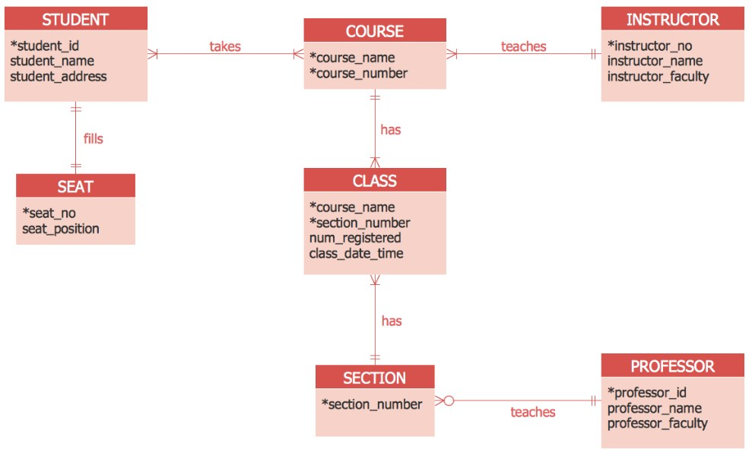

Question 1: Re-draw above model using lucidchart.com. If there are any M:N cardinalities, it must be broken down and cardinalities must be re-organized.
Question 2: Develop a complete list of business rules.

