Step 1: Develop Use-Case Glossary
Use-Case Glossary
Use-Case Name | Use-Case Description | Participating  Actors and Roles
Search Employee Directory | This use case describes the event of searching the employee directory. | Employee
Login | This is an abstract use case, which describes the login process.
Update Employee Profile | This use case describes the even of updating the employee profile information. | Employee
Enter New Employee Profile | This use case describes the event of entering a new employee with name, job title, supervisor, emergency contacts, payroll deductions, and United Way contributions. | Staffing Dept
View United Way Participation | This use case describes the event of viewing United Way participation for all employees a manager directly supervises. | Manager
Update Employee Secure Data | This use case describes the event of updating pay rates, job title, and supervisor for employees. | Staffing Dept
Query via SQL | This use case describes the event of building an ad-hoc query with SQL | Manager
Perform Employee Detail Lookup | This use case describes the event of viewing a list of employees in any one department so that one can be selected for View Employee Profile. | Manager  HR
Perform Employee Group Lookup | This use case describes the event of viewing a list of employees based on various selection conditions (job code, building, department, salary/wage range, home city, phone exchange, employment status, etc.) with the option of selecting one for View Employee Profile. | Manager  HR
View Employee Profile | This is an abstract use case, which describes the event of viewing a complete profile for a single employee.

Step 2: Develop Use-Case Diagram
This model should be constructed based on the use cases identified in step 1. The selection of subsystems will vary depending on the assumptions.

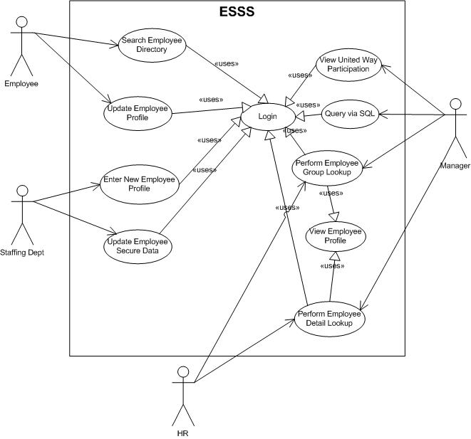

Step 3: Fully-documented Use-Case Narrative

