Evaluation Highlights:

The Robert Noyce Scholarship Program at CSUB*

Jianjun Wang

School of Social Sciences and Education

April 1, 2011

* This program started receiving funding from the National Science Foundation on July 15, 2009 under an NSF Grant (No. DUE-0934944).

Evaluation Highlights:

The Robert Noyce Scholarship Program at CSUB

The Robert Noyce Scholarship program is funded by the National Science Foundation (NSF DUE-0934944) to award a grant proposal entitled "CSUB Robert Noyce Teacher Scholarship Program - Phase I". Professor Andreas Gebauer serves as the Principal Investigator (P.I.) to oversee the management of student scholarships at California State University, Bakersfield (CSUB). The Noyce scholarship recipients are recognized as Noyce scholars with commitment to teaching science or mathematics in high need school districts after receiving the single subject credential. This report is focused on evaluation of the Noyce scholarship program at CSUB since Fall, 2009.
A main goal of the Noyce program is to increase the number of teachers with strong science, technology, engineering, or mathematics (STEM) content knowledge in high need school districts. Pursuant to the provisions of NSF 09-513, this evaluation project is designed to provide objective and timely feedback to support the Noyce program improvement. Both quantitative and qualitative approaches have been taken to triangulate outcome measures from document analyses, Noyce scholar interviews, GPA comparisons, and context examinations. To ensure objectivity of this investigation, the external evaluator, JJ Wang, works at a different academic division that has no administrative link to the grant team.
While the program starting date was set on July 15, 2009, the university Fall Quarter did not begin until September 2009, which left only three months of the program operation in the first year. In its original Noyce proposal, the grant team indicated its intention to “support data-driven decisions in order to strengthen the program and its outcomes over time” (p. 19). To reach this goal in a meaningful way, the last quarter of 2009 was devoted to development of data collection strategies, including seeking permission to access university data about the Noyce scholars, in support of the evaluation effort. Accordingly, due date of this first annual report was postponed to April 1, 2011 to cover the period since the program inception.
The schedule adjustment not only facilitated the data collection from various stakeholders, but also provided more time to coordinate the evaluation needs and program development. In particular, the evaluation effort has been closely aligned with the following “Intellectual Merit” delineated in the original proposal:
This program will contribute to the knowledge of how to best recruit, prepare and retain teachers in the science, technology, engineering, and mathematics (STEM) fields. It will a) identify and investigate strategies that are effective in the recruitment of Noyce scholars; b) describe and assess the Scholars’ progress and success as they fulfill their teaching service obligations; c) analyze the Noyce program’s effectiveness in improving teacher quality and student achievement; and d) support data-driven decisions in order to strengthen the program and its outcomes over time.
In 2010, only one Noyce scholar has graduated and entered the teaching force. Most scholars were working on their degree completion at CSUB. To match the pace of progress, the first evaluation report is primarily designated to an analysis of the program effectiveness within the university setting.

The Theoretical Framework
Recent studies suggested that college students of highest ability were less likely to go into the STEM teaching fields (Ballou, 1996; Gitomer, Latham, & Ziomek, 1999; Henke, Chen, Geis, & Knepper, 2000; Podgursky, Monroe, & Watson, 2004). Thus, “The Robert Noyce Teacher Scholarship Program seeks to encourage talented science, technology, engineering, and mathematics majors and professionals to become K-12 mathematics and science teachers” (http://www.nsf.gov/funding/pgm_summ.jsp?pims_id=5733&org=DUE&from=home, ¶. 1). As a result, good programs like the one at the University of Minnesota were able to claim that “STEM majors going into education are similar in ability to other STEM majors” (Lawrenz, Bowe, Braam, Kirchhoff, & Liou, 2010, p. 3). In contrast, Noyce scholars at CSUB had an average GPA that was around 0.4 point higher than the GPA from their counterparts on the STEM track at the point of graduation. The GPA comparison clearly justified high quality of the Noyce scholars at CSUB.
Given the fact that no program can be equally effective under all circumstances, Sloane (2008) suggested that “We change the basic research question from what works to what works for whom and in what contexts” (p. 43). Thus, the context, input, process, and product (CIPP) perspectives are articulated in this report to cover the core components of program evaluation. In history, CIPP was initially conceptualized in the mid 1960s for evaluating federal grants (Stufflebeam, 1983). The model matured through the development of national evaluation standards over the past four decades (Program Evaluation Standards, 2010; Yarbrough, Shulha, Hopson, & Caruthers, 2010). Eventually, the standards have been approved by the American National Standards Institute (ANSI) and sponsored by 17 North American professional organizations. Built on the extensive literature base, the CIPP model has been adopted by practitioners to evaluate various Noyce grants across the nation (Lawrenz, 2009).
As the improvement cycles being formulated to support context update by the previous product, the CIPP paradigm accommodates a sustainable mechanism for ongoing progress. This feature is especially important for a multiyear project to enhance the systematic data collection beyond baseline outcomes. Tom Angelo (1999), former director of the national assessment forum, maintained, “Though accountability matters, learning still matters most” (¶. 1). To integrate both formative learning and summative accountability in the evaluation design, qualitative and quantitative information from the student and program levels are articulated under the CIPP paradigm to streamline the result presentation in this report.

Context Assessment: Capacity to Support the Noyce Program Functioning
Based on the CSUB program structure, subject competency in the STEM field can be established on three tracks:
- Students who successfully complete the teacher preparation program will earn Single Subject Matter Competency in mathematics;
- Students with a natural science degree can establish their subject competency by passing the California Single Subject Examination for Teachers (CSET) exam;
- Those students who enroll in the new blended program in mathematics will be fully credentialed teachers after completing the degree.
CSUB is the only campus within the CSU system that offers a blended program on the third track to complete a combination of single subject matter competency and teaching credential within 4 years (or 196 units) of study. Students on the first two tracks will become high school teachers after finishing a teacher credentialing program.
To enhance the student orientation, an advisory board was assembled to involve key stakeholders, including faculty advisors, Deans of the School of Natural Sciences and Mathematics and the School of Social Science and Education at CSUB, as well as their counterparts at the Bakersfield College and Antelope Valley College. In addition, the advisory board has extended its membership invitation to selected school principals, experienced mathematics and science teachers, and other experts from other CSU campuses who have implemented a Noyce program. As a result, half of the Noyce scholars were able to transfer course credits from junior colleges toward their program completion at CSUB (see the plot below).
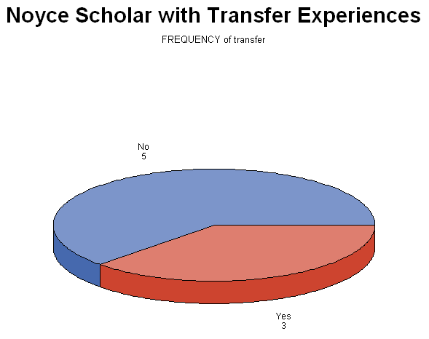
The extensive collaboration is built on a premise that the Noyce program will address the critical shortage of well-prepared secondary mathematics and science teachers. It has been shown that most teachers chose to teach at schools near the locations they were raised or went to college (Berry, 2004; Gebauer, 2009). Based on the free and reduced lunch indicators in each school, 70% of school districts in California have at least one school in that category. At the seat of Kern County, Bakersfield was ranked as one of the least educated metropolitan areas in the nation (Zumbrun, 2008). Consequently, all Noyce scholars experienced or observed high-need schools in their neighborhoods. The local context has naturally strengthened the program capacity to place Noyce scholars at high need schools.
During this evaluation period, half of the Noyce scholars will be the first generation college graduates from their families. Besides the family honor, they will set a role model for the next generation, and help enhance competitiveness of the local workforce in those traditionally underserved areas. When answering a question regarding their motivation to join the Noyce program, almost all of them indicated that the program would be good for their schools and communities – better teachers will offer more advanced courses, which translates to more students ready to start careers in the STEM fields.
Students also indicated when and under what circumstance they applied for the Noyce scholarship (see the interview questionnaire in Appendix 1). They were all beyond the stage of general education. The cohort of courses on the STEM track not only allowed them to share similar learning experiences with other scholars, but also tightened the cohort linkage to the job expectations at high need school. At the school level, the interview results indicated that the Noyce program has been articulated with other external grants, such as the CSUB MARC U*STAR program funded by NIH (http://www.csub.edu/marc/MARC.shtml) and CSUB Math and Science Teacher Initiative (http://www.csub.edu/mti/), as an integrated system. Because the whole of the system is larger than the sum of its part, impact of the Noyce grant becomes more sustainable with the mutual referrals among the STEM grant recipients.
In summary, supporting system has been established through internal program articulation and external institutional outreaching under the leadership of the Noyce advisory board. The collaborative effort not only supported student transition from community colleges, but also established a sustainable network across different programs. The contextual support has strengthened the local capacity building against the current budget crises that impacted resources at high need schools.

Input Description: Expanding the Pipeline of Qualified Noyce Scholars
In Kern County, many teachers were teaching outside of their subject areas (Gebauer, 2009). Two Noyce scholars reported their experiences of having PE teachers taught mathematics classes. Lack of school funding has made it more difficult to recruit better teachers. In recent years, negative budget information was disseminated through various channels, including parental conferences, local news media, and summer internship programs. STEM labs were reportedly cut at high need schools. Because schools were under local control, donations have been asked in high need communities. Thus, the Noyce Scholar Program faced a severe challenge in attracting students to enter the STEM teaching track, particularly in the region served by CSUB. In this section, demographic variables are examined in the input phase of the Noyce program to reflect recruitment needs in this diversified region.
The census data showed that less than half of the residents (i.e., 49.5%) were White in Kern County (http://en.wikipedia.org/wiki/Kern_County,_California#Demographics). High need schools are typically located in minority communities, but recruitment rates of teachers of color have not matched the rapidly rising enrollment rates of students of color (Kirby, Berends, & Naftel, 1999). Hanushek, Kain, and Rivkin (2004) indicated that white teachers, in particular, were more likely to move to schools with non-minority, higher income students, while African-American teachers moved to schools with more African-American students. Accordingly, the Noyce program has implemented a special policy, i.e., “Each year, two new awards will be reserved for minority or underrepresented gender applicants or persons with disabilities, unless there are no eligible applicants.”
After receiving the Noyce award, the CSUB team reviewed a total of 14 applicants between September 2009 and January 2010. Eight scholars have been admitted to the program, one already graduated in 2010, and another scholar discontinued his participation. Despite the small Noyce scholar pool at initial entry, the demographic information showed a balanced coverage of White, Black, Hispanic, and undeclared race combinations. The declared White scholars accounted for less than 50% of the group (see the plot below). At the program input phase, the ethnic diversity has enhanced the local population representation, and will eventually support Noyce scholar placement at high need schools in the future.

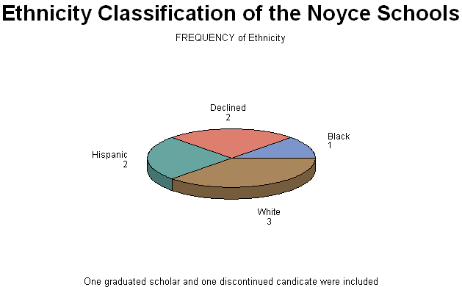

Whereas minority participation is clearly needed to expand the teaching force, the picture of gender distribution seems less clear in the research literature. Henke, Chen, Geis, and Knepper (2000) reported more female teachers in compulsory education, but Zumwalt and Craig (2005) observed a greater gender balance in secondary teaching. In the STEM area, however, more effort is needed to recruit female teachers (Frean, 2007). Due to the effort of enhancing recruitment in the underrepresented gender group, five females and three males were admitted to the Noyce scholar pool in 2010 (see the following plot). The more female representation will help enhance the impact of positive role modeling in STEM teaching.
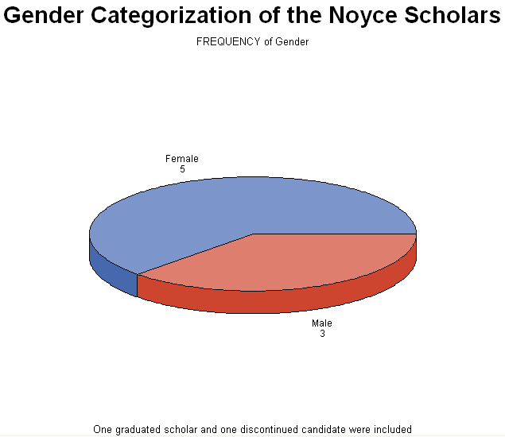

To balance the Noyce scholar representation, the CSUB faculty has taken various recruiting approaches, including
- Disseminating the Robert Noyce Scholarship Program information at a CSUB website (see http://www.csub.edu/Noyce/);
- Visiting STEM classes at CSUB, Bakersfield College, and Antelope Valley College by the Noyce advisory board members;
- Posting flyers and brochures at the afore-mentioned sites and inside the university/college buildings;
- Mailing the program documents to other southern California community colleges;
- Presenting the program information at meetings of student societies and clubs;
- Promoting the Noyce program at regularly occurring events, such as career fairs, financial aid workshops, and science competitions.
In addition, summer internships are offered to freshmen and sophomore students to support their participation in STEM research projects, which could naturally link them to the Noyce program. The interviews conducted by this evaluator have shown strong positive feedback from the Noyce scholars, including the one who discontinued this program. Even after his departure, he reaffirmed his original teaching commitment at high need schools. At the point of this report writing, one more Noyce scholar has been recruited to start in the next year. The ongoing admission was supported by a flexible recruitment policy, i.e., “There is no set deadline for applications. We continue to accept applications” (http://www.csub.edu/Noyce/).
The existing effort should be maintained to expand the Noyce scholar pool from 7 (the realized number) to 12 (the expected number) in the next year. Meanwhile, it should be reiterated that Kern County was ranked among the lowest regions in adult education across the United States (Brookings Institution, 2010). In coping with the recruitment difficulty in the input phase, the evaluator suggests additional strategies to further strengthen the momentum of student outreaching:
- Probationary Acceptance
The existing policy ensures academic excellence, i.e., a cumulative GPA of 3.0 or better for selection and continuation in the Noyce program. Scholarship awardees falling below this threshold will have one quarter to improve their GPA to 3.0 or above.
Perhaps the chance of improvement can be extended to students at the input phase. For those candidates with GPA slightly below 3.0, careful screening can be conducted to grant probationary acceptance under a condition of improving the GPA above this threshold with in one quarter.
- Pipeline Expansion
Collaborate the recruitment effort with other programs that support STEM teacher preparation. The Noyce program is relatively new to the CSUB community. The collaboration with long-established programs can enhance its visibility, and help advertise this new option to serve the pipeline of students in those traditional channels of recruitment.
- Noyce Scholar Profiling
A picture is worth a thousand words. Profiling the current Noyce scholars can be incorporated with the information technology that leads students to find those role models surrounding them. Besides releasing the individual information at websites, Noyce conference pictures can be posted as well. The web links may be distributed to a comprehensive STEM student e-mail list.
- Interdisciplinary Recruiting
Although the STEM track seemed more rigorous than other subjects, one of the Noyce scholars did start at CSUB as a history major before beginning his mathematics program. Thus, the recruitment from other department could be case-specific. But like in the probationary acceptance, mindful screening is needed to ensure a smooth transition in those unusual cases.

Process Analysis: Enhancing Depth of Teacher Preparation for High Need Schools
The Noyce scholarship is designed to prepare STEM teachers for high need schools. For the period covered by this report, Noyce scholars are primarily dealing with completion of their academic programs. Thus, the process analysis is focused on the depth of learning at the university setting. Transcript examinations and interview findings have presented here to support the process analysis.
The depth of student learning is analyzed using the SOLO (Structure of the Observed Learning Outcome) Taxonomy (Biggs & Collis, 1979, 1982, 1991). Similar to the impact of Bloom’s Taxonomy on improvement of the mastery learning strategies (Guskey & Pigott, 1988), the structural complexity specified by the SOLO Taxonomy provides a systematic measure of student learning through the following five stages (Biggs, 1987):
1. Pre-structural: here students are simply acquiring bits of unconnected information, which have no organization and make no sense.
2. Unistructural: simple and obvious connections are made, but their significance is not grasped.
3. Multistructural: a number of connections may be made, but the meta-connections between them are missed, as is their significance for the whole.
4. Relational level: the student is now able to appreciate the significance of the parts in relation to the whole.
5. Extended abstract level: At this level, the student is making connections not only within the given subject area, but also beyond it, able to generalize and transfer the principles and ideas underlying the specific instance.
Atherton (2011) noted that the taxonomy has been “claimed to be applicable to any subject area” (¶. 1). Feasibility of using the SOLO Taxonomy in teacher preparation has been demonstrated in a large-scale study sponsored by the National Board of Professional Teaching Standards (Smith, Gorden, Colby, & Wang, 2005).
Because students entered the Noyce program after the sophomore level, most of them have already planned career paths toward STEM teaching. The Noyce scholarship promoted the importance of STEM coursework as an indispensible component of teacher preparation. Thus, “the student is now able to appreciate the significance of the parts [STEM training] in relation to the whole [teacher preparation]” (www.learningandteaching.info/learning/solo.htm, p. 1), which placed them at the Relational level of the SOLO taxonomy.
To help Noyce scholars reach the highest Extended Abstract level, the learning experiences should support intellectual connections that facilitate the knowledge transfer beyond the specific STEM discipline. With the Noyce scholarship, students started taking teaching-related, non-STEM classes beyond the mathematics or science subject:
EDSE 403: Designing Specific Pedagogy
EDSE 410: Teaching English Language Learners
EDSE 416: Socio-Cultural Found of Education
EDSE 431: Classroom Management for Single Subject Teacher
EDSE 433: Reading across the Curriculum
EDBI 476: Introduction to Language Acquisition and Development
EDSE 532: Strategies & Methods for Teaching
EDSP 301: Teaching Exceptionally Diversified Learners
SOC 312: Social Psychology
SOC 327: Race and Ethnic Relations
SPAN 427: Hispanic-American Culture and Civilization
The plot below shows the number of non-STEM courses taken by Noyce scholars to support their teaching careers at high need schools. The person who took zero class at this level has chosen to discontinue the Noyce program in 2010. Thus, it is concluded that all Noyce scholars are moving into the highest level of the SOLO taxonomy with a front runner completed 12 credential courses to meet her graduation requirement.

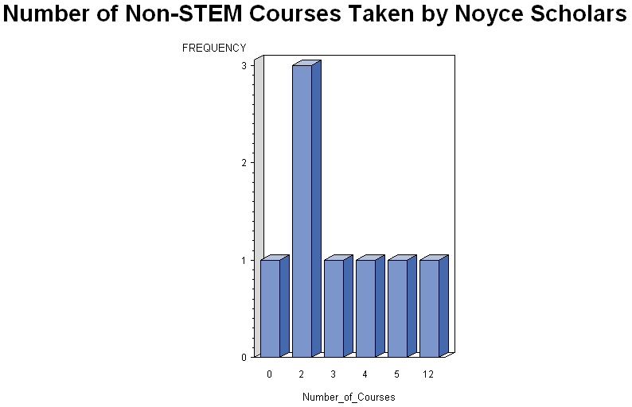
In summary, the process analysis indicated that the Noyce program has enhanced the depth of teacher preparation on the STEM teaching track, and the coursework has been carefully designed to meet the needs of high need schools. Noyce scholars concurred importance of course sequence that supported their effective learning processes across the stages of SOLO taxonomy. Because of frequent course cancellations resulted from unexpected budget cuts, the role of advisor seems crucial in the course setting that guides the student progress toward program completion.

Product Examination: Sustaining Cost-Effective Outcomes
Product is the last component of the CIPP paradigm. According to Stufflebeam (1983), “The CIPP approach is based on the view that the most important purpose of evaluation is not to prove but to improve”. Thus, the Product section of this report should not only address accountability of the Noyce scholar program in the first year, but also support ongoing program improvement in the next 4 years. To accomplish the dual mission of formative and summative evaluation, the product examination is centered on the following four questions:
- Did the participants benefit from this program, in what way?
- Which component of this program has shown more effectiveness?
- Did the project outcome worth the program cost?
- Is the program transportable or replicable?
While the first question justifies the return of the NSF funding in STEM teacher preparation, Questions 2 and 3 delineate directions of future improvement at both individual and program levels. Built on the intellectual merits justified by the first three questions, Question 4 is devoted to examination of the project sustainability on the broad impact aspect.
Major Benefits to the Noyce Scholars
During the interview, major benefits reported by the Noyce scholars can be classified into
three categories:
(1) The scholarship has allowed them to concentrate on learning the rigorous STEM subjects. Otherwise, they would have worked on multiple jobs while attending school;
(2) Through arrangement of the Noyce program, they have been linked to STEM subject advisors. Besides designing the course sequence, the benefit will be extended to ongoing support of STEM teaching for the scholar who has completed the blended program;
(3) Noyce scholars started developing professional network across different disciplines. The opportunity was derived from regional and national Noyce conferences. Arrangement has been made to share the conference resources at local scholar gatherings.
Exceptional Program Services
Since the Noyce program inception in 2009, every tenure-track faculty member in the School of Natural Sciences and Mathematics taught courses in the teaching-track portion of the major. The STEM faculty include recipients of 5 CSUB Outstanding Professor Awards, 3 CSUB Faculty Research Awards, 3 CSUB Faculty Leadership and Service Award, 1 Senior Fulbright Scholar Award, 1 El-Paso Award for Excellence in Teaching, 1 First INPUT Award, 2 CSU Forgivable Loan Sponsorships, 1 Bakersfield Math Council Outstanding Teacher Award, and 1 STAAR Faculty Award. Hence, among various services provided by the Noyce program, quality of the STEM teaching and learning is the most effective experience from the Noyce program at CSUB. The quality assurance not only enhances subject competency among the Noyce scholars, but also models professional STEM teaching practice for those future teachers.
As Frank Richtmyer (1933), a founder of the American Physics Society (APS), pointed out, “That a knowledge of subject matter, however thorough that knowledge may be, is not of itself an entirely adequate preparation for teaching is at once recognized from the fact that there are many excellent scholars who are poor teachers” (p. 1). To support STEM teaching, the network has been extended to include the existing CSU Noyce NSF Grant Team community (MERLOT Community) of Noyce scholars. The activities embrace face-to-face seminars and webinar workshops with the objective of connecting Western Region Noyce scholars and sharing high-quality, peer-reviewed instructional plans and strategies in secondary mathematics and science education. With the effective collaboration, individual scholars can handle widespread teaching and learning issues without making repeated discoveries of similar solutions in a disorganized manner.
Cost-Effectiveness of the Noyce Program
Data from California Commission on Teacher Credentialing (2010) indicated that CSUB produced more credentialed teachers than other institutions of the same size. Despite the recent tuition hike that pushed student’s yearly cost above $12,000, no request has been made by the Noyce program for a funding increase from the NSF. In particular, cost-effectiveness of the CSUB program was reflected by the control of additional cost due to its geographic location – Unlike other places, Kern County covers over 8,161 square miles with a land size as large as the state of New Jersey.
According to the zip code distribution, the Noyce scholars were spread across six different locations, which demanded more resources to plan recruitment, school placement, and advising. Instead of highlighting the extra cost of service delivery, the P.I. at CSUB strictly followed the same NSF guideline across the nation – “The Grantee is only allowed to use up to 20 percent of total funds allocated to address program and administrative costs associated with recruiting and preparing Noyce recipients and/or providing support for the recipients as they begin teaching, ...”.
The interview data indicated that all the Noyce scholars at CSUB were highly committed to teaching at a high need school. In part, this was because many schools in Kern County were in the high need category, and teachers would work at schools in their familiar setting (Berry, 2004; Gebauer, 2009). In contrast, despite the Noyce program’s goal to serve high need schools, the commitment did not seem so strong at other locations. For instance, Lawrenz, Bowe, Braam, Kirchhoff, and Liou (2010) observed three clusters of Noyce scholars: “1) less committed to becoming a teacher and teaching in a high need school, 2) highly committed to becoming a teacher but not to teaching in a high need school, and 3) highly committed to becoming a teacher and teaching in a high need school” (p. 4).
In summary, although the U.S. dollar has been devalued in recent years, the CSUB team accomplished more work with less resources. Triangulation of the results from both input and output perspectives consistently endorses cost-effectiveness of the Noyce program at CSUB.
Broadening of the Program Impact Through Sustainable Improvement
The results presented in this report clearly indicate a promising starting point since the program inception. The program is still at a baseline stage with only one scholar graduated in 2010. Thus, strategies for sustainable improvement are yet to be fully implemented for the teaching phase at high need schools. Guided by the Utility, Feasibility, Propeiety, and Accuracy standards for program evaluation (Yarbrough, Shulha, Hopson, & Caruthers, 2010), the evaluator adduces four recommendations below to broaden the future impact at both program and individual levels:
- Expand the Stakeholder Platform
The current project has incorporated input from all local stakeholders through the support of the Noyce program advisory board. Being part of the 23 campus system, CSUB is a member of the learning community across the CSU system. Perhaps leadership roles can be exercised by the CSUB faculty to establish a system-wide platform for information exchange among the Noyce program P.I.s and key stakeholders. As a result, transportable and/or replicable features of other programs can be considered locally to promote the best professional practice in a timely fashion.
- Strengthen Noyce Scholar Interactions
Noyce scholars reported needs for more personal interactions, particularly across the STEM subject divisions. However, some of them had difficulties to attend meetings at a specific time. Since the program serves a large area, using the online Blackboard setting could support cyber meeting rooms, academic helplines, scholar bulletin boards, and suggestion boxes. The one-stop location in the cyberspace will provide alternative way to engage the Noyce scholars at different parts of Kern County.
- Support Noyce Scholars with Special Needs
The interview results indicated that scholars could face unexpected situations that force them to adjust program schedules, or even discontinue the program. After the program completion, they might still encounter new issues not completely covered in regular STEM teacher preparation. As a Noyce program researcher observed, “Becoming a teacher and becoming a teacher in a high need setting appear to be separate constructs” (Lawrenz, 2010, p. 4). Thus, ongoing support mechanism could be established to meet those special needs.
- Improve Indicators of the Program Effectiveness
Beyond the stage of recruitment, more attention should be directed in the future years to (1) describe and assess the Scholars’ progress and success as they fulfill their teaching service obligations, and (2) analyze the Noyce program’s effectiveness in improving teacher quality and student achievement. The measurement accuracy is needed to support the ongoing program improvement and facilitate justification of the program accountability stipulated by the NSF provisions.
In conclusion, the Noyce scholar program at CSUB has attracted talented STEM students to meet the critical need of teacher preparation in high need schools. The program has been run effectively under professional leadership of the P.I. and Co-P.I. team. As a result, the Noyce scholars demonstrated higher GPA than their counterparts from the non-teaching track. The course sequence has led the depth of learning toward the highest level of SOLO Taxonomy. Those profound outcomes were accomplished at an affordable university with minimal indirect cost. Based on these evaluation findings, the Noyce program started demonstrating strong Intellectual Merit and Broad Impact in the area of STEM teacher preparation.

References
Angelo, T. (1999, May). Doing assessment as if learning matters most. American Association for Higher Education Bulletin, pp. 1-2.
Ballou, D. (1996). Do public schools hire the best applicants? Quarterly Journal of Economics 111 (1), 97-134.
Berry, B. Recruiting and retaining "highly qualified teachers" for hard-to-staff schools. NASSP Bulletin, 88(638), 5-27.
Biggs, J., & Collis, K. F. (1982). Individual differences in study processes and the quality of learning outcomes. Higher Education, 8 (4), 381-394.
Biggs, J. (1987). Student approaches to learning and studying. Melbourne: Australian Council for Educational Research.
Biggs, J., & Collis, K. F. (1982). Evaluating the quality of learning: The SOLO Taxonomy. NewYork: Academic Press.
Biggs, J., & Collis, K. F. (1991). Multimodal learning and the quality of intelligent behaviour. In H. Rowe (Ed.), Intelligence, reconceptualization, and measurement (pp. 57-76). New Jersey: Laurence Erlbaum Assoc.
Brookings Institution (2010). The state of metropolitan America: Educational
attainment. [Online] Available at www.brookings.edu/metro/MetroAmericaChapters/education.aspx [March 31, 2011].
California Commission on Teacher Credentialing (2010). Annual report Card on California teacher preparation programs for the Academic Year 2008-2009. Sacramento, CA: Author.

Frean, A. (2007). Recruiting male teachers 'will not close gender gap'. The Times [Online] http://www.timesonline.co.uk/tol/life_and_style/education/article2034112.ece [March 31, 2011]
Gebauer, A. (2009). CSUB Robert Noyce Teacher Scholarship Program - Phase I. Bakersfield, CA: California State University, Bakersfield.
Gitomer, D. H., Latham, A. S., & Ziomek, R. (1999). The academic quality of prospective teachers: The impact of admissions and licensure testing. Princeton, NJ: Educational Testing Service.
Guskey, T. & Pigott, T. (1988). Research on group-based mastery learning programs: A meta-analysis. Journal of Educational Research, 81(4), 197-216
Hanushek, E., Kain, J., & Rivkin, S. (2004). Why public schools lose teachers. Journal of Human Resources, 39(2), 326-354.
Henke, R. R., Chen, X., Geis, S. & Knepper, P. (2000). Progress through the teacher pipeline: 1992-93 college graduates and elementary/secondary school teaching as of 1997. (NCES Report No. 2000-152). Washington, DC: U.S. Department of Education, National Center for Education Statistics.
Kirby, S.N., Berends, M., & Naftel, S. (1999). Supply and demand of minority teachers in Texas: Problems and prospects. Educational Evaluation and Policy Analysis, 21(1), 47-66.

Lawrenz, F. (2009). Our beliefs about evaluation. Minneapolis, MN: Regents of the University of Minnesota.
Lawrenz, F. (2010). Robert Noyce Teacher Scholarship Program synopsis of 5 Years of evaluation. Minneapolis, MN: Regents of the University of Minnesota.
Lawrenz, F., Bowe, A., Braam, M., Kirchhoff, A., & Liou, P. (2010). Robert Noyce teacher scholarship program evaluation highlights. Minneapolis, MN: Regents of the University of Minnesota.
Podgursky, M., Monroe, R., & Watson, D. (2004). Academic quality of public school teachers: An analysis of entry and exit behavior. Economics of Education Review, 23, 507-518.
Program evaluation standards (2010). [Online] Available at http://www.jcsee.org/program-evaluation-standards [March 30, 2011].
Richtmyer, F. (1933). Physics is physics. The American Physics Teacher, 1, 1-5.
Sloane, F. (2008). Through the looking glass: Experiments, quasi-experiments, and the medical model. Educational Researcher, 37 (1), 41-46.
Smith, T., Gorden, B., Colby, S., & Wang, J. (2005). An examination of the relationship between depth of student learning and National Board certification status. Boone, NC: Appalachian State University.
Stufflebeam, D. L. (1983). The CIPP model for program evaluation. In G. F. Madaus, M. Scriven, & D. L. Stufflebeam (Eds.), Evaluation models (Chapter 7, pp. 117-141). Boston: Kluwer-Nijhoff.

Yarbrough, D. B., Shulha, L. M., Hopson, R. K., & Caruthers, F. A. (2010). The program evaluation standards (3rd ed.). Thousand Oaks, CA: Sage & the Joint Committee on Standards for Educational Evaluation.
Zumbrun, J. (November 28, 2008). America’s best- and worst-educated cities. [Online] Available at http://www.forbes.com [November 30, 2010].
Zumwalt. K., & Craig, E. (2005). Teachers’ characteristics: Research on the demographic profile. In M. Cochran-Smith & K. Zeichner (eds), Studying Teacher Education (pp. 111-156). Washington, DC: American Educational Research Association.

Appendix 1: NOYCE Scholar Interview Questionnaire

The following questions were used to interview NOYCE scholars at California State University, Bakersfield during the Winter-Spring quarter break in 2011. The scholars were assured confidentiality when responding to those questions.

I. Context Assessment – Improvement of Scholar Recruitment

- How did you know the NOYCE program?

- When and under what circumstance did you make the application?

- What is your observation about the need of STEM teachers in the local community, particularly at high-need schools?

- What would be your suggestion to improve the scholar recruitment on this campus and in this community?

II. Program Input – Characteristics of this NOYCE Scholar

- Are you/will you be the first generation of college graduate?

- Please describe your ethnicity background …*

- Please describe your academic preparation (course work/major) before joining the NOCYE program …

III. Learning Process – Preparation of NOYCE Scholars

- Please describe your course work supported by the NOYCE scholarship … How did the effort prepare you on the STEM teaching track?

- Please describe the mentorship you received from your NOYCE advisor … What unique roles did that person play?

- Please describe your interactions with other NOYCE scholars (in the same major and across different disciplines).

IV. Annual Outcome – Effectiveness of the NOYCE Program

- Please describe the role differentiation among the NOYCE advisors and the program director … How well was their collaboration in support of the NOYCE program?

- What was/were your major benefit from the NOYCE program?

- Besides the financial aspect, please indicate other areas of improvement for the existing NOYCE program.

V. Long-term Impact – Commitment of the NOYCE Scholars

- If future is completely under your control, which of the following options best describes your choice:
- I would rather not teaching;
- I would like to teach, but not quite in the STEM area;
- I would like to teach in the STEM area, but not at a high-need school;
- I would like to a STEM teacher at a high-need school.

- How far you would go with your higher education, particularly in meeting the needs of STEM education?

- Would you elaborate additional thought regarding your responses in this interview?

Thank you for your time. Whenever you have other information to support this evaluation project, please call the evaluator at 661-654-3048.

___________________________
*Candidate ethnicity was included in the Noyce scholar application form in Fall, 2009. Embedding this question was designed to assess consistency of the interview responses. The reliability index computed from the repeated measures was 1.00.

