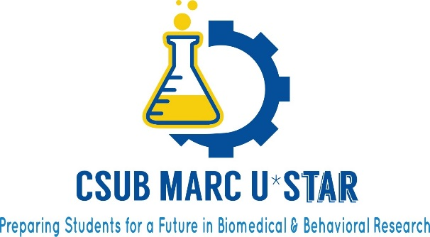

2017-2018 Application
Date of Application: Drop down to choose e-mail: email
First Name: First name Last Name: Last name
Address: Address City: City
State: State Zip Code: Zip Code Phone: Phone
CSUB Student ID: CSUB ID
Date of Birth and Place: Birth date and place
Are you a permanent resident: Choose an item.
U.S. Citizen: Choose an item Ethnicity: Choose an item.
If American Indian what tribe?Tribe
If Other Ethnicity, what Ethnicity: Other ethnicity
Are you considered a student with disabilities: Choose an item
Number of Persons in Household: # of persons Household Income: Income
Number of units completed: # of units Expected Date of Graduation: Date
Major: Major Minor: Minor
Overall GPA: Overall GPA Major GPA: Major GPA
Faculty Research Mentor :Faculty mentor Faculty email: email

I understand that I must turn in a completed application to the MARC U*STAR program in order to be considered for the program. The completed application consists of the application form, my statements, two letters of recommendation with recommendation forms signed (one from a faculty research mentor), Faculty Mentor Research Plan, transcript, and a copy of my current class schedule.

By signing this, I certify that all information contained is true and no false representations have been made.

Signature of Applicant:
Signature of Faculty Research Mentor:

Form date April 2017

