The California State University
Task Force on Expository Reading and Writing
EXPOSITORY READING AND WRITING
ASSIGNMENT TEMPLATE

MAGNETISM
Glencoe Science Level Blue
Chapter 23, Section 1 (666-671)
Teacher Version

READING RHETORICALLY
- PREREADING
- READING
- POSTREADING

Prereading
- Getting Ready to Read
- Surveying the Text
- Making Predictions and Asking Questions
- Introducing Key Vocabulary
Language Arts Standard: Writing Applications 2.3  Write brief reflective compositions on topics related to text, exploring the significance of personal experiences, events, conditions, or concerns by using rhetorical strategies (e.g., narration, description, exposition, persuasion). | Getting Ready to Read  As students approach this topic, you can engage them with the text through quick writes, models, brainstorming, or other activities to achieve the following goals:  - Show Bar magnet and how it interacts with other magnets and materials.  - Brainstorm-  - What is a magnet?  - How does a magnet work?  - What materials interact with magnets?  - Discuss how magnet works. Students will label North & South poles, draw magnetic field, and magnetic domain. (Attachment A)
Language Arts Standard: Reading Comprehension 2.1  Analyze both the features and rhetorical devices of different types of public documents (e.g., policy statements, speeches, debates, platforms) and how authors use these features and devices.  Language Arts Standard: Reading Comprehension 2.3  Verify and clarify facts presented in other types of expository texts by using a variety of consumer, workplace, and public documents. | Making Predictions and Asking Questions  Explain to students that Earth is a magnet. Ask questions to help students make predictions about what that means for the earth.  Help them notice that the bar magnets features are also present in the earth. You could ask questions like the following;  - Why do you think the Earth has a North and South Pole?  - A compass can tell you which way is north, what do you think the compass is reacting to?  - Do you think the Earth has a magnetic field?  - Can we feel or see the Earth’s magnetic field?  Have students label the North & South poles on their worksheet and draw in the magnetic field. Also have students label the North & south points on the compass. (Appendix B)

Language Arts Standard: Word Analysis and Systematic Vocabulary  Development 1.0 (as well as 1.1 and 1.2)  Students apply their knowledge of word origins to determine the meaning of new words encountered in reading materials and use those words accurately.  These activities are also designed to develop the kinds of vocabulary skills assessed by college placement exams such as the CSU English Placement Test and the UC Subject A exam.  Students should be able to  - Recognize word meanings in context.  - Respond to tone and connotation. | Introducing Key Vocabulary  Have students complete jigsaw activity to cover key vocabulary.  Key vocabulary.  - magnetism  - magnetic poles  - magnetic field  - magnetic domain  - permanent magnet  Have students complete word box for each term(Appendix C)

Reading
- First Reading
- Looking Closely at Language
- Rereading the Text
- Analyzing Stylistic Choices
- Considering the Structure of the Text

Language Arts Standard: Reading Comprehension 2.1  Analyze both the features and the rhetorical devices of texts and the way in which authors use those features and devices.  Language Arts Standard: Reading Comprehension 2.2  Analyze the way in which clarity of meaning is affected by the patterns of organization, hierarchical structures, repetition of main ideas, syntax, and word choice in the text. | First Reading  The first reading of the text is intended to help the students understand the information and confirm their prediction of volcanoes.  Have students use their text book to create a book to explain magnetism to a 6th grade student. (Appendix D). Their books should include the following information for magnetism;  - What is magnetism  - Diagram of a magnet  - North pole  - South pole  - Magnetic domain  - Magnetic field  - Interaction of magnets  - The Earth as a magnet  - Glossary of key terms  - References of Sources use
Language Arts Standards: Research and Technology 1.7:  Use systematic strategies to organize and record information (e.g. anecdotal scripting, annotated bibliographies).  Language Arts Standard: Reading Comprehension 2.2  Analyze the way in which clarity of meaning is affected by the patterns of organization, hierarchical structures, repetition of main ideas, syntax, and word choice in the text. | Rereading the Text  The Magnetism Lab will allow the students to see magnets in action and to record specific information about them. They will get to see right in front of them all the things that they had been learning about from the book.  Have students complete the magnetism lab and write up. (Appendix E)

Post-reading Activities
- Summarizing and Responding
- Thinking Critically

Prerequisite 7th Grade Language Arts Standard: Writing Application 2.5  Write summaries of reading materials, including main ideas and most significant details. Use own words. Reflect-explain underlying meaning.  Language Arts Standard: Writing Application 2.2a  Demonstrate a comprehensive understanding of the significant ideas in works or passages. | Summarizing and Responding  The final graphic organizer is meant to be a way for them to take all the knowledge they have learned and organize it in a meaningful way. The students will place words into the organizer and then writes a paragraph on the back of the paper using the words.  Have students use their book they created to complete the magnetism graphic organizer. (Appendix F)

APPENDICES

- Magnetic Domain

- Magnetosphere

- Word Box

- Magnet Book

- Magnetic Lab

- Magnets graphic organizer
APPENDIX A

Name: ________________
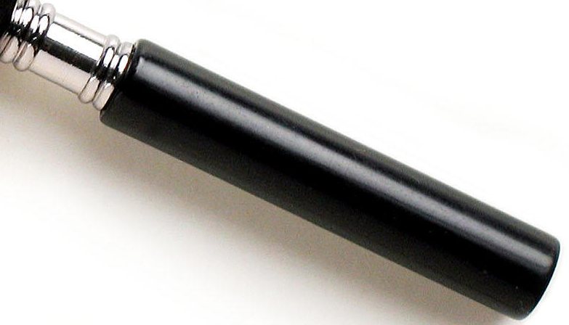
Period __________
APPENDIX B
Name :________________
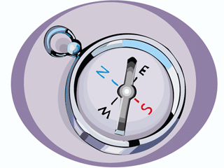
Period :________
APPENDIX C

Name: _________________
Period: _______________

Word Box

CAN
CAN NOT
DEFINITION
PICTURE
APPENDIX D
MAGENT BOOK

Write a book about magnets that would be suitable for 6th grade students to read. Your book will have three pages, a cover, and a glossary. Follow the guidelines below for what should be included in each section.

The book is worth 100 POINTS

COVER
  - Title
  - Picture

MAGNETIC PARTS-Page 1
- Poles
- Magnetic field
- Magnetic domain

MAGNETIC INTERACTIONS-Page 2
- Magnet to magnet
- Magnet to other Materials

MAGNETOSPHERE -Page 3
- Earth’s magnetic field)

GLOSSARY
- Define words
  - Magnetic field
  - Magnetic domain
  - Magnetosphere

APPENDIX E

Name: ___________

Period: ______

MAGNETIC POLES

Background
For electricity we found that there were positive and negative charges, that like charges repel each other and opposites attract. Let's see if there's an analogy for magnetism.

Materials Needed
1 compass
2 bar magnets
assorted magnets
2 round pens or pencils

Procedure
1. The bar magnets are marked with North and South poles. Put the pens under one of the bar magnets for rollers. Use the other bar magnet to determine if like poles attract or repel. Record your findings.
______________________________________________________________________
______________________________________________________________________
______________________________________________________________________
2. Move all of the magnets away from one bar magnet. Put the compass at the end of the magnet marked "N". Draw an arrow on the diagram below showing what direction the painted end of the compass needle points. Then repeat for the end marked "S".

MAGNETIC INSULATORS

Background
Let's see if there are magnetic insulators that are like electrical insulators.

Materials Needed
1 magnet
1 compass
notebook paper
brown paper
foil
cotton cloth
felt
plastic bag

Procedure
1. Earlier we found that there are materials that act as electrical insulators that interrupt the flow of electricity. What did we use to determine whether the electrical current was interrupted?
2. Based on your first exploration of magnets, what are two ways we can determine if a magnetic force is present?
______________________________________________________________________
______________________________________________________________________
______________________________________________________________________
3. Which of these methods do you think will be more likely to detect a weak magnetic force and why?
______________________________________________________________________
______________________________________________________________________
______________________________________________________________________
4. For each of the materials, put one layer of the material between the magnet and the detector. Test tor the presence of a magnetic force in two ways. Record your observations in the following chart.
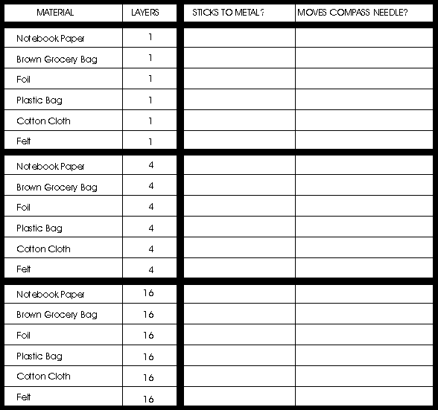

5. Repeat step 4 but put 4 layers of each material between the magnet and detector. Record your observations in the chart.
6. Repeat step 4 but put 16 layers of each material between the magnet and detector. Record your observations in the chart.

MAGNETIC FIELDS

Background
A magnetic field is the area around a magnet where its magnetic force can be felt.

Materials Needed
1 bar magnet
1 compass

Procedure
1. Place the magnet in the center of the next page.
2. Put the compass near one end of the magnet. Let the needle stop moving. Note the direction of the needle. Lift the compass and draw an arrow where the compass was. The arrow should point in the same direction as the painted end of the compass needle.

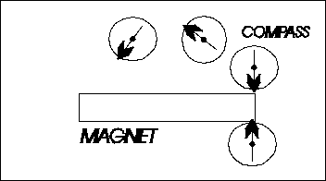

3. Move the compass toward the middle of the magnet. When the needle settles, note its direction and draw an arrow as before.
4. Repeat this as you move the compass to the other end of the magnet.
5. Now start again from a different place near the end of the magnet. Go from end to end at least 3 times. Explore both above and below the magnet.
6. When you're done, your arrows show you where the magnetic field is.
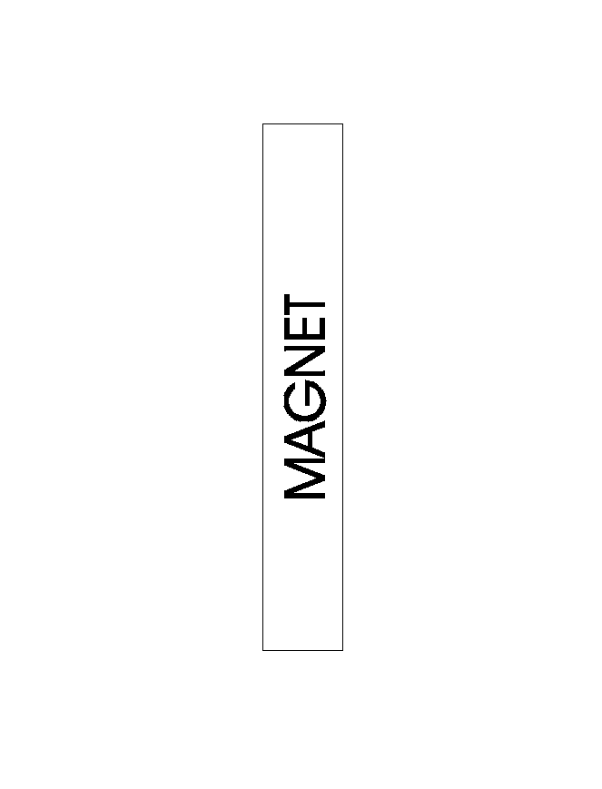

ELECTROMAGNET

Background
Here's an example of how electricity and magnetism are closely related.

Materials Needed
1 three foot long wire battery
1 nail paper clips
Procedure

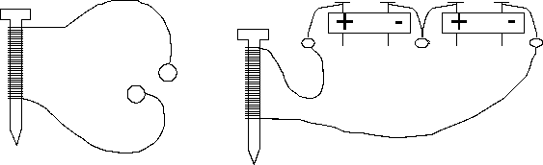
1. Wrap the wire tightly around the nail 10 times.
2. Try to pick up the paper clips by touching them with the nail.
What happens? ______________________________________
___________________________________________________
___________________________________________________
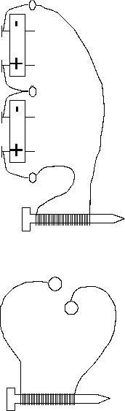
3. Hook up the batteries so that electricity is running through the wire.
4. Try again to pick up the paper clips.
What happens? ______________________________________
___________________________________________________
Why? _____________________________________________
___________________________________________________
5. Now disconnect the battery and try the paper clips again. Does the same thing happen as in step 2? What has happened to the nail?
______________________________________________________________________
______________________________________________________________________
6. Unwrap the wire from the nail and rewrap it 15 -20 times around the nail.
7. Reconnect the nail to the battery. Can you pick up more or less paperclips this time? ______________
8. Why do you think this is so? _______________________________________________________________________
________________________________________________________________________

APPENDIX F
Name: _________________
Period: _______________
1. Use the words in the word bank to fill in boxes.
have two poles
alike poles will
opposite poles
will
the Earth’s magnetic field is the
Magnets

WORD BANK

MagnetosphereREPEL

North POLE SOUTH POLE

ATTRACT

2. On the back of this paper write a paragraph using all of the words in the words bank.

