EXPOSITORY READING AND WRITING
The First Year Experience Novel for Fall 2008
California State University, Bakersfield
Funny in Farsi by Firoozeh Dumas
~Teacher’s Edition~
Module Written by Shannon Mooney, Abby Flachmann, and Jennifer Smith

READING RHETORICALLY
- PREREADING
- READING
- POSTREADING

Prereading
- Getting Ready to Read
- Introducing Key Concepts
- Surveying the Text
- Making Predictions and Asking Questions
- Introducing Key Vocabulary
English-Language Arts (ELA) Standard: Writing Applications  2.3 Write brief reflective compositions:  a. Explore the significance of personal experiences, events, conditions, or concerns by using rhetorical strategies (e.g., narration, description, exposition, persuasion). | Getting Ready to Read  Option #1: Quickwrite based on a quotation from the novel:  On page 3 and 4, Firoozeh Dumas writes of her father, “To him, America was a place where anyone, no matter how humble his [or her] background, could become an important person.” Write a journal entry for the following prompt: What kind of place is America? Do you agree with Dumas’ father? Or do you have a completely different perspective? Describe your perspective on America in your journal.  Option #2: Creative Writing Quickwrite (by Dale Drennan):  Your distant cousin and his/ her family are legally immigrating to the United States. Give some helpful advice to this family in a brief letter.
ELA Standards:  Word Analysis, Fluency, and Systematic Vocabulary Development  1.0 Students apply their knowledge of word origins to determine the meaning of new words encountered in reading materials and use those words accurately.  1.3 Discern the meaning of analogies encountered, analyzing specific comparisons as well as relationships and inferences. | Introducing Key Concepts  This section offers teachers opportunities to thread the module together conceptually. Key concepts are highlighted and taught through activities that will be revisited during the module in students’ discussions and writing. Vocabulary strategies are emphasized in this module, and specific directions for teachers to teach new words or concepts are offered in this section, as well as expanded upon in other sections during and following the reading of the text.  A PowerPoint entitled “Iran” provides students with background information on the topics connected with this module and has been included in this module. See Appendix A.  This PowerPoint briefly introduces students to the history behind the country, the culture, and modern-day life in Iran.  After going through the PowerPoint, ask students to answer the following questions:  - What was Iran formally called before 1935?  Persia  - What was the lasting effect from the Islamic revolution?  Transformed country from a monarch to an Islamic republic  - What occurred during the 1980s?  The American hostage crisis, resulting in increased mistrust between Iran and America.  - What kind of religion has the largest following in Iran?  Islam  - What segment of the population is the largest (the young or middle-aged or elderly)?  The young  - What is the young adult’s central issue of concern?  High unemployment  - What is the dress code for women in Iran (think back to the pictures from the power point)?  Women in Iran wear head covers, but their faces are not covered.
ELA Standard: Reading Comprehension  2.1 Analyze both the features and the rhetorical devices of different types of public documents (e.g., policy statements, speeches, debates, platforms) and the way in which authors use those features and devices. | Surveying the Text  - Look at the title. What does Funny in Farsi mean? What does Farsi mean? What is the meaning of the subtitle: A Memoir of Growing up Iranian in America? Can someone explain what memoir means?  Farsi is the language of Iran. Memoir is an account of one’s personal life or an autobiography.  - Look over the 27 chapter titles. What does this tell you about the readings? What does this imply about the author?  Answers may vary. It seems more like a journal entry. It appears that the author has a sense of humor.
ELA Standards: Reading Comprehension  2.1 Analyze both the features and the rhetorical devices of different types of public documents (e.g., policy statements, speeches, platforms) and the way in which authors use those features and devices.  2.3 Verify and clarify facts presented in other types of expository texts by using a variety of consumer, workplace, and public documents. | Making Predictions and Asking Questions  - Who is the intended audience for this book?  Americans—but also note that this book is currently very popular in Iran.  - Why do you think the author wrote this book? What is the  author’s purpose for writing this book?  Answers will vary, but probably should include the idea of  helping Americans understand Iranians.  - Go to Firoozeh Dumas’ website to learn more about her:  http://firoozehdumas.com  If this is not available to you, here is some information about  the author and the novel:  “Firoozeh Dumas (Author) was born in Abadan, Iran, and moved to Whittier, California, at the age of seven. After a two-year stay, she and her family moved back to Iran and lived in Ahvaz and Tehran. Two years later, they moved back to Whittier, then to Newport Beach. Firoozeh then attended UC Berkeley where she met and married a Frenchman.  Firoozeh grew up listening to her father, a former Fulbright Scholar, recount the many colorful stories of his life. In 2001, with no prior writing experience, Firoozeh decided to write her stories as a gift for her children. Random House published these stories in 2003. Funny in Farsi was on the SF Chronicle and LA Times bestseller lists and was a finalist for the PEN/USA award in 2004 and a finalist in 2005 for an Audie Award for best audio book. She lost to Bob Dylan. She was also a finalist for the prestigious Thurber Prize for American Humor, the first Middle Eastern woman ever to receive this honor. Unfortunately, she lost that one to Jon Stewart. Even though, as Firoozeh's dad likes to point out, Jon Stewart wrote his book with a team of writers, while Firoozeh wrote hers alone—before her children woke up for school.  The Persian version of Funny in Farsi is currently one of the bestselling books in Iran. Firoozeh's next book, Laughing Without an Accent, a series of autobiographical essays, will be published by Random House in May 2008. ABC has been developing a sitcom based on Funny in Farsi. (Above information found at http://groups.yahoo.com/group/firoozehdumasfc/)
ELA Standards:  Word Analysis and Systematic Vocabulary  Development  1.0 Students apply their knowledge of word origins to determine the meaning of new words encountered in reading materials and use those words accurately.  1.1 Trace the etymology of significant terms used in political science and history.  1.2 Apply knowledge of Greek, Latin, and Anglo-Saxon roots and affixes to draw inferences concerning the meaning of scientific and mathematical terminology.  College Expectations: These activities are also designed to develop the kinds of vocabulary skills assessed by college placement exams such as the CSU English Placement Test and the UC Analytical Writing Placement Exam. Students should be able to  - Recognize word meanings in context.  - Respond to tone and connotation. | Introducing Key Vocabulary  Students will come across words that they might be culturally unaware of as they begin to read this novel. Firoozeh Dumas, author of Funny in Farsi, defines most Persian words in context in the course of the novel, but the following terms may be useful to readers.  • ameh — father’s sister  • amoo — father’s brother  • aqd — Persian wedding ceremony  • dye-yee — mother’s brother  • khaleh — mother’s sister  • pessar ameh — son of father’s sister  • pessar amoo — son of father’s brother  • shohar ameh — husband of father’s sister  • shohar khaleh — husband of mother’s sister  • sofreh — a hand-sewn cloth on which family arranges food and objects that carry special meaning in the traditional wedding ceremony  (*made available by Julie Cooper’s study guide from Random House)

Reading
- First Reading
- Looking Closely at Language
- Rereading the Text
- Analyzing Stylistic Choices
- Considering the Structure of the Text
ELA Standards: Reading Comprehension  2.1 Analyze both the features and the rhetorical devices of different types of public documents (e.g., policy statements, speeches, debates, platforms) and the way in which authors use those features and devices.  2.2 Analyze the way in which clarity of meaning is affected by the patterns of organization, hierarchical structures, repetition of main ideas, syntax, and word choice in the text. | First Reading  Funny in Farsi contains 27 chapters, each addressing various themes for discussion. To begin a general discussion of the book, ask the following question: “What chapter stands out for you and why?”  The following is a chapter-by-chapter guide provided by the author with a set of general questions at the end. We recommend allowing students to view the questions before reading each chapter to provide a focus for reading and then having students answer the chapter questions after reading each chapter or set of chapters. Answers will vary.  Ch. 1: Leffingwell Elementary School  1. How do you react to someone who does not speak English? Do you make assumptions about their intelligence?  2. When Firoozeh’s mother could not find Iran on the map, who do you think was more embarrassed, Firoozeh or her mother? Why?  3. Do you think geography matters? Why?  Ch. 2: Hot Dogs and Wild Geese  1. In some cultures, it is considered very rude not to try new foods. Do you try new foods? Is there a polite way to refuse?  2. What foods in this culture might seem strange to a foreigner?  Ch. 3: In the Gutter  1. What role does television play in shaping our hopes and dreams?  2. Have you ever quit something because you thought you were not good enough?  Ch. 4: Save Me, Mickey  1. Have you ever been lost?  2. Have you ever been mistaken for someone from another country?  3. Have you ever assumed you know where someone is from based on his or her appearance?  Ch.5: Swoosh, Swoosh  1. Why did Nematollah feel compelled to try every American food item?  2. What do you think of the culture of weight loss in this country?  3. Why did Nematollah believe the ads on TV?  Ch. 6: With a Little Help From My Friends  1. Do you have a world map in your house?  2. By studying geography from first grade, Iranian students learn that the  world matters. Do you think the rest of the world matters?  3. Do you believe that kindness is never forgotten? If yes, give an example from your life.  4. How would this book be different if Firoozeh had only known America after the Iranian Revolution?  Ch. 7: Bernice  1. When you see negative events in the news about another country, what assumptions, if any, do you make about the people of that country?  2. Imagine coming to America and only watching the news. What would you think of American society? Would you feel safe?  Ch. 8: A Dozen Key Chains  1. Share your worst camp experience.  2. Do you think Firoozeh would have made friends if she had bathed?  Ch. 9: You Can Call Me Al  1. Find Abadan on a map. Find the Caspian Sea. Trace the drive through Tehran, the capital of Iran. If you drive that distance from your hometown, where do you end up?  2. How do you define “vacation”?  Ch. 10: Of Mosquitoes and Men  1. Do you like to travel to exotic locations or do you prefer the familiar?  2. Why do you think some people seek adventure when they travel while others seek only comfort?  Ch. 11: The “F” Word  1. How do you react to someone with a difficult name?  2. Do you know an immigrant who changed his name to an American name?  3. On Ellis Island, many immigrants were given new anglicized versions of their last names. Discuss the pros and cons.  Ch. 12: Waterloo  1. Has anxiety ever prevented you from learning something?  2. Do you think anyone at any age can learn anything or is there a time limit on certain skills?  Ch. 13: America, Land of the Free  1. Do you automatically try all free samples?  2. We all know the expression “nothing is free.” Is that true?  Ch. 14: The Ham Amendment  1. Firoozeh’s father believes that there are good and bad people in every religion. Do you agree?  2. How is religion used to divide people? How does it unite?  Ch. 15: Treasure Island  1. Education changed Kazem’s life. Do you think education can transform everyone?  2. Meeting Albert Einstein was the most exciting event in Kazem’s life. If you could meet anyone, whom would you pick?  Ch. 16: It’s All Relatives  1. Family plays a huge role in the Iranian culture. What role does it play in the American culture?  2. In America, the role of family has changed over the years. Discuss the pros and cons.  Ch. 17: Me and Bob Hope  1. What is it like to live in America and not celebrate Christmas?  2. Some non-Christians celebrate Christmas so their children do not feel left out. How do you feel about this?  3. Even though Christmas is a religious holiday, many believe that it has become a shopping extravaganza. What do you think?  Ch. 18: I Ran and I Ran and I Ran  1. How did this chapter make you feel?  2. Were you surprised by the events?  3. Firoozeh wrote this story because nobody was seriously hurt. Do you think she would have written this if anyone had been seriously injured?  Ch. 19: I-Raynians Need Not Apply  1. Even though America is the land of immigrants, immigrants do not necessarily feel welcome. During the 19th century, Irish immigrants were faced with signs in shop windows stating “N.I.N.A.” meaning No Irish Need Apply. How do we treat immigrants now?  2. Who was the immigrant in your family?  3. Some people feel we should limit immigration. Do you agree?  Ch. 20: Girls Just Wanna Have Funds  1. Firoozeh held a string of odd jobs to earn money. Have you ever had an odd job?  2. Firoozeh’s Aunt Sedigeh did not have the educational opportunity that Firoozeh had. Do you think that educational opportunities for the next generation are improving in America?  3. Do you think that anyone who wants an education in America can obtain one?  Ch. 21: Joyeuse Noelle  1. Firoozeh’s summer in Paris turned out very differently than what she had imagined. Have your expectations of an event ever clashed with reality?  2. Noelle was very excited that Firoozeh was from California. What stereotypes might foreigners have of Californians? What has shaped their ideas?  Ch. 22: The Wedding  1. Have you ever attended a wedding of people from different religions?  If so, what was it like?  2. Some people believe that people should only marry within their own religion. Do you agree?  3. Firoozeh says that her mother became a “pioneer” by accepting Francois. Did you expect Firoozeh’s mother to react that way?  4. Every culture has marriage traditions. What are yours?  Ch. 23: I Feel the Earth Move Under My Feet  1. Firoozeh described her china as having “bad karma.” What do you think she meant by that?  2. Do you agree with what Firoozeh did with the china?  Ch. 24: A Nose By Any Other Name  1. Firoozeh says Iranians are obsessed by noses. What is the obsession in America?  2. How do different cultures define beauty?  3. The librarian had learned to accept herself as she was. How different would we be if we accepted ourselves as we are? What would happen to the beauty or diet industry?  Ch. 25: Judges Paid Off  1. What do you think of beauty pageants?  2. Firoozeh said she thought the beauty pageant should be replaced with a spelling bee. Do you think it would be any easier to lose in a spelling bee?  Ch. 26: If I Were a Rich Man  1. Why do you think Firoozeh’s father refuses to apologize for his mistakes?  2. What is the American dream? Has it changed over the years? Is it achievable?  3. How we define wealth in America?  Afterword: Kazem and Nazireh Jazayeri  1. Firoozeh still keeps in touch with her second grade teacher, Mrs. Sandberg. Why do think this is?  2. Firoozeh says that everybody has a story to tell and everybody’s story counts. Do you agree?  General questions:  1. The theme of Funny in Farsi is “shared humanity.” What does that mean to you?  2. How would our communities, both locally and globally, be different if we saw our commonalities before our differences?  3. Most Americans’ perception of the Middle East is limited to what is shown on the evening news. Since only bad news is news, how does this effect the perception of Middle Eastern immigrants in this county?  4. Immigrants often do not try to be a part of American society,  preferring instead to spend time with their own compatriots. What can be done to encourage assimilation?  5. Should immigrants speak their native language at home?  6. Firoozeh’s book is funny without being mean. Discuss the humor found in television.
ELA Standard:  Word Analysis, Fluency, and Systematic Vocabulary Development  1.0 Students apply their knowledge of word origins to determine the meaning of new words encountered in reading materials and use those words accurately. | Looking Closely at Language  Students are to circle and write down two words from every chapter in the novel in a reading log or journal, so by the time students have completed the novel they will have added fifty-four words to their vocabulary. Their job is to learn these words very well by completing the following:  - Write down the word in a reading log  - Note the page number and the context of the word from Dumas’ text.  - Find and write down in your reading log the word’s appropriate definition as it pertains to the way the word is used in the novel.  - Create a sentence for the word to prove your new understanding.

ELA Standard: Writing Strategies  1.7 Use systematic strategies to organize and record information (e.g. anecdotal scripting, annotated bibliographies).  ELA Standard: Reading Comprehension  2.2 Analyze the way in which clarity of meaning is affected by the patterns of organization, hierarchical structures, repetition of main ideas, syntax, and word choice in the text. | Rereading the Text  Students can either complete a journal entry or write a short paper on any of the following prompts:  Funny in Farsi (pages 3-41)  1. Is school an important part of American life? Why? What does this say about our culture?  Funny in Farsi (pages 42-81)  2. What does your name mean? (If you do not know, research the meaning of you name.) Is the meaning something special to you? Does it reflect your culture?  Funny in Farsi (pages 82-115)  3. “Without my relatives, I am but a thread; together, we form a colorful and elaborate Persian carpet” (Dumas 103) Family plays an important role in Funny in Farsi. Describe your “family,” whether it is your blood relations or a community you belong to. How do they influence you? Support you? What role does the family play in American culture?  Funny in Farsi (pages 116-153)  4. To what extent does discrimination exist in the United States? What kinds of discrimination are there? Have you ever been discriminated against? What can or should be done about discrimination?  Funny in Farsi (pages 154-198)  5. “‘But, Firoozeh,’ he said, ‘I’m a rich man in America, too. I just don’t have a lot of money’” (Dumas 187). What does this quote say about Firoozeh’s father’s view on wealth? How does the United States view wealth? How does this affect the way we live and work? How do you view wealth?  MORE RESOURCES  On pages 211-214 of Funny in Farsi, you will find “Reading Group Questions and Topics for Discussion.” In these three pages are twenty-four questions that could serve any instructor or small group leader with various ideas for this stage of reading, writing, and critical thinking.  Random House has developed a teaching guide for Funny in Farsi, which is available online: www.randomhouse.com.
ELA Standard: Literary Response and Analysis  3.3 Analyze the ways in which irony, tone, mood, the author's style, and the “sound” of language achieve specific rhetorical or aesthetic purposes or both.  College Expectations: These activities are also designed to develop the kinds of close reading skills assessed by college placement exams such as the CSU English Placement Test and the UC Analytical Writing Placement Exam.  Students should be able to  - Draw inferences and conclusions.  - Respond to tone and connotation. | Analyzing Stylistic Choices  Words:  - Dumas refers to the United States as “The Promise Land,” but paints very different images of what the promise land means to her and what the promise land means to her father (4). What is the connotative meaning of “The Promise Land,” and how do you see this connotative meaning in Funny in Farsi?  The “Promise land” refers to the land God promised the Israelites in the Bible. In Funny in Farsi, America is the Promise Land to Dumas because she could buy more clothes for her Barbies. To her father, America represents the Promise land because anyone can rise up and build a future for herself or himself.  - “Thanks to my father’s translations, we stayed away from hot dogs, catfish, and hush puppies, and no amount of caviar in the sea would have convinced us to try mud pie” (9). Some English words were lost in translation; how does this add humor to the text? What other instances were words or culture lost in translation?  - It adds humor to the text because it makes us, as English speakers, think about the literal meaning of some of our words. Other answers may vary.  - One page 96, Dumas gives a variety of words meaning “tan”: “deep tan, fading tan, bronze tan, a new tan [. . .] a farmer’s tan [. . .] a fake ‘n’ bake [. . .] a surfer’s tan.” What are the denotative and connotative meanings for each word? Which are positive? Which are negative? What do these examples show about the power of word choice?  Each word means the browning of skin. The positive words are a “deep tan,” a “bronze tan,” a “surfer’s tan.” The negative words are a “fading tan,” a “new tan,” a “farmer’s tan,” and a “fake ‘n’ bake.” Writers can use word choice to make a reader feel positive or negative about a subject.  - “‘But, Firoozeh,’ he said, ‘I’m a rich man in America, too. I just don’t have a lot of money’” (Dumas 187). What are the connotative meanings of the word “rich” in this sentence within the context of Funny in Farsi?  Dumas’ father believes his opportunities in America make him rich, not his bank account.  Sentences:  - Some of the sentences are sarcastic. Find a few examples of sarcasm in Funny in Farsi. How does sarcasm add to your understanding of the story and the author? How does Dumas use sarcasm to get her point across?  Answers will vary.  - At times, Dumas’ sentences hold a lot of humor. Find a few examples of humorous sentences. How does the author use humor to connect to readers? Is it effective storytelling? Why or why not?  Answers will vary.  - “[E]very place we saw delighted us. There was, however, one attraction that stood apart, one whose sweatshirts we wore with pride, one that generated near religious devotion: Disneyland” (Dumas 17) What role does the colon play in this sentence? Why does Dumas use it? Is it effective?  The colon acts as a dramatic separator from Disneyland and the powerful words that describe it. Other answers will vary.  - “Without my relatives, I am but a thread; together, we form a colorful and elaborate Persian carpet” (Dumas 103). Notice the semicolon connects the two independent clauses. Dumas could have easily used a period instead. Why do you suppose she used a semicolon? What affect does it have on you as a reader? Using the semicolon shows how closely related the two statements are. Other answers will vary.
ELA Standards: Reading Comprehension  2.1 Analyze both the features and the rhetorical devices of different types of public documents (e.g., policy statements, speeches, debates, platforms) and the way in which authors use those features and devices.  2.2 Analyze the way in which clarity of meaning is affected by the patterns of organization, hierarchical structures, repetition of main ideas, syntax, and word choice in the text. | Considering the Structure of the Text  Descriptive Outlining:  Ask students to write brief statements describing the rhetorical function and content of each section.  As an example, Dumas’ chapter “The ‘F Word’” seems to have more of a clear purpose/argument than other chapters. This is also apparent in chapters such as “America, Land of the Free,” “The Ham Amendment,” “I Ran and I Ran and I Ran,” and “I-raynians Need Not Apply.” Some of Dumas’ chapters feel like a journal entry while the ones above feel like she would like to persuade the reader in some way. The goal here is to see if your students can see this difference.  The answers that follow pertain to “The ‘F Word’”  1. What is the content of this chapter?  This chapter discusses the difficulties of having a foreign name in “a country where monosyllabic names reign supreme” (Dumas 62). The title of this chapter refers to an American Dumas met who refused to pronounce her name, so she decided to refer to Dumas as the “F Word.”  2. How does this chapter affect the reader?  The reader feels sympathetic towards Dumas and other immigrants with the same plight.  3. What is the writer trying to accomplish?  It appears that Dumas’ aim is to try and make Americans aware of the difficulties involved in being an immigrant. In the end, it seems Dumas is trying to move her readers towards empathy and understanding of the realities of being an immigrant in America.

Post-reading Activities
- Summarizing and Responding
- Thinking Critically
Prerequisite 7th Grade ELA Standard: Writing Applications  2.5 Write summaries of reading materials:  a. Include the main ideas and most significant details.  b. Use the student's own words, except for quotations.  c. Reflect underlying meaning, not just the superficial details.  ELA Standard: Writing Applications  2.2 Write responses to literature:  a. Demonstrate a comprehensive understanding of the significant ideas in works or passages. | Summarizing and Responding  Summarizing is a very important strategy that students need to learn. It involves extracting the main ideas from a reading selection and explaining what the author says about them. Here are some options for teaching this complex strategy:  1. Assign each student a chapter (there are 27 chapters)  2. For each chapter, students must identify  - the theme/lesson  - examples and rhetorical techniques used by Dumas to teach/show/support her theme/lesson  - how the examples/techniques used by Dumas help to support her lesson/theme  - two questions from the chapter to use in class discussion  3. An alternate or additional idea is to have students create an illustration or collage that represents the theme/lesson from the assigned chapter and present their findings in front of the class.
ELA Standards: Reading Comprehension  2.4 Make warranted and reasonable assertions about the author’s arguments by using elements of the text to defend and clarify interpretations.  2.5 Analyze an author’s implicit and explicit philosophical assumptions and beliefs about a subject.  2.6 Critique the power, validity, and truthfulness of arguments set forth in public documents; their appeal to both friendly and hostile audiences; and the extent to which the arguments anticipate and address reader concerns and counterclaims (e.g., appeal to reason, to authority, to pathos and emotion).  College Expectations: These questions are also designed to develop the kinds of skills assessed by college placement exams such as the English Placement Test and the UC Analytical Writing Placement Exam. Students should be able to  - Identify important ideas.  - Understand direct statements.  - Draw inferences and conclusions.  - Detect underlying assumptions.  - Recognize word meanings in context.  - Respond to tone and connotation. | Thinking Critically  The following questions move students through the traditional rhetorical appeals. Using this framework, help students progress from a literal to an analytical understanding of the reading material.  Questions about Logic (Logos):  - What messages does Dumas try to communicate to her readers in Funny in Farsi? Is she successful?  Dumas tries to portray the immigrant experience in America. Other answers will vary.  - Is there any message that appears to be weak or unsupported? Which one and why?  Answers will vary.  Questions about the Writer (Ethos):  - Does Dumas have the appropriate background to speak with authority on this subject?  Yes she does because she is an Iranian immigrant and it is her own story.  4. Is Dumas knowledgeable? How do you know?  Yes she is knowledgeable because it is her story.  5. What does Dumas’ style and language tell you about her?  She is lighthearted, funny, and smart.  6. Does Dumas seem trustworthy? Why or why not?  Yes. Answers will vary.  7. Does Dumas seem deceptive? Why or why not?  No. Answers will vary.  Questions about Emotions (Pathos):  - Does this book affect you emotionally? Which parts and why?  Answers will vary.  - Is Dumas trying to manipulate the emotions of her audience? In what way? At what point?  She is trying to show readers the struggles immigrant families face. Answers will vary.  - Do the readers’ emotions conflict with a logical interpretation of Funny in Farsi?  Answers will vary.  - How does Dumas’ use of humor and irony affect your acceptance of her ideas?  Answers will vary.  Quickwrites (5 minutes):  Ask students to complete the following quickwrite in their journals:  Look back at the quickwrite you did before reading Funny in Farsi? Did your opinion change? How? Why?

CONNECTING READING TO WRITING
- WRITING TO LEARN
- USING THE WORDS OF OTHERS

Writing to Learn
Although the writing process can be divided into stages, writing, like reading, is essentially a recursive process that continually revisits different stages. Much of the pre-writing stage has already been accomplished at this point because students have been “writing to learn” while reading. They have been using writing to take notes, make marginal notations, map the text, make predictions, and ask questions. Now they are ready to use what they have learned to produce more formal assignments.

Prerequisite 9th-10th Grade ELA Standard: Reading Comprehension  2.4 Synthesize the content from several sources or works by a single author dealing with a single issue; paraphrase the ideas and connect them to other sources and related topics to demonstrate comprehension.  Prerequisite 9th-10th Grade ELA Standards: Writing Strategies  1.5 Synthesize information from multiple sources and identify complexities and discrepancies in the information and the different perspectives found in each medium (e.g., almanacs, microfiches, news sources, in-depth field studies, speeches, journals, technical documents).  1.6 Integrate quotations and citations into a written text while maintaining the flow of ideas.  1.7 Use appropriate conventions for documentations in the text, notes, and bibliographies by adhering to those in style manuals (e.g., Modern Language Association Handbook, The Chicago Manual of Style).  ELA Standard: Writing Strategies  1.7 Use systematic strategies to organize and record information (e.g., anecdotal scripting, annotated bibliographies). | Using the Words of Others  One of the most important features of academic writing is the use of the words and ideas from written sources to support the writer’s own points. There are essentially four ways to incorporate words and ideas from sources.  - Direct quotation: Firoozeh Dumas says, “At an age when most of my classmates were discovering the Nordstrom shoe department, I had watched my parents cut up their credit cards” (122).  - Paraphrase: In Funny in Farsi, Firoozeh Dumas discusses how she worried about her family’s financial situation when most of her friends were concerned about buying their next outfit (122).  - Summary: In Funny in Farsi, Firoozeh Dumas tells the story of the various jobs she held as a teenager in an attempt to make money to pay her way through college. While this seems like an odd worry for a young teen, her parents’ financial situation, due to the Iranian Revolution, made it a necessary worry for Firoozeh (122).  What citation format should I teach?  This is not an easy question to answer, because most students will end up using at least two formats in their college work. The two most common documentation styles used are Modern Language Association (MLA), which is used mainly by English departments, but is also used sometimes in business, and the American Psychological Association format (APA), which is common in the social sciences. In this template, we demonstrate the MLA format in Appendix A and the APA format in the introduction. It is probably best for high school teachers to teach the MLA format, because the freshman composition instructor is likely to require it. Other formats that students may encounter are CBE (Council of Biology Editors), used in the sciences, and Chicago, based on The Chicago Manual of Style published by the University of Chicago Press. The popular Manual for Writers of Term Papers, originally written by Kate Turabian, is based on Chicago style. When your students are in college, their instructors will tell them what format is required.  Whatever format they use, students need to learn to record all of the necessary information and to get in the habit of documenting sources. For print material, at a minimum they need to record the author, title, city of publication, publisher, date, and page number.  MLA Style  Here is the “Works Cited” format for a typical book in MLA style:  Bean, John C., Virginia A. Chappell, and Alice M. Gilliam. Reading Rhetorically: A Reader for Writers. New York: Longman, 2002.  Here is the bibliographic information for the article quoted above, in MLA format:  Dumas, Firoozeh. Funny in Farsi. New York: Random House, 2003.  Students often want to incorporate material from websites. To document a website, they need to give the author (if known), the title of the site (or a description like “Homepage” if no title is available), the date of publication or update (if known), the name of the organization that sponsors the site, the date of access, and the web address (URL) in angle brackets. For example:  University Writing Center. 26 June 2003. University Writing Center, Cal Poly Pomona. 26 May 2004 <http://www.csupomona.edu/uwc/>.  The author is unknown for the above site and so is left out. This entry would appear in the “Works Cited” section alphabetized by “University.”  MLA style also requires “in text” documentation for every direct quotation, indirect quotation, paraphrase or summary. Many students are confused about this, believing that documentation is only necessary for direct quotations. If the author is given in the text, the page number should be given in parentheses at the end of the sentence containing the material. For example, here is a paraphrase of material from Funny in Farsi. Because the author is not named in the text, the last name goes in the parentheses:  After trying her hand at many odd jobs, such as baby-sitting, house-sitting, and silver-polishing, the author finally gave up hope that she would be able to pay for college. Soon after, she found a skill that she was not only very good at, but would actually help her with her college tuition much more than the minimum wage jobs she tried in the past—writing essay for college scholarships (Dumas 129).  An academic paper is most often a dialogue between the writer and his or her sources. If students learn to quote, paraphrase, summarize and document sources correctly, they are well on their way to becoming college students.  This short introduction presents only the basic concepts of MLA documentation. Students need access to some kind of handbook that covers the system in more detail.  Writing Assignment: An exercise that can help students learn to incorporate material from other sources is “Quote, Paraphrase, Respond.” Ask students to choose three passages from the text they are reading that they might be able to use in an essay. First, they write each passage down as a correctly punctuated and cited direct quotation. Second, they paraphrase the material in their own words with the correct citation. Finally, they respond to the idea expressed in the passage by agreeing or disagreeing with it and explaining why, again with the correct citation. It is easy to see if the students understand the material by looking at the paraphrases. Later, they can use this material in an essay.
WRITING RHETORICALLY
- PREWRITING
- WRITING
- REVISING AND EDITING
- EVALUATING AND RESPONDING

Prewriting
- Reading the Assignment
- Getting Ready to Write
- Formulating a Working Thesis
ELA Standard: Writing Strategies  1.1 Demonstrate an understanding of the elements of discourse (e.g., purpose, speaker, audience, form) when completing narrative, expository, persuasive, informational, or descriptive writing assignments. | Reading the Assignment  Many students have trouble with writing assignments because they don’t read the assignment carefully. Here are some strategies that might help students overcome this problem:  - Read the assignment carefully with students. Many problems with student work, particularly in timed, high-stakes writing situations, arise because students fail to completely understand what the writing assignment asks them to do.  - Help students clearly understand the subject of their upcoming essay. Is the subject specified for them? Do they have choices to make about the subject?  - Discuss the purpose of the assignment. Are they informing or reporting? Are they persuading their readers of something? Help students recognize how the purpose of the assignment affects the type of writing they will do.  - Read the assignment for information about process and deadlines. Teachers may want to help students sketch out a timeline for completing the assignment in reasonable steps.  - Ask students to examine the assignment for information about how they will be graded. Upon what criteria will their written work be evaluated? Do they understand each criterion?  - Look for information in the assignment about the audience to whom the writing will be addressed (see “Getting Ready to Write”).  Writing Assignment: Authentic Writing Using the Rhetorical Modes of Description, Narration, and Example  You are a journalist at the Los Angeles office of Time magazine. You’ve noticed that Los Angeles has become the “Ellis Island”* of the twenty-first century, as recent reports and studies have indicated. You decide to pitch to your editor the idea of following an immigrant family on their journey to and experiences in the United States. She decides that it would make for a great story and grants you permission. You know that other journalists will be writing on similar topics, since it is the latest hot topic in the media, so you know you’ll need to take a creative angle on the story in order for the magazine to sell. Your boss expects you to write an article of at least two to three pages describing what you hear, see, taste, and feel on your journey with the immigrant family. Remember your boss requires a point or purpose to every news story and is expecting quotations from family members you interview. You always have a colleague read your story before you turn it in, so you’ll want to have your first draft completed by [your deadline]. Your boss expects the finished version on her desk on [your deadline].  * Make sure students know that Ellis Island refers to the processing center for immigrants arriving in America during the immigration flood of the early 1900s.  Writing Assignment: Memoir Writing Using the Rhetorical Modes of Description, Narration, and Example  You will have a chance to write on the subject you know most about—yourself. You will be required to write on five chapters throughout the semester, but each chapter must point to a larger theme. Funny in Farsi, while discussed many topics and issues, focused on stories that expressed the experiences of an immigrant and the culture clashes between Iranian culture and American culture; you must find your own theme. Each chapter must have a title and be 200-300 words long, and it must be typed. Remember to provide vivid description, follow the 5 Ws and H,* and use specific examples to support your purpose for each chapter. At the end of the semester, you will combine your five mini-stories into one memoir. The memoir must have a unique title. You will also be required to design a cover for your memoir that represents you and your story. The first and last chapter topics have already been decided for you, but you can freely choose the other three. If you wish to write on a chapter topic that is not listed here, please discuss it with your instructor first.  * The 5 Ws and H refer to the questions who, what, where, when, why, and how.  Chapter One (Required): Who are you? Describe your family, your neighborhood, your culture, the meaning of your name, your religion, anything that paints a vivid picture of who you are.  For chapters two-four choose any of the following topics:  Family: “Without my relatives, I am but a thread; together, we form a colorful and elaborate Persian carpet” (Dumas 103) Family plays an important role in Funny in Farsi. Describe your “family,” whether it is your blood relations, friends, or a community you belong to. How do they influence and/or support you?  Reading: What was one of your favorite books when you were growing up? Why did you enjoy that book so much? OR What has been the most important and influential book to you? Why?  Holidays: Describe a favorite holiday memory. Who was there? What happened? When and where did it happen? Why is that holiday memory important to you? How did you feel?  First Day of School: Everyone is a little nervous on the first day of school. Describe the most vivid memory you have of one of your first days of school. How old were you? What school did you attend? What happened on that day? How did you feel?  Role Model: Who has been the most influential person in your life? Describe his or her personality, his or her looks. What has he or she done to make a positive impact in your life? What lessons have you learned from this person?  First Job: Describe your first job. Select one of the following focuses: the interview process (How did you feel? What did you do to prepare? Did anything unexpected happen?) OR the worst day at your first job (What happened? Who was involved? How did you react? What did you learn?).  Chapter Five (Required): The Future. What are you looking forward to in the future? What are your goals and dreams? How do you plan to reach them?
ELA Standard: Writing Strategies  1.0 Students write coherent and focused texts that convey a well-defined perspective and tightly reasoned argument. The writing demonstrates students’ awareness of the audience and purpose and progression through the stages of the writing process. | Getting Ready to Write: Authentic Writing Assignment  The following activity will help students move as smoothly as possible from reading to writing. Students may want to refer to their reading notes before engaging in this activity. The prewriting strategy we are demonstrating is Questioning for the Authentic Writing assignment.  Before your students start writing, have them answer the following questions:  - What message do you want to get across to your readers?  - List some characteristics of the family.  - Who in the family will be the focus of your story? Why?  - What was the family’s life like before deciding to immigrate?  - Why did they decide to come to the United States?  - Where were they living before immigrating to the United States? Where do they live in the United States now?  - When did they immigrate?  - How did they immigrate?  - What have been some of the challenges that the family has faced?  - What have been some of the triumphs and achievements the family has made?  Getting Ready to Write: Memoir Writing  The following activity will help students move as smoothly as possible from reading to writing. Students may want to refer to their reading notes before engaging in this activity. The prewriting strategy we are demonstrating is Clustering for the Memoir Writing assignment.  Before your students start writing, have them do the following activity:  - Decide on a focus/theme for your memoir; place this in the center bubble of the Cluster.  - Each of the five chapters should have their own bubble in the next level of the Cluster. Each chapter bubble should support the theme in the center bubble.  - Within the third and final level of the Cluster, answer the 5 Ws and H* for each of the five chapters.  - Keep this as a reference for the rest of the project.  You may want your students to do prewriting for each chapter in addition to their Cluster for more detailed prewriting. Allow students to select their own prewriting activity according to their learning style.  *The 5 Ws and H refer to the questions who, what, where, when, why and how.
ELA Standard: Writing Strategies  1.3 Structure ideas and arguments in a sustained, persuasive, and sophisticated way and support them with precise and relevant examples. | Formulating a Working Thesis  Most students will find it helpful to formulate a working thesis statement at this point for the Authentic Writing assignment. Students can go through their “invention” work to decide what statement or assertion they might be able to support with stories and experiences from the immigrant family they are following. Although students can be successful with different approaches to writing, a strong and focused thesis statement provides all writers a focus and foundation for the rest of the essay.  Students may want to think about or write answers to the following questions as part of their pre-writing strategies:  - What is your tentative thesis?  - What support have you found for your thesis?  - What evidence have you found for this support? For example, facts, statistics, authorities, personal experience, anecdotes, stories, scenarios, and examples.  - How much background information do your readers need to understand about your topic and thesis?  - If readers were to disagree with your thesis or the validity of your support, what would they say? How would you address their concerns? What would you say to them?  After students formulate a working thesis, give them feedback, either individually or as a class activity, before they begin to write. Potential writing problems can be averted at this stage just by checking students’ working thesis.

Writing
- Composing a Draft
- Organizing the Essay
- Developing the Content
ELA Standard: Writing Strategies  1.3 Structure ideas and arguments in a sustained, persuasive, and sophisticated way and support them with precise and relevant examples. | Composing a Draft  The first draft of an essay provides a time for students to discover what they think about a certain topic. It is usually “writer-based;” the goal is simply to get the writer’s ideas down on paper. Students should start with their brainstorming notes, informal outlines, freewriting, or other materials they have and write a rough draft of their essay.
ELA Standard: Writing Strategies  1.3 Structure ideas and arguments in a sustained, persuasive, and sophisticated way and support them with precise and relevant examples. | Organizing the Essay: Authentic Writing Assignment  The following items are traditional parts of an essay. The number of paragraphs in an essay depends upon the nature and complexity of the students’ argument.  Introduction:  - Students might want to include the following in their introductory paragraph(s):  - A “hook” to get the reader’s attention  - Background information to lead readers to thesis  - A thesis statement, along with some indication of how the essay will be developed (“forecasting”). A thesis statement often states the topic of the essay and the writer’s position on that topic. Students may choose to sharpen or narrow the thesis at this point.  Body:  - Paragraphs that present support of the thesis statement usually in topic sentences support with claims  - Paragraphs that include different points of view or address counterarguments  - Paragraphs or sentences where the writer addresses those points of view  - by refuting them  - by acknowledging them but showing how the writer’s argument is better  - by granting them altogether but showing they are irrelevant  - Evidence that students have considered the values, beliefs, and assumptions of their audience, students’ own values, beliefs, and assumptions, and whether they have found some common ground that appeals to the various points of view  Conclusion:  A final paragraph (or paragraphs) that includes a solid argument to support the thesis and indicates the significance of the argument—the “so what” factor  Organizing the Essay: Memoir Writing Assignment  The following items are traditional parts of a narrative essay. Each chapter should be organized by the following:  Introduction:  - Students might want to include the following in their introductory paragraph(s):  - A “hook” to get the reader’s attention  - Background information (setting, main characters)  - A purpose statement(s) that supports memoir’s theme  Body:  - Within the body paragraphs, students should answer the 5Ws and H questions.  - Students should pay careful attention to showing instead of telling—using the five senses.  - Students should also describe the actions and characters in such a way their readers can picture the action and actors.  - The action in the story should be chronological.  Conclusion:  A final paragraph (or paragraphs) that wraps up the story, support theme of memoir, and indicates the significance of the chapter—the “so what” factor
ELA Standard: Writing Strategies  1.1 Demonstrate an understanding of the elements of discourse (e.g., purpose, speaker, audience, form) when completing narrative, expository, persuasive, informational, or descriptive writing assignments. | Developing the Content  Students need to understand that body paragraphs explain and support their thesis statements, purpose, or theme as they move their writing from writer-based to reader-based prose.  - Most body paragraphs consist of a topic sentence (or an implied topic sentence) and concrete details to support that topic sentence.  - Body paragraphs give evidence in the form of examples, illustrations, statistics, etc. and analyze the meaning of the evidence.  - Each topic sentence is usually directly related to the thesis statement.  - No set number of paragraphs makes up an essay.  The thesis dictates and focuses the content of an essay.

Revising and Editing
- Revising the Draft
- Editing the Draft
- Reflecting on the Writing
Prerequisite 9th and 10th Grade ELA Standard: Writing Strategies  1.9 Revise writing to improve the logic and coherence of the organization and controlling perspective, the precision of word choice, and the tone by taking into consideration the audience, purpose, and formality of the context.  ELA Standards: Writing Strategies 1.4 Enhance meaning by employing rhetorical devices, including the extended use of parallelism, repetition, and analogy; the incorporation of visual aids (e.g. graphs, tables, pictures); and the issuance of a call for action.  1.5 Use language in natural, fresh, and vivid ways to establish a specific tone.  1.9 Revise text to highlight individual voice, improve sentence variety and style, and enhance subtlety of meaning and tone in ways that are consistent with the purpose, audience, and genre. | Revising the Draft  Students now need to work with the organization and development of their drafts to make sure that their essays are as effective as possible.  Students should produce the next drafts based on systematic feedback from others. These drafts will be more “reader-based” than the first draft because they will naturally take into consideration the needs of the readers as they respond to the text.  Peer Group Work: In groups of three or four, each student can read his or her essay aloud to other members of the group. They should then complete the Revising Evaluation Form (Appendix E, Part I) for each essay.  Paired Work: Students can work in pairs to decide how they want to revise the problems that group members identified.  Individual Work: Students can then revise the draft based on the feedback they have received and the decisions they have made with their partners. You might also direct them to these additional questions for individual work.  Revision Guidelines for Individual Work:  - Have I responded to the assignment?  - What is my purpose for this essay?  - What should I keep? What is most effective?  - What should I add? Where do I need more details, examples, and other evidence to support my point?  - What could I get rid of? Did I use irrelevant details? Was I repetitive?  - What should I change? Are parts of my essay confusing or contradictory? Do I need to explain my ideas more fully?  - What should I rethink? Was my position clear? Did I provide enough analysis to convince my readers?  - How is my tone? Was I too overbearing, too firm? Do I need qualifiers?  - Have I addressed differing points of view?  - Does my conclusion show the significance of my essay?
Prerequisite 9th and 10th Grade ELA Standards: Written and Oral English Language Conventions  1.1 Identify and correctly use clauses (e.g., main and subordinate), and phrases (e.g., gerund, infinitive, and participial), and mechanics of punctuation (e.g., semicolons, colons, ellipses, hyphens).  1.2 Understand sentence construction (e.g., parallel structure, subordination, proper placement of modifiers) and proper English usage (e.g., consistency of verb tenses).  1.3 Demonstrate an understanding of proper English usage and control of grammar, paragraph and sentence structure, diction, and syntax.  ELA Standards: Written and Oral English Language Conventions  1.1 Demonstrate control of grammar, diction, and paragraph and sentence structure and an understanding of English usage.  1.2 Produce legible work that shows accurate spelling and correct punctuation and capitalization.  1.3 Reflect appropriate manuscript requirements in writing. | Editing the Draft  Students now need to work with the grammar, punctuation, and mechanics of their drafts to make sure that their essays conform to the guidelines of standard written English.  - In this case, students will benefit most from specific instructor or tutor feedback rather than from peer evaluation.  - This work can be preceded by mini-lessons on common grammar, usage, punctuation, and mechanics.  Individual Work: Students can edit their drafts based on the information they received from an instructor or a tutor. Appendix E, Part II offers them some helpful Editing Guidelines. The suggestions below will also help them edit their own work.  Editing Guidelines for Individual Work:  - If possible, set your essay aside for 24 hours before rereading to find errors.  - If possible, read your essay out loud to a friend so you can hear your errors.  - Focus on individual words and sentences rather than overall meaning. Take a sheet of paper and cover everything except the line you are reading. Then touch your pencil to each word as you read.  - With the help of your teacher, figure out your own pattern of errors—the most serious and frequent errors you make.  - Only look for one type of error at a time. Then go back and look for a second type, and if necessary, a third.  - Use the dictionary to check spelling and confirm that you’ve chosen the right word for the context.

Reflecting on the Writing
When you are about to collect students’ final drafts or when you return essays to your students, a good practice is to ask them to reflect on the writing process for that particular assignment.

An effective question for an essay you are returning to students might be the following: what did you learn from this writing assignment that you plan to apply to the next writing assignment? Write down three specific ideas.

The following is a reflection exercise students can do on their final drafts right before they turn them into instructors:

1) Ask students to place a wavy line by three parts of their essay that they like and explain in the margin why they like these sections.
2) Next, ask students to place an “X” next to three parts of their essay that they feel still needs improvement, and ask them to explain their frustration about these areas of their essay.

Appendix A: Iran PowerPoint

Slide 1 | 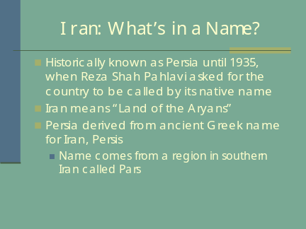 | ___________________________________  ___________________________________  ___________________________________  ___________________________________  ___________________________________  ___________________________________  ___________________________________
Slide 2 | 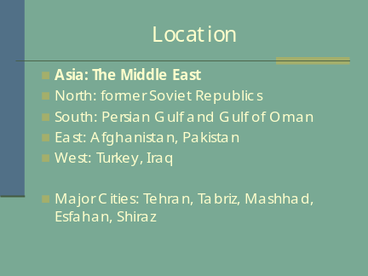 | ___________________________________  ___________________________________  ___________________________________  ___________________________________  ___________________________________  ___________________________________  ___________________________________
Slide 3 | 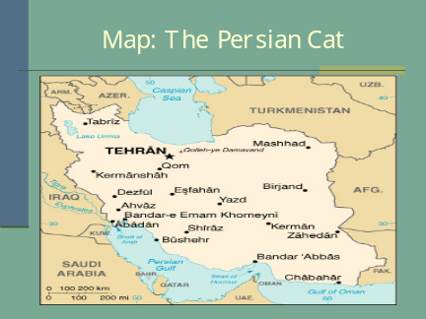 | ___________________________________  ___________________________________  ___________________________________  ___________________________________  ___________________________________  ___________________________________  ___________________________________
Slide 4 | 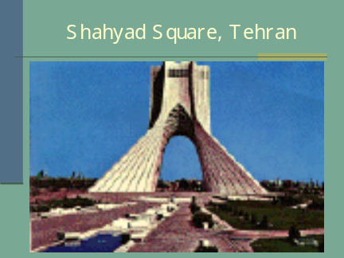 | ___________________________________  ___________________________________  ___________________________________  ___________________________________  ___________________________________  ___________________________________  ___________________________________
Slide 5 | 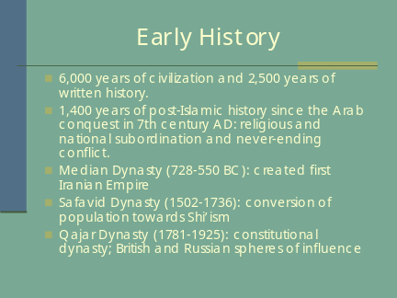 | ___________________________________  ___________________________________  ___________________________________  ___________________________________  ___________________________________  ___________________________________  ___________________________________
Slide 6 | 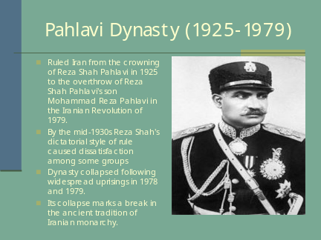 | ___________________________________  ___________________________________  ___________________________________  ___________________________________  ___________________________________  ___________________________________  ___________________________________
Slide 7 | 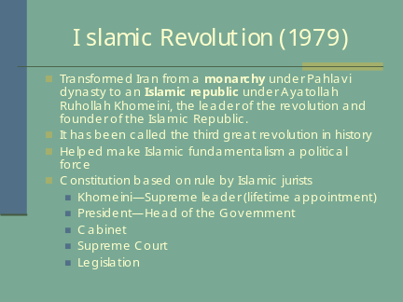 | ___________________________________  ___________________________________  ___________________________________  ___________________________________  ___________________________________  ___________________________________  ___________________________________
Slide 8 | 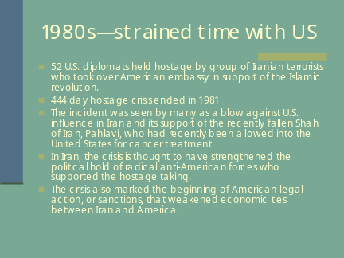 | ___________________________________  ___________________________________  ___________________________________  ___________________________________  ___________________________________  ___________________________________  ___________________________________
Slide 9 | 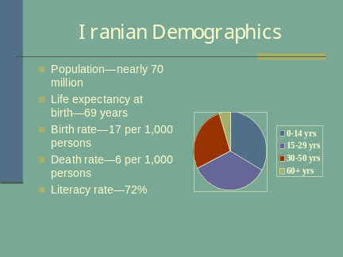 | ___________________________________  ___________________________________  ___________________________________  ___________________________________  ___________________________________  ___________________________________  ___________________________________
Slide 10 | 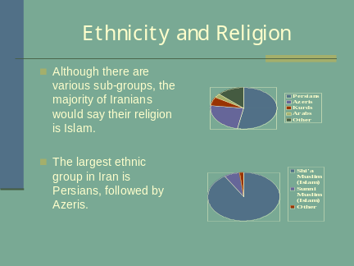 | ___________________________________  ___________________________________  ___________________________________  ___________________________________  ___________________________________  ___________________________________  ___________________________________
Slide 11 | 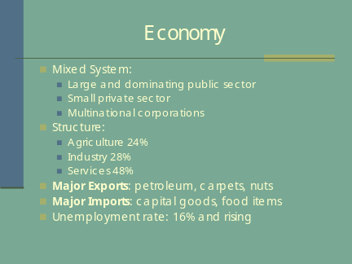 | ___________________________________  ___________________________________  ___________________________________  ___________________________________  ___________________________________  ___________________________________  ___________________________________
Slide 12 | 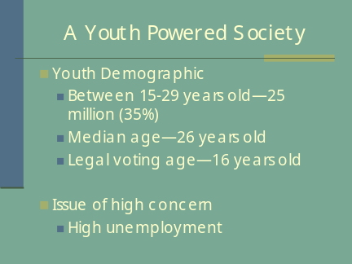 | ___________________________________  ___________________________________  ___________________________________  ___________________________________  ___________________________________  ___________________________________  ___________________________________
Slide 13 | 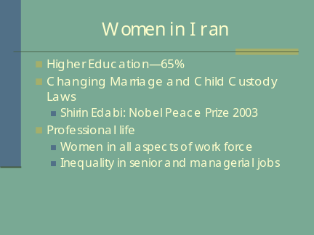 | ___________________________________  ___________________________________  ___________________________________  ___________________________________  ___________________________________  ___________________________________  ___________________________________
Slide 14 | 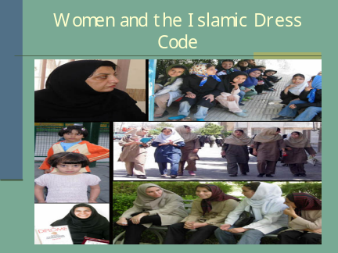 | ___________________________________  ___________________________________  ___________________________________  ___________________________________  ___________________________________  ___________________________________  ___________________________________
Slide 15 | 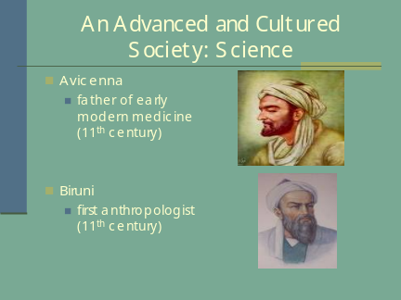 | ___________________________________  ___________________________________  ___________________________________  ___________________________________  ___________________________________  ___________________________________  ___________________________________
Slide 16 | 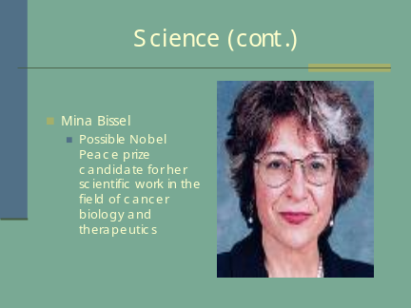 | ___________________________________  ___________________________________  ___________________________________  ___________________________________  ___________________________________  ___________________________________  ___________________________________
Slide 17 | 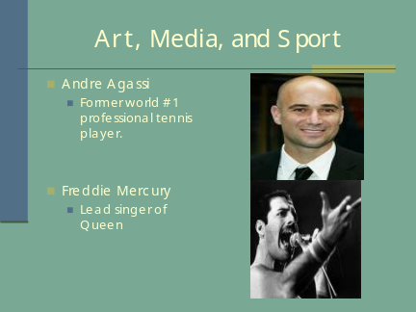 | ___________________________________  ___________________________________  ___________________________________  ___________________________________  ___________________________________  ___________________________________  ___________________________________
Slide 18 | 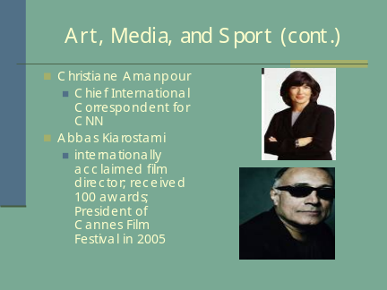 | ___________________________________  ___________________________________  ___________________________________  ___________________________________  ___________________________________  ___________________________________  ___________________________________
Slide 19 |  | ___________________________________  ___________________________________  ___________________________________  ___________________________________  ___________________________________  ___________________________________  ___________________________________
Slide 20 | 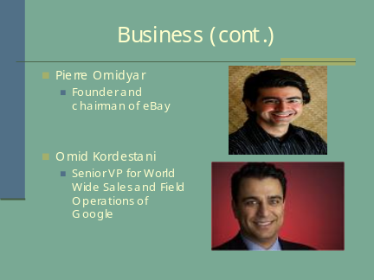 | ___________________________________  ___________________________________  ___________________________________  ___________________________________  ___________________________________  ___________________________________  ___________________________________
Slide 21 | 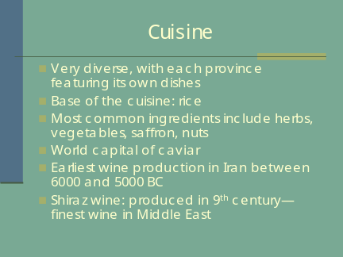 | ___________________________________  ___________________________________  ___________________________________  ___________________________________  ___________________________________  ___________________________________  ___________________________________
Slide 22 | 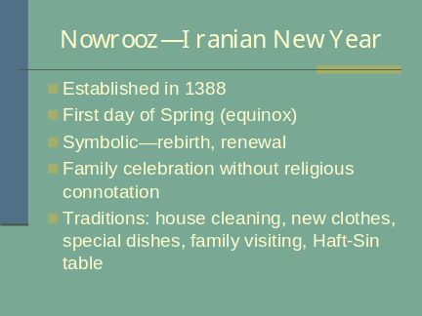 | ___________________________________  ___________________________________  ___________________________________  ___________________________________  ___________________________________  ___________________________________  ___________________________________

APPENDIX E: EVALUATION FORM
Based on the CSU English Placement Test (EPT)
Part I: Revising Checklist—Circle the appropriate categories.
 | Superior | Strong | Adequate | Marginal | Weak | Very Weak | Comments
Response to the topic | Addresses the topic clearly and responds effectively to all aspects of the task. | Addresses the topic clearly, but may respond to some aspects of the task more effectively than others. | Addresses the topic, but may slight some aspects of the task. | Distorts or neglects aspects of the task. | Indicates confusion about the topic or neglects important aspects of the task. | Suggests an inability to comprehend the question or to respond meaningfully to the topic.
Understanding and use of the assigned reading | Demonstrates a thorough critical understanding of the assigned reading in developing an insightful response. | Demonstrates a sound critical understanding of the assigned reading in developing a well-reasoned response. | Demonstrates a generally accurate understanding of the assigned reading in developing a sensible response. | Demonstrates some understanding of the assigned reading, but may misconstrue parts of it or make limited use of it in developing a weak response. | Demonstrates very poor understanding of the main points of the assigned reading, does not use the reading appropriately in developing a response, or may not use the reading at all. | Demonstrates little or no ability to understand the assigned reading or to use it in developing a response.
Quality and clarity of thought | Explores the issues thoughtfully and in depth. | Shows some depth and complexity of thought. | May treat the topic simplistically or repetitively. | Lacks focus or demonstrates confused or simplistic thinking. | Lacks focus and coherence, and often fails to communicate its ideas. | Is unfocused, illogical, or incoherent.
Organization, development, and support | Is coherently organized and developed, with ideas supported by apt reasons and well-chosen examples. | Is well organized and developed, with ideas supported by appropriate reasons and examples. | Is adequately organized and developed, generally supporting ideas with reasons and examples. | Is poorly organized and developed, presenting generalizations without adequate support, or details without generalizations. | Has very weak organization and development, providing simplistic generalizations without support. | Is disorganized and undeveloped, providing little or no relevant support.
Syntax and command of language | Has an effective, fluent style marked by syntactic variety and a clear command of language. | Displays some syntactic variety and facility in the use of language. | Demonstrates adequate use of syntax and language. | Has limited control of syntax and vocabulary. | Has inadequate control of syntax and vocabulary. | Lacks basic control of syntax and vocabulary.
Grammar, usage, and mechanics (See list on back for details) | Is generally free from errors in grammar, usage, and mechanics. | May have a few errors in grammar, usage, and mechanics. | May have some errors, but generally demonstrates control of grammar, usage, and mechanics. | Has an accumulation of errors in grammar, usage, and mechanics that sometimes interfere with meaning. | Is marred by numerous errors in grammar, usage, and mechanics that frequently interfere with meaning. | Has serious and persistent errors in grammar, usage, and mechanics that severely interfere with meaning.
Part II: Editing Checklist
Problem | Questions | Comments
Sentence Boundaries | Are there fragments, comma splices, or fused sentences?
Word Choice | Are word choices appropriate in meaning, connotation, and tone?
Verb/Subject Agreement | Do main verbs agree with the subject in person and number?
Verb Tense | Is the tense appropriate to the topic and style? Does the writing shift back and forth from present to past inappropriately?
Word Forms | Are any parts of verb phrases missing or incorrect? Are verb endings correct? Do other words have correct endings and forms?
Noun Plurals | Do regular plurals end in “s”? Are irregular plurals correct? Are there problems with count and non-count nouns?
Articles | Are articles (a, an, and the) used correctly? (Note: Proper nouns generally don’t have an article, with exceptions like “the United States” and “the Soviet Union,” which are more like descriptions than names.)
Prepositions | Are prepositions used the way a native-speaker of English would naturally use them? (Note: It is difficult to learn prepositions through definitions or rules. They have to be acquired through seeing or hearing them in use.)
Spelling | Are words spelled correctly?
Punctuation | Are periods, commas, and question marks used correctly? Are quotations punctuated correctly? Are capital letters used appropriately?
Pronoun Reference | Does every pronoun have a clear referent? (Note: Pronouns without referents, or with multiple possible referents, create a vague, confusing style.)
Other Problems | Are there other important problems not on the list?

