
Expository Reading and Writing Course

Online Community

Please join us online in the 12th Grade Expository Reading and Writing community. This website contains current versions of course modules, ancillary materials of various kinds, news items, links to important documents and resources, schedules of upcoming meetings, and most important of all, discussion boards where you can ask questions, make comments, and share your experiences using the modules.

To get started please visit http://writing.csusuccess.org. If you lost the e-mail with your account information, please click the “I lost my password” link, and a new username and password will be e-mailed to you. If you have any difficulties logging in send an e-mail to the ERWC Web Support Team at ERWC_feedback@calstate.edu. We look forward to seeing you online!

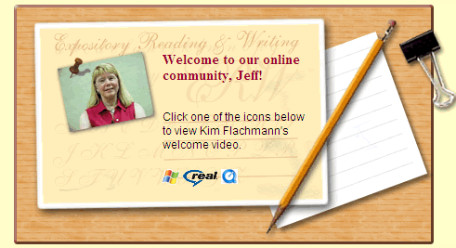
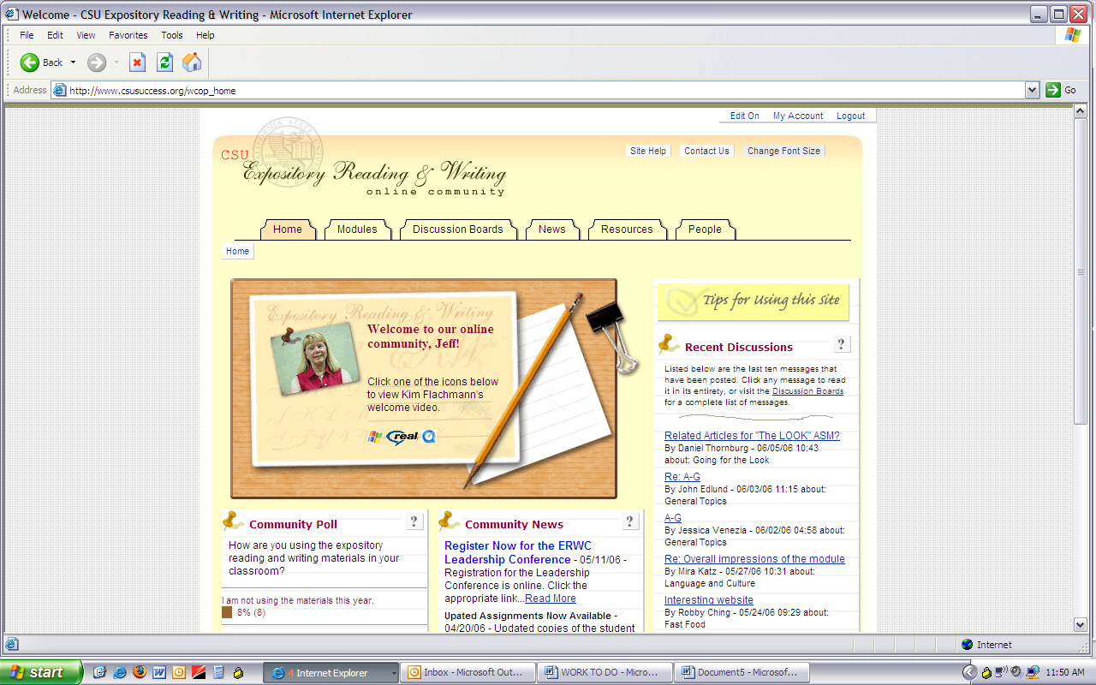
http://writing.csusuccess.org

