The Destruction of Our Ecosystem

Reading selections for this module:
- “Sharks Find Themselves in Danger” What’s Happening in the World? by Lawrence Gable
- “The Great Barrier Reef Struggles to Survive” What’s Happening in the World? By Lawrence Gable

Suggested Youtube clips:
- Shark Fin Frontier by Blue Sphere Media
http://www.youtube.com/watch?v=zep7B1esW-M
- More than Half of the Great Barrier Reef has been Destroyed in the Last Quarter Century
http://www.youtube.com/watch?v=xo6DrLOo3ho

 | Reading Rhetorically
 | Prereading | Getting Ready to Read  Introducing Key Concepts  Surveying the Text  Making Predictions and Asking Questions  Introducing Key Vocabulary
 | Reading | First Reading  Looking Closely at Language  Rereading the Text  Analyzing Stylistic Choices  Considering the Structure of the Text
 | Postreading | Summarizing and Responding  Thinking Critically
Connecting Reading to Writing
Writing to Learn
Using the Words of Others
Negotiating Voices
 | Writing Rhetorically
 | Prewriting | Reading the Assignment  Getting Ready to Write  Formulating a Working Thesis
 | Writing | Composing a Draft  Organizing the Essay  Developing the Content
 | Revising and Editing | Revising the Draft  Revising Rhetorically  Editing the Draft  Reflecting on the Writing
 | Evaluating and Responding | Grading Holistically  Responding to Student Writing  Using Portfolios

Reading Rhetorically
Prereading
English−Language Arts (ELA) Content Standard: Writing Applications (Genres and Their Characteristics)  2.3 Write reflective compositions:  a. Explore the significance of personal experiences, events, conditions, or concerns by using rhetorical strategies (e.g., narration, description, exposition, persuasion). | Getting Ready to Read (Article 1)  Activity 1: Quickwrite for 2 minutes on the topic of Oceans followed by discussion of quickwrite.  Activity 2: Youtube video on Shark Finning  - Have students take notes from video to use later.  - Discuss the video  Do you think the behavior of finning is ethical? Why/why not? Justify/explain your answer using examples from the clips and your own personal experience.  Have students discuss their responses. | Getting Ready to Read (Article 2)  Activity 3: KWL handout (fill out what they know and what they want to know)  Activity 4: Youtube video on Great Barrier Reef  - Have students take notes from video to use later.  - Discuss the video  - Fill in the what did they learn from the KWL handout
Word Analysis, Fluency, and Systematic Vocabulary Development  1.0 Students apply their knowledge of word origins to determine the meaning of new words encountered in reading materials and use those words accurately.  1.3 Discern the meaning of analogies encountered, analyzing specific comparisons as well as relationships and inferences. | Introducing Key Concepts  Key Terms: Article 1  Finning  Ecosystem  Species  Food Chain  Cultural Practices | Introducing Key Concepts  Key Terms: Article 2  Habitat Destruction  Oil Pollutants

Reading Comprehension (Focus on Informational Materials)  2.1 Analyze both the features and the rhetorical devices of different types of public documents (e.g., policy statements, speeches, debates, platforms) and the way in which authors use those features and devices.  2.3 Verify and clarify facts presented in other types of expository texts by using a variety of consumer, workplace, and public documents. | Making Predictions and Asking Questions  (Article 1)  - What will the future for sharks look like in the future?  - What will happen to other populations of fish? | Making Predictions and Asking Questions  (Article 2)  - What is the future for the Great Barrier Reef if things don’t change?  - What regulations do you think oil companies should have in regards to the Great Barrier Reef?  What will happen to other ecosystems if the Great Barrier Reef is not there?
Word Analysis, Fluency, and Systematic Vocabulary Development  1.0 Students apply their knowledge of word origins to determine the meaning of new words encountered in reading materials and use those words accurately.  1.1 Trace the etymology of significant terms used in political science and history.  1.2 Apply knowledge of Greek, Latin, and Anglo-Saxon roots and affixes to draw inferences concerning the meaning of scientific and mathematical terminology.  COLLEGE EXPECTATIONS  In addition to responding to the ELA standards, this activity is designed to develop the vocabulary skills assessed by college placement exams, such as the California State University English Placement Test and the University of California Analytical Writing Placement Exam. Students should be able to do the following:  • Recognize word meanings in context.  • Respond to tone and connotation. | Introducing Key Vocabulary (Article 1 Handout)  - Maturity  - Species  - Compensate  - Consume  - Ecosystem  - Prohibit  - Symbol  - Estimate  Activity 5: Word Sorts. Have students fill out first column by themselves. Then give them the opportunity to look up the definitions in a dictionary to complete the rest of the activity. | Introducing Key Vocabulary (Article 2 Handout)  Habitat  Cease  Function  Impact  Diversity  Activity 6: Use the vocabulary words given and create synonyms for the words in varying degrees.

 | Reading
- Reading Selections: “Sharks Find Themselves in Danger” What’s Happening in the World? by Lawrence Gable
- “The Great Barrier Reef Struggles to Survive” What’s Happening in the World? By Lawrence Gable
Reading Comprehension (Focus on Informational Materials)  2.1 Analyze both the features and the rhetorical devices of different types of public documents (e.g., policy statements, speeches, debates, platforms) and the way in which authors use those features and devices.  2.2 Analyze the way in which clarity of meaning is affected by the patterns of organization, hierarchical structures, repetition of the main ideas, syntax, and word choice in the text. | First Reading  The first reading of an essay is intended to help the students understand the text and confirm their predictions. This is sometimes called reading “with the grain” or “playing the believing game” (Bean, Chappell, and Gillam, 2007).  As students read “Sharks Find Themselves in Danger” have them complete the following:  Activity 7: As an effective metacognitive activity, have students annotate the text during their first read in the following manner:  - Highlight or underline any words, sections, phrases, etc. for which the meaning may be unclear.  - Place any questions about the text in the right hand margin. |  | Second Reading  The second reading of an essay is intended to help the students understand the text and confirm their predictions.  As students read “The Great Barrier Reef Struggles to Survive” have them complete the following:  Activity 8: As an effective metacognitive activity, have students annotate the text during their first read in the following manner:  - Highlight or underline any words, sections, phrases, etc. for which the meaning may be unclear.  - Place any questions about the text in the right hand margin.
Writing Strategies  1.7 Use systematic strategies to organize and record information (e.g., anecdotal scripting, annotated bibliographies).  Reading Comprehension (Focus on Informational Materials)  2.2 Analyze the way in which clarity of meaning is affected by the patterns of organization, hierarchical structures, repetition of the main ideas, syntax, and word choice in the text. | Rereading the Text  As students reread a text, they should develop fluency and build vocabulary, both of which are integral to successful comprehension.  Activity ? Ask students to revisit the questions they wrote in the right hand margin and determine if their understanding of the information allows them to answer the question.
 | Postreading
Prerequisite Seventh Grade: Writing Applications (Genres and Their Characteristics)  2.5 Write summaries of reading materials:  a. Include the main ideas and most significant details.  b. Use the student’s own words, except for quotations.  c. Reflect underlying meaning, not just the superficial details.  Writing Applications (Genres and Their Characteristics)  2.2 Write responses to literature:  a. Demonstrate a comprehensive understanding of the significant ideas in works or passages.  Reading Comprehension (Focus on Informational Materials)  2.4 Make warranted and reasonable assertions about the author’s arguments by using elements of the text to defend and clarify interpretations.  2.5 Analyze an author’s implicit and explicit philosophical assumptions and beliefs about a subject.  2.6 Critique the power, validity, and truthfulness of arguments set forth in public documents; their appeal to both friendly and hostile audiences; and the extent to which the arguments anticipate and address reader concerns and counterclaims (e.g., appeal to reason, to authority, to pathos and emotion).  COLLEGE EXPECTATIONS  In addition to responding to the ELA standards, these questions are designed to develop the skills assessed by college placement exams, such as the English Placement Test and the Analytical Writing Placement Exam. Students should be able to do the following:  • Identify important ideas.  • Understand direct statements.  • Draw inferences and conclusions.  • Detect underlying assumptions.  • Recognize word meanings in context.  • Respond to tone and connotation. | Thinking Critically  The following questions move students through the traditional rhetorical appeals. Using this framework, student’s progress from a literal to an analytical understanding of the reading material.  Questions for Reading Rhetorically (Article 1 Handout)  Activity 4: Pass out the handout and have students respond to these questions about article:  - What questions does the article address?  - Who is the intended audience?  - How does the author support his or her thesis with reasons and evidence?  - How does the author hook the intended reader’s interest and keep the reader reading?  - How does the author make himself or herself seem credible to the intended audience?  - Are this author’s basic values, beliefs, and assumptions similar to or different from my own?  - How do I respond to this text?  - How do this author’s evident purposes for writing fit my purposes for reading? | How to Structure a Rhetorical Precis (Article 2 Handout)  How to Structure A Rhetorical Précis  Sentences 1: Name of author, genre, and title of work, date in parentheses; a rhetorically accurate verb (such as “claims,” “argues,” “asserts,” “suggests”); and a THAT clause containing the major assertion or thesis statement in the work.  Sentence 2: An explanation of how the author develops and supports the thesis, usually in chronological order.  Sentence 3: A statement of the author’s apparent purpose, followed by an “in order to” phrase.  Sentence 4: A description of the intended audience and/or the relationship the author establishes with the audience.

 | Connecting Reading to Writing
Writing to Learn

Although the writing process can be divided into stages, writing, like reading, is essentially a recursive process that continually revisits different stages. Much of the pre-writing stage has already been accomplished at this point because students have been “writing to learn” while reading. They have been using writing to take notes, make marginal notations, map the text, make predictions, and ask questions. Now they are ready to use what they have learned to produce more formal assignments.
Prerequisite Ninth and Tenth Grade: Reading Comprehension (Focus on Informational Materials)  2.4 Synthesize the content from several sources or works by a single author dealing with a single issue; paraphrase the ideas and connect them to other sources and related topics to demonstrate comprehension.  Prerequisite Ninth and Tenth Grade: Writing Strategies  1.5 Synthesize information from multiple sources and identify complexities and discrepancies in the information and the different perspectives found in each medium (e.g., almanacs, microfiche, news sources, in-depth field studies, speeches, journals, technical documents).  1.6 Integrate quotations and citations into a written text while maintaining the flow of ideas.  1.7 Use appropriate conventions for documentation in the text, notes, and bibliographies by adhering to those in style manuals (e.g., Modern Language Association Handbook, The Chicago Manual of Style).  Writing Strategies  1.7 Use systematic strategies to organize and record information (e.g., anecdotal scripting, annotated bibliographies). | Using the Words of Others  The following information will help students begin to prepare themselves for incorporating the words of others into their own writing. This form of synthesis is an important but complex skill for writers. Students will also naturally use their content words from the module as they synthesize.  One of the most important features of academic writing is the use of words and ideas from written sources to support the writer’s own points. There are essentially three ways to incorporate words and ideas from sources.  - Direct quotation: Jon Pareles states, “Immediate responses to 9/11 and to the invasion of Iraq arrived along familiar lines” (1).  - Paraphrase: In “Pop Music and the War: The Sound of Resignation,” Jon Pareles describes the evolution of popular protest songs since the Vietnam War.  - Summary: In “Pop Music and the War: The Sound of Resignation,” Jon Pareles provides a multitude of examples of current protest songs to demonstrate the extent of social outcry in the music world. This “cultural response to war in Iraq and the war on terrorism” crosses all genres of music: rap, country, and pop (Pareles 1).  What citation format should I teach?  This is not an easy question to answer, because most students will end up using at least two formats in their college work. The two most common documentation styles used are Modern Language Association (MLA), used in Humanities disciplines and occasionally in business, and the American Psychological Association format (APA), common to the social sciences. In this version, we use the MLA format. It is probably best for high school teachers to teach the MLA format, because freshman composition in college is likely to require it. Other format students may encounter are CBE (Council of Biology Editors), Chicago (based on the Chicago Manual of Style), and ASA (American Sociological Association). When your students are in college, their instructors will tell them the required format.  Whatever format is used, students need to learn to record all of the necessary information and to get in the habit of documenting sources.  You also need to learn to take notes with full citation information. For print material, at a minimum you need to record the author, title, city of publication, publisher, date, medium, and page numbers (if applicable). Here is the “Works Cited” format for a typical book in MLA style:  Bean, John C., Virginia A. Chappell, and Alice M. Gilliam. Reading  Rhetorically: A Reader for Writers. New York: Longman, 2002. Print.  Here is the citation information for the article quoted above in MLA format. This is a newspaper citation:  Pareles, Jon. “Pop Music and the War: The Sound of Resignation.”  The New York Times. 2 January 2007, Sec. E: 1. Print.  You might also want to incorporate material from websites. To document a website, you need to give the author (if known), the title of the site (or a description like “Homepage” if not title is available), the date of publication or update (if known), the name of the organization that sponsors the site, the date of access, and the medium. For example:  University Writing Center. 26 June 2003. University Writing Center,  Cal Poly Pomona. 26 May 2004. Web.  The author is unknown for the above site. This entry would appear in the Works Cited section alphabetized by “University.”  MLA style also requires “in text” documentation for every direct quotation, indirect quotation, paraphrase or summary. If the author is given in the text, the page number should be given in parentheses at the end of the sentence containing the material. For example, here is a quote from the Pareles article:  Contemporary protest is a “cultural response to war in Iraq and the war on terrorism,” crossing all genres of music: rap, country, and pop (Pareles 1).  For extra practice: Ask students to practice in text citations by choosing three passages from the text. Use the first as a direct quotation, the second as paraphrase, and the third as a summary.  For help with citations, keep a current copy of the MLA handbook available for students. Or, if there is access to the internet, the students can refer to Purdue’s Online Writing Lab at <http://owl.english.purdue.edu/>.

Writing Rhetorically
Prewriting
Writing Strategies  1.0 Students write coherent and focused texts that convey a well-defined perspective and tightly reasoned argument. The writing demonstrates students’ awareness of the audience and purpose and progression through the stages of the writing process. | Reading the Assignment  Questions about Logic (Logos):  - Locate major claims and assertions and ask, “Do you agree with the author’s claim that…?”  - Look at support for major claims and ask, “Is there any claim that appears to be weak or unsupported? Which one and why?”  - What are counter-arguments that the author does not consider?  - Do you think the author has left something out on purpose? Why or why not?  Questions about the Writer (Ethos):  - Is the author knowledgeable? How can you tell?  - What does the author’s style and language tell you about him or her?  - Does this author seem trustworthy? Why or why not?  - Does this author seem deceptive? Why or why not?  - Does this author appear to be serious? Why or why not?  Questions about Emotions (Pathos):  - How does this piece affect you emotionally? What parts?  - Where and how is the author trying to manipulate your emotions?  Do your emotions conflict with their logical interpretation of the arguments? Why or why not?
Writing Strategies  1.1 Demonstrate an understanding of the elements of discourse (e.g., purpose, speaker, audience, form) when completing narrative, expository, persuasive, or descriptive writing assignments. | Getting Ready to Write  The following activities help students move as smoothly as possible from reading to writing. Students may want to refer to their reading notes before engaging in these activities:  - Have students use invention strategies to generate ideas, points, and arguments. Brainstorming, free write, cluster mapping, and graphic organizers are effective strategies.  - Strategies to help students consider the audience for the essay. Students should think about what most people know and think about the topic of their paper. If students want to change the opinions of the audience, they need to think about persuasive techniques, both logical and emotional.  Writing Prompt  Humans are destroying the ecosystem. Explain how our ecosystem is in danger by using support from the articles and videos. Predict what will happen if our society doesn’t change our current habits. Use direct quotes and at least one writing template from below.  Writing Template  - One implication of X’s treatment of _________ is that __________.  - Although X does not say so directly, _____apparently assumes that _________.  - When it comes to the topic of ________most of us will readily agree that__________.  - X claims that ______.  - According to X, “___________.”  - In other words, X believes __________.  - These conclusions will have significant applications in ________ as well as In ________.  Handout EPT rubric to students
Writing Strategies  1.3 Structure ideas and arguments in a sustained, persuasive, and sophisticated way and support them with precise and relevant examples. | Formulating a Working Thesis  Most students will find it helpful to formulate a working thesis statement at this point. Students can go through their brainstorming work to decide what statement or assertion they might be able to support. Although students can be successful with different approaches to writing, a strong, focused thesis statement can keep the writer on track.  Tell your student that writing down a tentative thesis at this point is a good habit to develop in the writing process. Their thesis should be a complete sentence and can be revised several times. However, a focused thesis will keep their writing on track.  Encourage your students to answer the following questions in their journals:  Record your responses to the following questions in preparation for writing your tentative thesis statement.  - What specific question will your essay answer? What is your response? (This is your tentative thesis)  - What support have you found for your thesis?  - What evidence have you found for this support? For example: facts, statistics, authorities, personal experience, anecdotes, stories, scenarios, and examples.  - How much background information do your readers need to understand your topic and thesis?  - If readers were to disagree with your thesis or the validity of your support, what would they say? How would you address their concerns?  Now, draft a possible thesis for your essay.  After students formulate a working thesis, give them feedback prior to writing. Potential writing problems can be averted at this stage before the students generate their first drafts.
 | Writing
Writing Strategies  1.3 Structure ideas and arguments in a sustained, persuasive, and sophisticated way and support them with precise and relevant examples. | Composing a Draft  The first draft of an essay provides a time for students to discover what they think about the topic. It is usually “writer-based,” the goal of which is simply to get the writer’s ideas down on paper. Students should start with their brainstorming notes and other materials they have and write a rough draft of their essay.
Writing Strategies  1.3 Structure ideas and arguments in a sustained, persuasive, and sophisticated way and support them with precise and relevant examples. | Organizing the Essay  The following items are traditional parts of an essay, which should be included in the letter portion of the business letter. The number of paragraphs in an essay depends upon the nature and complexity of the student’s argument.  Introduction  - Students might wasn’t to include the following in their introductory paragraph(s):  - A “hook” to get the reader’s attention  - Background information the audience may need  - A thesis statement, along with some indication of how the essay will be developed.  Body  - Paragraphs that present support of the thesis statement, usually in topic sentences supported with evidence (see Getting ready to Write)  - Paragraphs that include different points of view or address counter-arguments  - Paragraphs or sentences where the writer addresses those points of view  - By refuting them  - By acknowledging them but showing the writer’s argument is better  - By granting them altogether but showing they are irrelevant  - Evidence that students have considered the values, beliefs, and assumptions of their audience, students’ own values, beliefs and assumptions, and whether they have found some common ground that appeals to the various points of view  Conclusion  A final paragraph or paragraphs that includes a solid argument to support the thesis and indicate the significance of the argument—the “so what” factor
Writing Strategies  1.1 Demonstrate an understanding of the elements of discourse (e.g., purpose, speaker, audience, form) when completing narrative, expository, persuasive, or descriptive writing assignments. | Developing the Content  Students need to understand that body paragraphs explain and support their thesis statements as they move their writing from writer-based to reader-based prose.  - Most body paragraphs consist of a topic sentence (or an implied topic sentence) and concrete details to support that topic sentence.  - Body paragraphs give evidence in the form of examples, illustrations, statistics, etc. and analyze the meaning of the evidence.  - Each topic sentence is usually directed related to the thesis statement.  - No set number of paragraphs make up an essay.  - The thesis dictates and focuses the content of an essay.

 | Revising and Editing
Prerequisite Ninth and Tenth Grade: Writing Strategies  1.9 Revise writing to improve the logic and coherence of the organization and controlling perspective, the precision of word choice, and the tone by taking into consideration the audience, purpose, and formality of the context.  Writing Strategies  1.4 Enhance meaning by employing rhetorical devices, including the extended use of parallelism, repetition, and analogy; the incorporation of visual aids (e.g., graphs, tables, pictures); and the issuance of a call for action.  1.5 Use language in natural, fresh, and vivid ways to establish a specific tone.  1.9 Revise text to highlight the individual voice, improve sentence variety and style, and enhance subtlety of meaning and tone in ways that are consistent with the purpose, audience, and genre. | Revising the Draft  Students now need to work with the organization and development of their drafts to make sure that their essays are as effective as possible.  Students should produce the next drafts based on systematic feedback from others. These drafts will be more “reader-based” than the first because they will naturally take into consideration the needs of the reader as they respond to the text.  Peer Group Work: In small groups, each student can read his or her essay aloud to the other members of the group. The other students will then complete the Revising Evaluation Form (see Appendix E, Part I) for each essay they hear. Give each student enough copies of the form to evaluate the others in the group.  Paired Work: Students can work in pairs to decide how they want to revise the problems identified by the peer group.  Individual Work: Students can then revise the draft based on the feedback they have received and the decisions they have make with their partners. The following questions can direct them in individual work.  Revision Guidelines for Individual Work:  - Have I responded to the assignment?  - What is my purpose for this essay?  - What should I keep? What is most effective?  - What should I add? Where do I need more details, examples, and other evidence to support my point?  - What could I get rid of? Did I use irrelevant details? Was I repetitive?  - What should I change? Are parts of my essay confusing or contradictory? Do I need to explain my ideas more fully?  - What should I rethink? Was my position clear? Did I provide enough analysis to convince my readers?  - How is my tone? Was I too overbearing, too firm? Do I need qualifiers?  - Have I addressed differing points of view?  - Does my conclusion show the significance of my essay?

Prerequisite Ninth and Tenth Grade: Written and Oral English Language Conventions  1.1 Identify and correctly use clauses (e.g., main and subordinate), phrases (e.g., gerund, infinitive, and participial), and mechanics of punctuation (e.g., semicolons, colons, ellipses, hyphens).  1.2 Understand sentence construction (e.g., parallel structure, subordination, proper placement of modifiers) and proper English usage (e.g., consistency of verb tenses).  1.3 Demonstrate an understanding of proper English usage and control of grammar, paragraph and sentence structure, diction, and syntax.  Written and Oral English Language Conventions  1.1 Demonstrate control of grammar, diction, and paragraph and sentence structure and an understanding of English usage.  1.2 Produce legible work that shows accurate spelling and correct punctuation and capitalization.  1.3 Reflect appropriate manuscript requirements in writing. | Editing the Draft  Students now need to work with the grammar, punctuation, and mechanics of their drafts to makes sure that their essays conform to the guidelines of standard written English.  - In this case, students will benefit most from specific instructor or tutor feedback rather than from peer evaluation.  - This work can be preceded by mini-lessons on common grammar, usage, punctuation, and mechanics.  Individual Work: Students can edit their drafts based on the information they received from an instructor or tutor. Along with the editing checklist of the grading rubric (see Appendix E, Part II) the suggestions below will help them edit their own work.  Editing Guidelines for Individual Work:  - If possible, set your essay aside for 24 hours before rereading to find errors.  - Read your essay out loud to a friend so you can hear your own errors.  - Focus on individual words and sentences rather than overall meaning. Take a sheet of paper and cover everything except the line you are reading. Touch your pencil to each word as you read.  - With the help of your teacher, figure out your own pattern of errors—the most serious and frequent.  - Only look for one type of error at a time. Then go back and look for a second type, and so on.  Use the dictionary to confirm spelling and that you have chosen the right word for the context (especially if it is a word from a thesaurus).
Reflecting on the Writing

When you return essays to your students, a good practice is to ask them to reflect in writing about the process of writing the essay, what they learned that they can apply to their next assignment, or how they feel about the comments you gave them on the essay.

Ask the students to respond to the following questions, once the essays have been completed and graded:
- What was the most difficult part of this assignment?
- What was the easiest?
- What did you learn about literary analysis by completing this assignment?
- What was the strongest portion of your essay? Place a wavy line in the margin where those strong parts are.
- Were there any weak portions? Place an X by the parts of the essay you would like help with. Write any questions in the margin as well.
- What did you learn about your own writing process—preparation, first draft, revising, editing?
- Were the comments from the teacher helpful and clear? Are they suggestions that can help you in the next assignment?

Readings
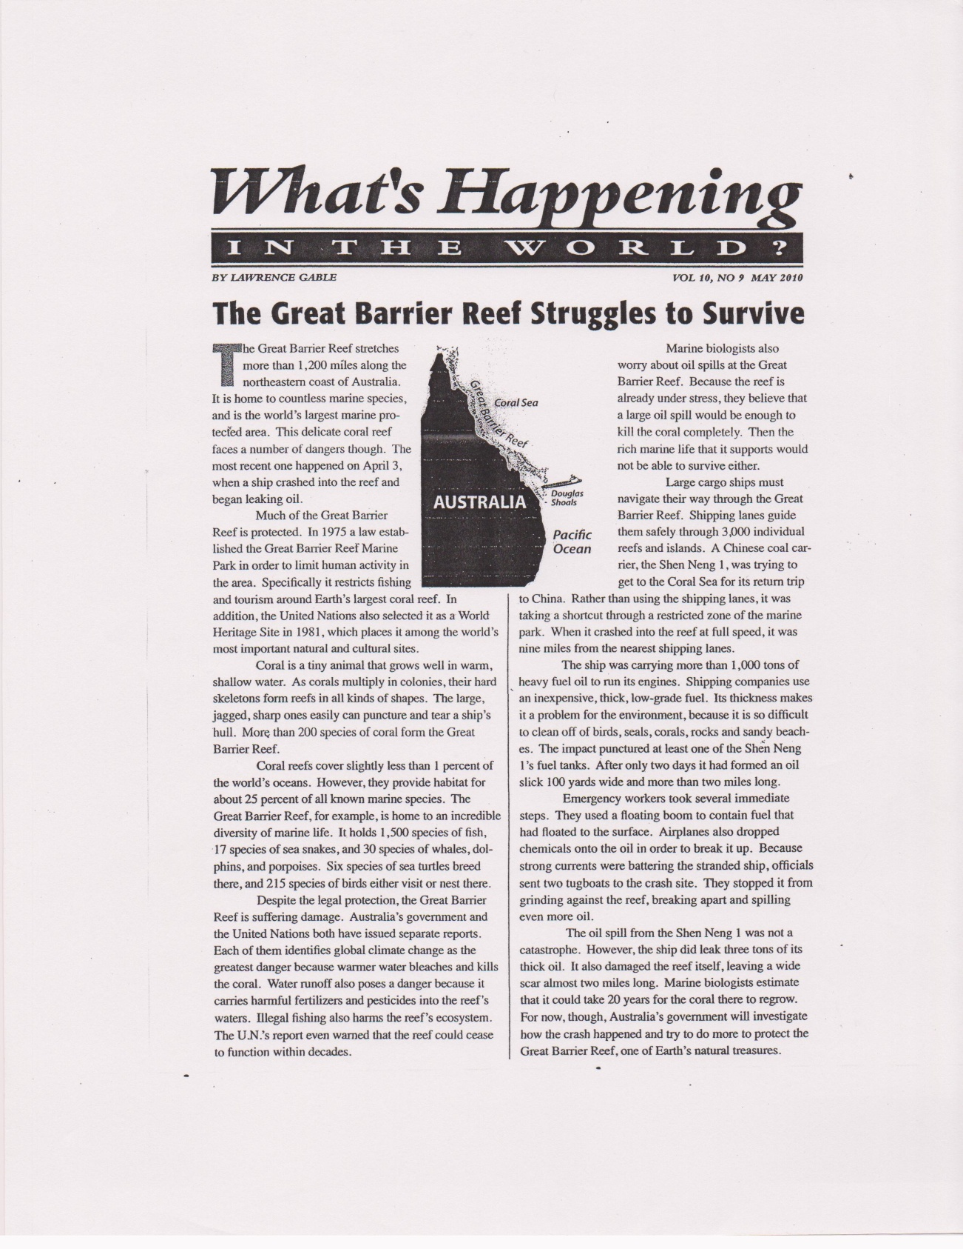

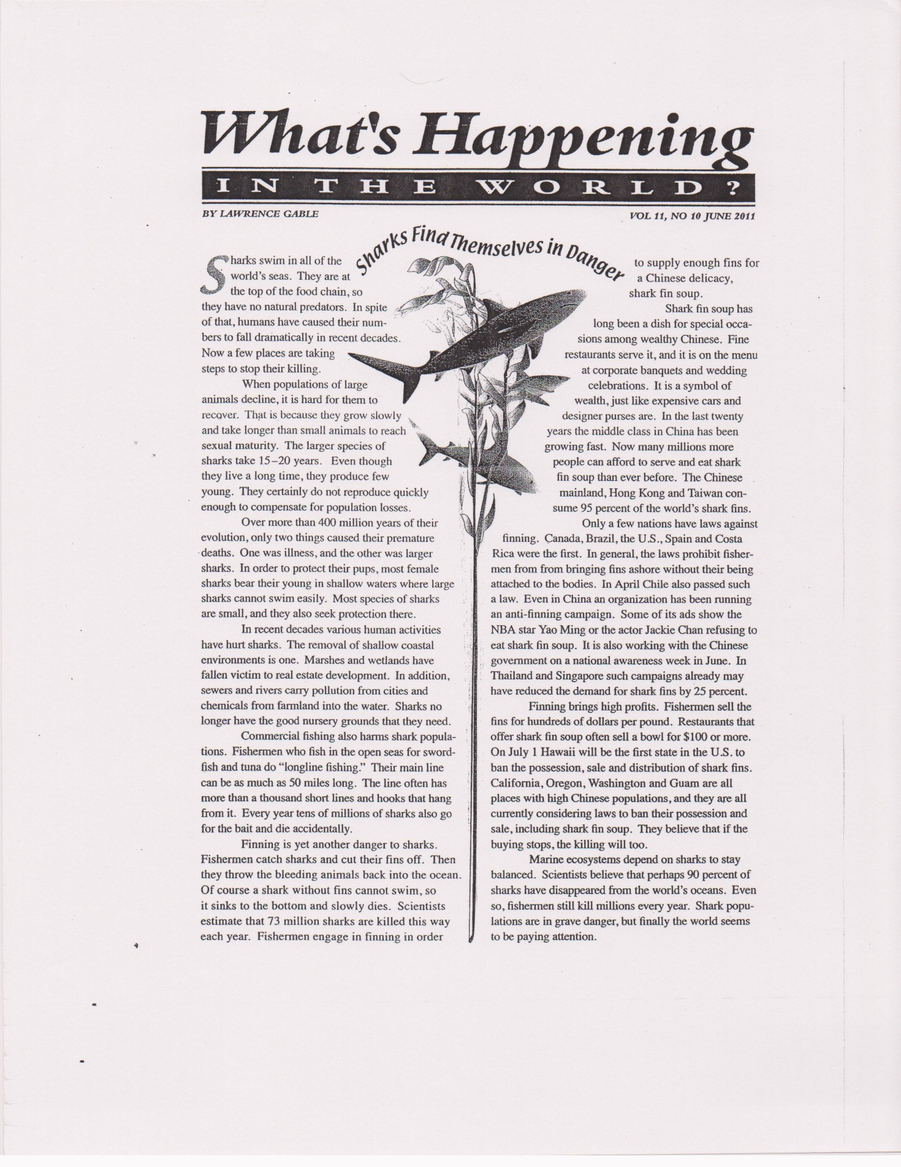

Appendix A

KWL Graphic Organizer

Directions
1) List what you know (K) about a topic; 2) what you want (W) to learn about a topic; and 3) with you learned (L) about a topic after reading about it.
K W L
What I KNOW | What I WANT to Know | What I LEARNED
APPENDIX B
Key Assignment Words
Analyze | Break the issue or problem into separate parts and discuss, examine, or interpret each part and the relationships between them. Sometimes this involves looking carefully at causes and effects.
Analyze the Argument and the Conclusion | Look at the truth and persuasiveness of the reasons given for a position and the degree to which the conclusion is justified on the basis of those reasons.
Compare and Contrast | Describe the similarities and differences between two objects, situations, or ideas. Sometimes this involves a before-and-after comparison.
Define | Tell what a particular word or term means in your essay. Usually, this is not a dictionary definition; rather, it clarifies the way in which you are using the term.
Describe | Give a detailed account, naming characteristics, parts, or qualities.
Discuss | This is a general term that covers explanations, reasoning, pro and con arguments, examples, analysis, and so forth.
Evaluate | This term literally means to determine the “value” of something, to discover how good or bad something is. It usually means that you should argue that something is good or bad, and then discuss your reasoning.
Explain | Help the reader understand the reasoning behind your position by showing the logical development in step-by-step fashion. You might also be asked to show how something works or how to do something.
Illustrate | In a writing prompt, this usually does not mean to draw pictures. Instead, it means to give examples.
Prove | This usually means that you should support your opinion with facts and arguments.
State | Tell the reader your opinion strongly and concisely.

APPENDIX C
Reading Strategies
Book marks. Book marks can be used to help students think about how they read (reflecting on the mental process itself) and what they read (focusing strategically on content, style, and form). They can also be used to facilitate a reader’s ability to develop interpretations and aid in their formulation of questions to help anchor reading in the text. See Burke for examples of classroom uses.
Chunking. Proficient readers monitor their comprehension and often “chunk” language—break it up into smaller units—within sentences to help them understand what they read. Chunking can be used with complex sentences or with longer passages, depending on the reader’s needs. Such divisions will vary from person to person. See Schoenbach et al. and Burke for examples of classroom uses.
GIST (Generating Interactions between Schemata and Text). Involving five major steps, this strategy is an excellent way to show students how to write a summary: (1) read the passage or chapter; (2) circle or list the important words, phrases, and ideas; (3) put the reading material aside; (4) use the important words, phrases, and ideas to generate summary sentences; and (5) add a topic sentence. See Cunningham et al. for more information on this strategy.
Graphic organizers. By visually representing a text, graphic organizers help students understand textual and informational structures and perceive connections between ideas. Graphic organizers can also support comprehension and help students reflect on which parts of a text are the most important. See Schoenbach et al. and Burke for examples of classroom uses.
Quickwrites. A form of freewriting, quickwrites are spontaneous, stream-of-consciousness responses to a single issue or related issues (Fulwiler).
Reciprocal Teaching. Reciprocal Teaching entails taking turns in leading a discussion on a reading selection with the intention of helping oneself and others understand and retain the author’s main points. It involves guiding the group toward reasonable predictions, important questions, essential clarifications or explanations, and coherent summaries. See Schoenbach et al. and Burke for examples of classroom uses. Also see Palincsar and Brown.
Rereading or repeated reading. Rereading increases readers’ comprehension and raises their confidence, especially with challenging texts. It also helps less-skilled readers develop fluency. See Schoenbach et al. and Burke for examples of classroom uses.
Say, mean, matter. This strategy is the process of answering three questions as they relate to a reading selection: What does it say? What does it mean? What or why does it matter? The purpose of this exercise is to encourage students to move beyond literal-level thinking (Blau).
SQP2RS. This is the process of (1) surveying—previewing a text or part of a text; (2) questioning—listing two or three questions you think will be answered by reading the text; (3) predicting—stating three or four things you think will be learned by reading this text, then asking the class to narrow the list of questions to focus on three or four of them; (4) reading reading the assigned text; (5) responding—confirming and negating predictions, answering the questions already generated and asking new ones, and discussing the text with the class; and (6) summarizing— either orally or in writing. See Echevarria et al. and Vogt.
Talking to the text/annotating the text/highlighting. Writing responses and questions in the margins and underlining and highlighting key ideas are ways of increasing readers’ engagement with ideas presented in the text. These interactions with the reading material help to activate students’ prior knowledge and support their comprehension. See Jordan, Jensen, and Greenleaf and Burke for examples of classroom uses. Also see Davey.
Think aloud. Narrating the thought process while reading a passage aloud can help students externalize points of confusion, articulate questions about the text or its content, and make connections between the text and the students’ background knowledge and life experience. It is common to have students alternate reading sentences, paragraphs, or sections aloud. Think alouds help to make internal thinking processes observable. See Schoenbach et al. and Burke for examples of classroom uses. Also see Kucan and Beck for a review of the research.

APPENDIX D
Vocabulary Activities
Concept map. Teachers ask students to generate additional words, contexts, examples, and non-examples for a new term, concept, or key vocabulary word.
Cubing. Originally created by Cowan and Cowan Neeld, students freewrite about a vocabulary term, using each of the six ways to discuss the term: describe it, compare it, associate it, analyze it, apply it, and argue for or against it. Allow students to write about each “side” of the cube for roughly three minutes. After they have done all six sides, students can share or develop their own definition of the term.
Denotation/connotation making. Students predict word meanings or look up words based on their denotations (dictionary definitions) and connotations (personal meanings).
Frayer model. Students define the key concept, describe its attributes, compare and contrast it to other related concepts, provide examples for it, and explain why the example is appropriate. Using this model, the students can distinguish between examples and non-examples (Frayer, Frederick, and Klausmeier).
Rich use of language. Reading research shows that the more experiences and richer experiences students have with new words, the more likely they are to learn the word. Those experiences include opportunities for oral and written use of the new words as well as identifying and comprehending them in text. Teachers can provide students with more practice words by having them use the new words to create scripts for performing commercials, skits, role plays, poems, raps, songs, and so forth.
Self-assessment charts. These charts allow students to view key terms from the text to see whether they know them and, if so, to what extent. Students can then learn the words they do not know, and teachers will gain some insight as to which words may need direct instruction.
Semantic maps, webs, spiders. This graphic organizer is for categorizating, grouping, and organizing information.
Sorting activities. Students sort words by derivation or by concept. For a sorting activity, the teacher makes a list of words that are related either by root/derivation or by concept. The words are then listed on a grid and manipulated with signs or symbols. The teacher may choose to have an open sort (no headings stated) or a closed sort (the teacher tells the students what the headings will be).
Synonym/antonym chart with examples. Students identify synonyms for the new word given, increasing their list of words that are similar but also enhancing their own understanding of the word in relation to other words that share the meaning. To promote even more understanding and more words in their storage banks, students look at antonyms. Then they provide examples of the word in sentences or give the context.
What Am I? This is an activity in which questions are asked about what the vocabulary term is and what it is not on the basis of the meaning of the word. Students might explore one word and “teach” it to the class, sharing the clues discovered while studying the word.
Word trees. These are used for derivations and to build similar words on the basis of meaning.
Vocabulary notebooks or logs. These are used for the indirect teaching of vocabulary. With vocabulary logs, students direct their own learning as they identify and log unknown words that they find in text.
APPENDIX E
Prewriting Strategies
Brainstorming. Based on free association, this is the act of making a list of related words and phrases.
Clustering/webbing. This is the process of mapping any ideas that come to mind on a specific topic. It involves writing a key word or phrase at the center of a page and drawing a circle around it, then writing and circling any related ideas that come to mind and drawing lines to the words that prompted the new words.
Discussing. This is the act of talking with another person about one’s subject matter and grappling aggressively with the ideas in the process.
Freewriting. Based on free association, this is the strategy of writing for a brief period of time about anything that comes to mind.
Outlining. This is the listing of the main ideas and the details related to the subject in the order in which they will likely be addressed.
Questioning. This is the process of asking questions that will generate new ideas and topics. This process is often based on the five Ws and one H: Who? What? Why? Where? When? and How?
Scanning. This is the process of scanning and spot reading specifically to generate ideas and form opinions.

APPENDIX F
Strategies for Reading and Writing Rhetorically
PAPA Square
The PAPA Square is adapted from Maxine Hairston’s Contemporary Composition (short edition). Through a PAPA Square, students analyze the purpose, argument, persona, and audience of a text.
Around the perimeter of the box, students answer the following questions in response to their own writing: Who is my audience? What is the persona, or public image, that I create for myself through my language choices and tone? What is my thesis or argument? What is my purpose or the desired outcome of my argument (i.e., what would I like my reader to do if he or she is persuaded my argument)? In the center of the PAPA Square, students identify the stylistic devices and the emotional, logical, and ethical appeals they use to persuade their audiences. These may include types of evidence, figurative language, text structures (e.g., cause and effect), and tone.
Purpose:
Rhetorical Methods and Strategies
Audience: Argument:

Persona:
Rhetorical Précis
In a rhetorical précis, students write a brief analysis of the content, purpose, and persuasive strategies of a text using the pattern below (from Reading Rhetorically by John C. Bean, Virginia A. Chappell, and Alice M. Gillam):
Sentence 1: Note the name of the author, the genre and title of the work, and the publication date in parentheses; a rhetorically accurate verb; and a that clause containing the major assertion or thesis statement in the work.
Sentence 2: An explanation of how the author develops and supports the thesis, usually in chronological order.
Sentence 3: A statement of the author’s apparent purpose, followed by an “in order to” phrase.
Sentence 4: A description of the intended audience, the relationship the author establishes with the audience, or both.

APPENDIX G
Evaluation Form
Based on the CSU English Placement Test (EPT)
Part I: Revising Checklist—Mark the appropriate categories.
Response to the topic | Superior | Strong | Adequate | Marginal | Weak | Very Weak | Comments
 | Addresses the topic clearly and responds effectively to all aspects of the task | Addresses the topic clearly but may respond to some aspects of the task more effectively than others. | Addresses the topic but may slight some aspects of the task. | Distorts or neglects aspects of the task | Indicates confusion about the topic or neglects important aspects of the task. | Suggests an inability to comprehend the question or to respond meaningfully to the topic.
Understanding and use of the assigned reading | Demonstrates a thorough critical understanding of the assigned reading in developing an insightful response. | Demonstrates a sound critical understanding of the assigned reading in developing a well reasoned response. | Demonstrates a generally accurate understanding of the assigned reading in developing a sensible response. | Demonstrates some understanding of the assigned reading but may misconstrue parts of it or make limited use of it in developing a weak response. | Demonstrates very poor understanding of the main points of the assigned reading. Does not use the reading appropriately in developing a response or may not use the reading at all | Demonstrates little or no ability to understand the assigned reading or to use it in developing a response.
Quality and clarity of thought | Explores the issues thoughtfully and in depth. | Shows some depth and complexity of thought. | May treat the topic simplistically or repetitively. | Lacks focus or demonstrates confused or simplistic thinking. | Lacks focus and coherence and often fails to communicate ideas. | Is unfocused, illogical, or incoherent.
Organization, development, and support | Is coherently organized and developed, with ideas supported by apt reasons and well-chosen examples. | Is well-organized and developed, with ideas supported by appropriate reasons and examples. | Is adequately organized and developed, generally supporting ideas with reasons and examples. | Is poorly organized and developed, presenting generalizations without adequate support or details without generalizations. | Has very weak organization and development, providing simplistic generalizations without support. | Is disorganized and undeveloped, providing little or no relevant support.
Syntax and command of language | Has an effective, fluent style marked by syntactic variety and a clear command of language. | Displays some syntactic variety and facility in the use of language. | Demonstrates adequate use of syntax and language. | Has limited control of syntax and vocabulary. | Has inadequate control of syntax and vocabulary. | Lacks basic control of syntax and vocabulary.
Grammar, usage, and mechanics  (See list on next page for details) | Is generally free from errors in grammar, usage, and mechanics. | May have a few errors in grammar, usage, and mechanics. | May have some errors but generally demonstrates control of grammar, usage, and mechanics | Has an accumulation of errors in grammar, usage, and mechanics that sometimes interfere with meaning. | Is marred by numerous errors in grammar, usage, and mechanics that frequently interfere with meaning. | Has serious and persistent errors in grammar, usage, and mechanics that severely interfere with meaning.

Part II: Editing Checklist
Problem | Questions | Comments
Sentence boundaries | Are there fragments, comma splices, or fused sentences?
Word choice | Are word choices appropriate in meaning, connotation, and tone?
Subject-verb agreement | Do main verbs agree with the subject in person and number?
Verb tense | Is the tense appropriate to the topic and style? Does the writing shift back and forth from present to past inappropriately?
Word forms | Are any parts of verb phrases missing or incorrect? Are verb endings correct? Do other words have correct endings and forms?
Noun plurals | Do regular plurals end in “s”? Are irregular plurals correct? Are there problems with count and non-count nouns?
Articles | Are articles (a, an, and the) used correctly? (Note: Proper nouns generally don’t have an article, with exceptions like “the United States” and “the Soviet Union,” which are more like descriptions than names.)
Spelling | Are words spelled correctly?
Punctuation | Are periods, commas, and question marks used correctly? Are quotations punctuated correctly? Are capital letters used appropriately?
Pronoun reference | Does every pronoun have a clear referent? (Note: Pronouns without referents or with multiple possible referents create a vague, confusing style?)
Other problems | Are there other important problems?

APPENDIX H
Holistic Scoring Guide
(Based on the English Placement Test Criteria)
The categories of each score are consistent with the following legend:
- response to the topic
- understanding and use of the passage
- quality and clarity of thought
- organization, development, and support
- syntax and command of language
- grammar, usage, and mechanics
Score of 6: Superior
A 6 essay is superior writing, but may have minor flaws. A typical essay at this level is characterized by these features:
- addresses the topic clearly and responds effectively to all aspects of the task
- demonstrates a thorough critical understanding of the passage in developing an insightful response
- explores the issues thoughtfully and in depth
- is coherently organized and developed, with ideas supported by apt reasons and well-chosen examples
- has an effective, fluent style marked by syntactic variety and a clear command of language
- is generally free from errors in grammar, usage, and mechanics
Score of 5: Strong
A 5 essay demonstrates clear competence in writing. It may have some errors, but they are not serious enough to distract or confuse the reader. A typical essay at this level is characterized by these features:
- addresses the topic clearly, but may respond to some aspects of the task more effectively than others
- demonstrates a sound critical understanding of the passage in developing a well-reasoned response
- shows some depth and complexity of thought
- is well organized and developed, with ideas supported by appropriate reasons and examples
- displays some syntactic variety and facility in the use of language
- may have a few errors in grammar, usage, and mechanics
Score of 4: Adequate
A 4 essay demonstrates adequate writing. It may have some errors that distract the reader, but they do not significantly obscure meaning. A typical essay at this level is characterized by these features:
- addresses the topic, but may slight some aspects of the task
- demonstrates a generally accurate understanding of the passage in developing a sensible response
- may treat the topic simplistically or repetitively
- is adequately organized and developed, generally supporting ideas with reasons and examples
- demonstrates adequate use of syntax and language
- may have some errors, but generally demonstrates control of grammar, usage, and mechanics
Score of 3: Marginal
A 3 essay demonstrates developing competence, but is flawed in some significant way(s). A typical essay at this level reveals one or more of the following weaknesses:
- distorts or neglects aspects of the task
- demonstrates some understanding of the passage, but may misconstrue parts of it or make limited use of it in developing a weak response
- lacks focus, or demonstrates confused or simplistic thinking
- is poorly organized and developed, presenting generalizations without adequate and appropriate support or presenting details without generalizations
- has limited control of syntax and vocabulary
- has an accumulation of errors in grammar, usage, and mechanics that sometimes interfere with meaning
Score of 2: Very Weak
A 2 essay is seriously flawed. A typical essay at this level reveals one or more of the following weaknesses:
- indicates confusion about the topic or neglects important aspects of the task
- demonstrates very poor understanding of the main points of the passage, does not use the passage appropriately in developing a response, or may not use the passage at all
- lacks focus and coherence, and often fails to communicate its ideas
- has very weak organization and development, providing simplistic generalizations without support
- has inadequate control of syntax and vocabulary
- is marred by numerous errors in grammar, usage, and mechanics that frequently interfere with meaning
Score of 1: Incompetent
A 1 essay demonstrates fundamental deficiencies in writing skills. A typical essay at this level reveals one or more of the following weaknesses:
- suggests an inability to comprehend the question or to respond meaningfully to the topic
- demonstrates little or no ability to understand the passage or to use it in developing a response
- is unfocused, illogical, or incoherent
- is disorganized and undeveloped, providing little or no relevant support
- lacks basic control of syntax and vocabulary
- has serious and persistent errors in grammar, usage, and mechanics that severely interfere with meaning
Readers should not penalize ESL writers excessively for slight shifts in idiom, problems with articles, confusion over prepositions, and occasional misuse of verb tense and verb forms as long as such features do not obscure meaning.
Works Cited
Bean, John C., Virginia A. Chappell, and Alice M. Gillam. Reading Rhetorically: Brief Edition. 2nd ed. New York: Pearson/Longman, 2007.
Blau, Sheridan. The Literature Workshop: Teaching Texts and Their Readers. Portsmouth, NH: Heinemann, 2003.
Burke, Jim. Reading Reminders: Tools, Tips, and Techniques. Portsmouth, NH: Boynton/Cook, 2000.
Cowan, Gregory, and Elizabeth Cowan Neeld. Writing. New York: Wiley, 1980.
Frayer, Dorothy A., Wayne C. Frederick, and Herbert J. Klausmeier. A Schema for Testing the Level of Cognitive Mastery. Madison: Wisconsin Center for Education Research, 1969.
Schoenbach, Ruth, et al. Reading for Understanding: A Guide to Improving Reading in Middle and High School Classrooms. San Francisco: Jossey-Bass, 1999.
Vogt, MaryEllen. “Content Learning for Students Needing Modifications: An Issue of Access.” Creativity and Innovation in Content-Area Teaching. Ed. Maureen McLaughlin and Mary Ellen Vogt. Norwood, MA: Christopher Gordon, 2002. 329–51.

