Budget Transfer Form Instructions
(PeopleSoft Budget Entry Form)
PURPOSE
The Budget Transfer Form is used to transfer budget funding from one department/account to another department/account within the same fund.
- You cannot use the Budget Transfer Form to transfer budget from one fund to another.
- You cannot use the Budget Transfer Form to transfer any Salary 601XXX or Benefit 603XXX accounts
PROCESS
  - Download the form from the Budget Transfers website: (https://www.csub.edu/budget/Budget%20Transfer/index.html)
  - Complete the form
  - Obtain appropriate administrators’ signatures. Appropriate administrators are MPP or Division Heads who have signature authority for the department of which funds are being transferred from.
  - Email the completed form and spreadsheets to budget@csub.edu. The Budget Office established this email address specifically for department end users.
  - Mail the signed, approved hard copy to the Budget Office.
  - The Budget Office will only process Budget Transfer Forms after an approved hard copy is received with the appropriate administrator’s signature. If you have questions, or concerns, please do not hesitate to contact the University Budget Office at (661) 654-2606 or (661) 654-6238.
Sample Completed Budget Transfer Form
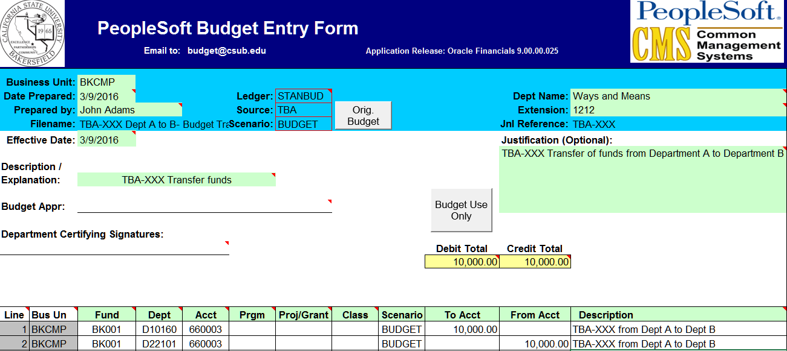
FORM INSTRUCTIONS
- You must fill out all the required fields
- This form contains validation cells to ensure the data is uploaded in the proper alphanumeric format.
- If the Debit Total and the Credit Total do not equal, an error message will appear in red. Please correct the error before submitting this form.
- Use the TAB key, to move between cells on the form.
Business Unit | The budget transfer form is designed for use with any of the five business units at CSUB. Enter the appropriate business unit by utilizing the pull down menu to select a value. The default value is set for BKCMP.  - BKCMP – CSUB campus (Stateside)  - BKFDN – CSUB Foundation  - BKASI – Associated Students Inc.  - BKSTU – Student Union & Student Recreation Center  - BKSPA – Foundation Grants
Date Prepared | The current date will automatically default.
Prepared by | Enter your name
Filename | This field will default to what you name your file.
Ledger | Leave the default value, “STANBUD”, which stands for Standard Budget. This ledger is where all departmental budget transfers will occur.
Source | Leave the default value, “TBA”, which stands for Transfer of Budget Allocation.
Scenario | From the drop down, select BUDGET
Dept Name | Enter the name of the Department for which you are employed.
Extension | Enter your campus telephone extension.
Jnl Reference | This field will default to what you name your file.
Effective Date | The Effective Date will default to the current date. Please do not change this date.
Justification | Explain the reason(s) for the budget transfer(s). The Budget Office staff will review and verify your justification.
Description / Explanation | Enter any information that you would like to use as a reference for your records.
Budget Appr | Leave blank. The Fiscal Services approver will complete this field.
Department Certifying Signature | Leave blank. The requesting department will provide signatures for the hard copy journal entry.
Debit Total | Calculates automatically as you enter information in the To Acct cells. This value should match the value in the Credit Total.
Credit Total | Calculates automatically as you enter information in the From Acct cells. This value should match the value in the Debit Total.
Line | This field will populate itself automatically as you enter information in the columns. Please do not change the column format.
Bus Un | This field will populate itself automatically as you enter information in the columns. Please do not change the column format.
Fund | Enter the fund from which you intend to transfer budget to or from (i.e. BK001 for General Fund). You can only transfer budget within the same fund.
Dept | Enter the Dept ID from which you intend to transfer budget to or from (i.e., DXXXX)
Acct | Enter the account chart field from which you intend to transfer the budget To/From.  - Be sure to use the proper alphanumeric account, for which you want to transfer funds to or from.
Prgm | Enter the Program, if applicable
Proj/Grant | Enter the Project or Grant, if applicable
Class | Enter the Class, if applicable
Scenario | This field will automatically default to “BUDGET”, please do not change it.
To Acct | Enter the dollar amount you wish to transfer To.  - Do not use the minus “-“ sign in cells.  - Use a different line for the “To Acct” and the “From Acct” information.
From Acct | Enter the dollar amount you wish to transfer From.  - Do not use the minus “-“ sign in this column.  - Use a different line for the “To Acct” and the “From Acct” information.
Description | Enter any information that you would like to use as a reference for your records.

