CSUB GIFT CARD/CERTIFICATE PURCHASE PRE-AUTHORIZATION FORM
Pre-authorization is required for the purchase of all gift cards and certificates. Gift cards/certificates may only be purchased on a ProCard by a University employee. A copy of this approved form, original detailed receipt, and Gift Acknowledgement Form must accompany the ProCard Reconciliation Packet.
- Gift cards/certificates awarded to students will be reported to Financial Aid and may be included on the 1098-T.
- Gift cards/certificates awarded to visitors may be included on a 1099-MISC form.
- Gift cards/certificates awarded for participation in research projects cannot exceed a value of $50.
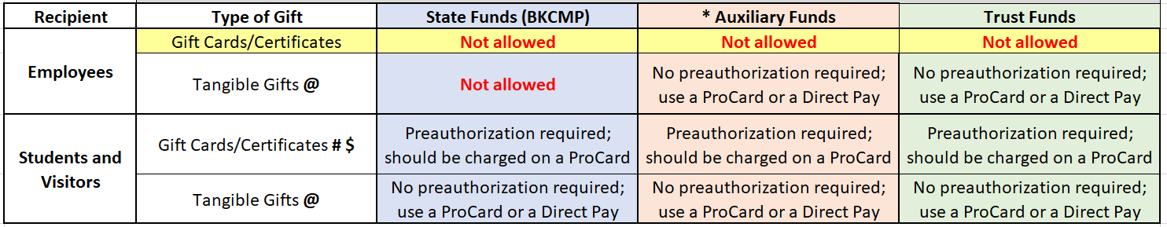
Description of what is going to be purchased (including number and dollar amount of items to be purchased): Click here to enter text.
Description of intended use of gifts (e.g., research project, survey, drawing, student recognition, etc): Click here to enter text.
Vendor Name (entity from which gifts are to be purchased): Click here to enter text.
- If Human Subjects Research, IRB approval is required. Protocol Number: Click here to enter text. Title of Project: Click here to enter text.
- If Grant related, SPPA Sponsored Programs Post Award approval is required. Fund # Click here to enter text. Project # Click here to enter text.
Month and Year gifts are to be distributed: Click here to enter text.
Total Requested Dollar Amount: Click here to enter text.
Chartfield (including business unit) Click here to enter text.
Requestor’s Name: Click here to enter text.

Requestor’s Signature: X_________________________________________ Date: Click here to enter text.
Contact Extension/Email Click here to enter text.
If authorization is granted, the requestor agrees to be responsible for the safekeeping of all gift cards/certificates in a secure location until they are awarded (i.e. a locked desk or office) and to maintain a copy of all documentation related to this request.
Appropriate Approval Signature (i.e., Dean, Department Chair, Administrator or Principal Investigator)
If charging a grant, the Principal Investigator’s approval is required.

__________________________________________
Signature Name (Printed) Date
___
Title

Send Grant related forms to spapostaward@csub.edu
Send Human Subjects Research forms to IRB gparnell@csub.edu
All others: Send to Payment Services accounts_payable@csub.edu
_________________________________________
Business Services Director or AVP Signature

_________________________________________
IRB approval (if applicable)

_________________________________________
SPPA Sponsored Programs Post Award approval (if applicable) Link to Hospitality Policy (under Payment Services)

